Stage 2 Research Project
Assessment Type 1: Folio

RESEARCH PROJECT

How do music and movement combine within the genre of physical theatre to convey a story?

My Topic
From the first time I heard about the Research Project I knew that I wanted to do something that revolved around music. I have learnt the alto saxophone for eight years which helped to accommodate my interest in music. My first idea was to take up the cello and show my progress for my research project but I quickly realised that it would be far too expensive. So as this was not an option, I looked into composing music for dance and after a while this also seemed unviable as it was too long and complicated a process to learn how to compose a piece of music for a dance. Finally, I settled on the idea of looking into how music and movement combine within physical theatre to tell a story and the processes that go into making this happen.
Planning
P1@B
Evidence of identification and refinement of a question from a broad topic.
Research Processes
I am going to begin my research by firstly creating five focusing questions, researching them and analysing them to guide my research. I will use secondary sources such as articles, books and websites to gather information and annotate them by means of analysing them. I will then use primary sources once I have gathered enough background information. The primary sources that I will use will be observation, interviewing and surveying and also conducting an experiment on one of my focusing questions, which is how music affects emotions.
Planning
P2@C
Identification of research processes appropriate to the research question are described but not explained.
Throughout the duration of the project I will keep a journal of reflections of my progress along the way which will document how far I have come, the knowledge I have learnt and the ways in which feel that I have gained skills and improved in my personal attributes.
I will have to consider taking ethics into consideration, ensuring that no copyright occurs
and that all surveys and interviews are conducted in an ethical manner.

Capability
Development
D4@C
Identification of a relevant capability and some demonstration of understanding that should be further developed throughout the folio.
The capability that I am choosing to focus on for my research project is the Personal and Social Capability. I am choosing this as I find it to be the most relevant and appropriate to the topic that I am pursuing and conducting over time. I believe that the research processes that I am undertaking will ensure that I gain better skills within my personal attributes such as organisation and efficient time planning. Also, I will be gaining a large amount of knowledge and understanding to do with my topic that will enrich and enlighten me, rendering the fact that my understanding will have developed from the beginning of the project to the end.
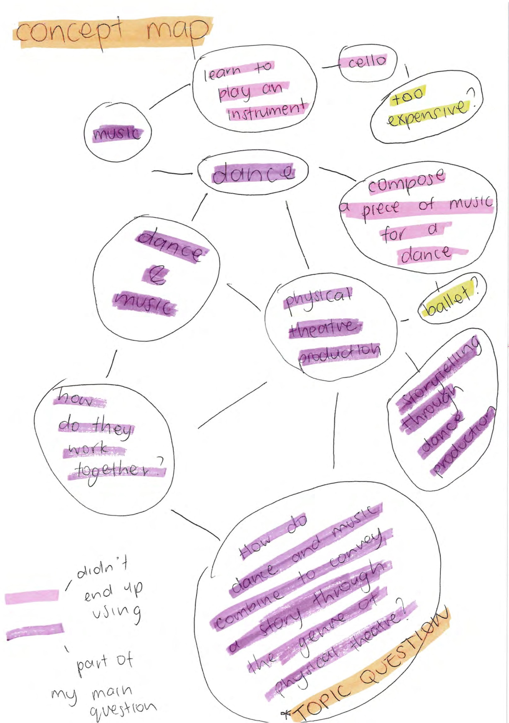
Planning
P1@C
Evidence of refining a research question is evident through a visual concept map.
IMPORTANT REFLECTIONS (Extracts from my Journal)
Extract 1
After talking to my research project teacher and careful deliberation, I decided to refine my research project question even further. It had come to my attention that composing an entire piece of music in such a short amount of time may be too time-consuming and an unreasonable ask. I had begun to actually try and use Sibelius and realised that trying to learn how to use it on top of all the research I was going to have to conduct would be too immense and that it wouldn't be doable in the time frame I had been given. I have begun to think of ways to refine the topic even further so the end result would actually be achievable in such a short space of time.
Planning
P1@B
Evidence of refining the research question demonstrated by considering the manageability of the question within the time frame and narrowing the question to be researchable.
Extract 2
I have been working on my new topic for roughly a week now. I changed it so that the topic question is now 'How do music and movement combine within the genre of physical to convey a story?' I came to this question by looking at my previous topic and deciding which parts I wanted to take out of it and transfer to the new question — and these were the dance and music elements. I then took this and tried possible questions I could make out of it until I came to how the two combine to tell a story. I thought this may be too generalised so I narrowed it down even further to within the genre of physical theatre. I created a concept map to show my ideas and started to adjust my research accordingly to fit my new ideas. I kept the same timeline as I could easily catch up on the things I had missed out and everything else could be done according to schedule.
Extract 3
I have collected a few background secondary sources and started annotating them, as well as observing some YouTube videos to do with music and movement. Watching and analysing Mao's Last Dancer was still relevant to my studies as the analysis I did was on how the music and movement worked together. I chose another movie to watch and analyse and that was Fantasia. This was a perfect movie to analyse as the whole film is created around the way(s) in which music and movement work together and it shows it as the characters move on and with the beat. There are notes from the movie included in my folio.
Extract 4
In the past couple of days, I have come up with my focusing questions that I will use in my outcome. These are 'What is physical theatre?' How does music affect emotions?' How when the two elements of music and movement combine is it more profound than when the two operate on their own?' and 'What is the importance of the relationship between the choreographer and composer? I also started working on my survey questions to be filled in sometime soon.
Extract 5
To help answer one of my focusing questions I created a video where I asked a different group of people how a certain song made them feel and what it made them think of. The results were basically as expected — more positive sounding songs, songs in a major key, produced happier and more joyful emotions whereas the more negative sounding songs, in a minor key, produced more solemn and sad emotions. This was an interesting experiment though, as even though the results were generalised, each specific person had their own different take on what exactly each song made them think of and it was just interesting to see how music affects each person differently.

Extract 6
Today I decided to look further into the relationships between choreographers and composers to help answer my focusing question arid choreographers and composers. There was one particular collaboration that my saxophone teacher told me to look into — Igor Stravinsky and Sergei Diaghilev.
Development
D1@C
Demonstration of evidence of research development by designing focusing questions, designing a survey and conducting an experiment.
Diaghilev was born in Russia and the founder of Ballet Russes and as well as being a choreographer, he also composed and painted and Stravinsky was a Russian-born, naturalised French, later naturalised American composer, pianist, and conductor.
They were definitely a notable composer-choreographer duo. Diaghilev had heard Stravinsky's orchestral works Fireworks and Scherzo fantastique, and asked Stravinsky to arrange some pieces by Chopin for the Ballets Russes. In 1910, Stravinsky and Diaghilev worked on their first score together as a choreographer-composer correlation, The Firebird. Petrushka (1911) and The Rite of Spring (1913) followed shortly afterwards, and the two also worked together on Pulcinella (1920) and Les notes (1923). Stravinsky was crucial in the artistic development of the Ballets Russes, his works rarely out of the company's repertoire. Hardly a month went by without contact with Diaghilev, to discuss ideas or work in progress.
This shows the intense work that goes into the relationship if you want the collaboration to work well. The choreographer and the composer have to be on the same wavelength for the music and dance to work together, and to achieve this, they have to work together very closely.
Extract 7
Planning
P2@C
Demonstration of some planning in the management of research processes used-provides further support of appropriateness of process to the question.
I have gathered enough information to start writing my outcome. I am able to answer my focusing question, 'How do music and movement combine to convey a story within the genre of physical theatre?' I have all of my secondary sources, annotated, for the background information and then as my primary research I have my surveys which have been filled out, the observations I have made and the experiment I conducted. I feel confident that I have researched enough to safely be able to start my outcome and produce a well-written, knowledgeable and in depth essay on the ways in which music and movement combine to tell a story through physical theatre.

Timeline for the research project

Term 1 | Week | Activity
 | 3 | Inform teacher of the topic I have chosen  Start writing proposal  Start collecting secondary sources + annotating
 | 5 | Hand up proposal  Hand up record of research (the 1st checkpoint)  Gather more secondary sources
 | 6 | Annotate secondary sources  Start writing surveys  Prepare discussion notes
 | 7 | Keep working on record of research  Keep preparing discussion
 | 8 | Do discussion
 | 9
 | 10 | Hand up record of Research (the 2nd checkpoint)
 | 11 | Answer focusing questions and work on ethical considerations
Holidays
 |  | Work on everything!
Term 2
 | 1 | Check focusing questions with teacher
 | 2 | Put out surveys and get them filled in, analyse
 | 3 | Start working on outcome and finalising folio
 | 4 | Hand up folio
 | 5 | Outcome due
 | 6 | Summary due
 | 7 | Evaluation due.

Methodology

Focusing question one: What is physical theatre?
Development
D3@C
Demonstration of development of research skills is evident when considering the range of sources available although the choices have not been justified.
How do you intend to research this?
I intend to research physical theatre by using secondary sources to define it, and gain some background knowledge on it.
What sources will you use?
Internet websites and possibly books.

Focusing question two: How does music affect emotions?
How do you intend to research this?
Primary and secondary sources. I intend to conduct an experiment to ask people the way certain songs make them feel and analyse their answers to incorporate them into this focusing question.
Planning
P2@B
Demonstration of the planning of research processes appropriate to the research question.
What sources will you use?
My experiment and also a number of websites, articles and books.

Focusing question three: What is the importance of the relationship between the choreographer and composer?
How do you intend to research this?
By researching into certain choreographer-composer relationships, researching how they worked and by using secondary sources.
What sources will you use?
The internet, books and articles.

Focusing question four: How when the two elements of music and movement combine is it more profound than when the two operate on their own?
How do you intend to research this?
By observation, observing movies and YouTube videos and seeing how when the two are combined the overall effect is more intense and better overall than when the two operate on their own, Also by using answers from surveys, and analysed secondary sources.
What sources will you use?
Observation, secondary sources — articles, books, the internet.
Development of the Capability
I chose to focus on the Personal and Social Capability in my research project.
I chose this as I found it was the most relevant and appropriate to the topic that I was investigating and the research that I would be conducting over time as the project lent itself to a vast amount of progress occurring and new skills having to be learnt such as time management and organisation as it was so large. This proved accurate, as over the duration of the research project, I became more confident within myself in my communication skills and also my interpersonal and intra-personal skills due to having to ask people whether I could survey or interview them or not. Developing these skills was a large part of my research project as by the end I was to a large degree much more comfortable talking to people and surveying people and this made it a lot easier to do, and made the entire project run much more smoothly.
Development
D4@C
Demonstrates a general understanding of the Personal and Social Capability. Evidence of the development of the capability is concrete although specific examples are not described.
I also found that throughout the project my time management and organisational skills improved tenfold, which again made the project much easier to manage with my newfound skills, At the beginning of the project, I was unable to really plan or use my time efficiently but towards the end of the project I found that I could these things with much more ease and it was endlessly helpful in helping me get things done on time and be more productive. These skills come from basically having to acquire them, from taking on such a big project, which had to be managed effectively.
I also found that through the duration of my research, my persistence and resilience increased towards my work, and that if one thing did not work out then I did not give up. Refining my topic showed this as I encountered many obstacles such as two of my topic questions not working out but I changed this to suit the parameters of my own means, budget and time-wise.

Ethical considerations
The ethical considerations that I had to take into account were making sure that I did not plagiarise any work, which was easy to ensure by properly referencing all of my work.
I also made sure that everybody I surveyed was aware of the fact that their answers would be used for my research project and that the people who partook in the experiment that I conducted gave permission to be videoed and that they permitted the video to be shown for my research project.

Survey analysis
As I conducted my surveys over the internet, it is difficult to include hard copy samples of the surveys, so I will just include the question and samples of some of the more in depth answers.
Development
D2@C
Demonstrates some analysis of information when comparing the various answers to the survey questions and drawing conclusions.
Do you think that music plays an important part in dance productions? Please explain why.
- "Definitely! Although it’s possible to dance without music, the song chosen can really help capture the emotions and expressions that the dancer or choreographer want to convey."
- "Of course! While not completely essential for some times of dance, it sets the mood, adds a third dimension. One in which emotions can be emitted, and eventually aids the dance production."
- "Yes - the music sets the mood and ultimately controls the tempo and movement in the dance. Choreographers can only create light and shade in a routine when there is variation in the music, and it is at the heart of every dance production (whether as a member of the audience, or as a dancer)."

Do you think that when the music and movement in a dance production correlate and work together it makes it more interesting? Please explain why.
These answers clearly show the general consensus that music is very important in dance productions as it expresses emotions and controls the movement in the dance. It shows that choreographers and composers need to work together to create a 'whole' performance as choreographers can only create one dimension of the performance
- "Absolutely. This is why the music plays such a great role. It is an audio and visual display, when both elements relate to each other it becomes more interesting"
- "Yes, in nature there is a basic correlation between movement and sound (footsteps for instance), and in my opinion observing this phenomenon gives us a vicarious sympathy - ie on some primal level we interpret the spectacle as our own movement. When human movement is engineered, with music (which is so evocative for its own reasons), it is a simple and easy way to excite the observer, and at the same time establish a mood."
- "Definitely. Like mentioned above, choreographers wilt for the most part adapt their steps to suit the music. They are able to create light and shade in their choreography through crescendos and softer parts. It is much more interesting to watch a performance in which the movement is linked closely with the music - it is far more aesthetically pleasing."

These answers show that it is definitely much more interesting when music and movement work together as it makes it a whole performance, as the performance is an 'audio and visual display' which infers that both elements are needed to make this performance so.
What sort of preparation do you believe goes into making sure the music and movement of the dance work together?
- "As someone who has been a dance teacher for a year and a half, I can appreciate that there is a great deal of time that goes in to making the movements work with the music, and the vice versa. Preparation would mostly include finding music that presents the right mood of the dance, and that can complement the movements."
- "Making sure the music is suitable for the pace and style of the movements that may be included. Making sure the music has a similar "feel" to the moves."
- "rehersal. lots and lots of rehersal. making movement to fit music is very difficult. creating patterns within the music with movement is very hard with most music as there can be underlying beats, dancers must listen to the music and find the beat the choreography fits on."

Do you think that the composer/choreographer relationship is important when making a dance production and ensuring that the music fits the dance?
These answers show a general conception that there is a lot of work that goes into ensuring that the music and movement work together in a performance/production. They believe that a lot of preparation goes into it, although they may not be sure exactly what said preparation entitles.
- "They have to be pretty tight and both share at least a VERY similar vision as to what the end product will be. Without that it would be hard to communicate ideas and it would be far less likely to create a routine with matching (correlating) dance and song."
- "Yes. Given that both are interdependent on one another if aiming to achieve a perfect blend between music and movement, the relationship is extremely important."
- "yes, otherwise they would not be able to co-ordinate and work with each other properly"

Who do you think would be the more important person in the relationship - the composer or the choreographer?
All of the answers given were similar and that was that 'yes' the relationship is important as obviously, the closer they are able to work together, the better the work that they produce will be. This is true, because as my research showed, the closer that the duo work together, the more comprehensive an understanding the two will have of the other's ideas and what they want for the performance.
73.9% - Choreographer
43.8% - Composer

When watching a dance, how much notice do you take of the music behind it and how the moves work with it?
I agree with the 73.9% as although the composer is very important, the composer is more working to suit the choreographer's needs as the music will be written for the dance, and not the other way around. The choreographer will usually direct the composer to suit his needs, although both individuals are very important when working together.
- "As a dancer, I take a lot of notice of the music! There is nothing worse than watching a dance that has not necessarily been poorly choreographed, but that simply does not fit with the music chosen. The best dance performances require a distinct correlation between the visual movements and the music heard."
- "I think quite a lot actually, because I guess it helps me see a story behind the movements and i can imagine why the song was chosen for the dance."
- "I would expect the combination of music and dance to speak for itself. Dance moves based around musical structure should be plainly obvious, The more attention I need to pay the less the music and dance would fit together."
These answers insinuate that observers of dance productions do take notice of the music and would be able to notice if they didn't work together but as the two should just flow together, they should not have to pay too much attention to it. It also shows that the observers take a lot of notice of the way that the music and movement work together and also believe that they should correlate and there should be a distinct connection between the movements and the music.

Bibliography
www.artmedia.com.au (accessed 9/3/2011)
http://www.blackfishacademy.com/physical.htm (accessed 11/4/2011)
Music and the Brain, Laurence O'Donnell http://neurosci.nature.com (accessed 10/3/2011)
Emotions of the Musical Keys,
http://www.gradfree.com/kevin/some theory on musical keys.htm accessed (10/3/2011)
Emotional responses to pleasant and unpleasant music correlate with activity in paralimbic brain regions, Anne J. Blood, Robert J. Zatorre, Patrick Bermudez and Alan C. Evans (accessed 10/3/2011)
Music and the Brain, Laurence O'Donnell http://neurosci.nature.com (accessed 10/3/2011)

Nature Neuroscience volume 2 no 4 April 1999 (accessed 15/4/2011)
Music and Movement Survey, conducted (accessed 11/05/11)
http://www.madamhelen.com/code/choreography.htm (accessed 4/05/2011)
http://nycphysicaltheatre.com/definition.aspx (accessed 6/5/2011) http://en.wikipedia.org/wiki/Physical theatre (accessed 9/5/2011) http://www.blackfishacademy.com/physical.htm (accessed 9/5/2011)
http://www.gradfree.com/kevin/some theory on musical keys.htm (accessed 11/4/2011)
A Study of the Choreogropher/Composer Collaboration — Van Stiefel (accessed 17/5/2011)
Stage 2 Research Project Performance Standards
 | Planning | Development | Synthesis | Review
 | Assessment Type 1: Folio |  | Assessment Type 2:  Research Outcome  Assessment Type 3: Review
A | P1 Thorough consideration and refinement of a research question.  P2 Thorough planning of research processes that are highly appropriate to the research question. | D1 Thorough and highly resourceful development of the research.  D2 In-depth analysis of information and exploration of ideas to develop the research.  D3 Highly effective development of knowledge and skills specific to the research question.  D4 Thorough and informed understanding and development of one or more capabilities | S1 Insightful synthesis of knowledge, skills, and ideas to produce a resolution to the research question.  S2 Insightful and thorough substantiation of key findings relevant to the research outcome.  S3 Clear and coherent expression of ideas. | R1 Insightful review of knowledge and skills developed in response to the research question.  R2 In-depth discussion of decisions made in response to challenges and/or opportunities.  R3 Insightful reflection on the quality of the research outcome
B | P1 Consideration and some refinement of a research question.  P2 Considered planning of research processes that are appropriate to the research question. | D1 Considered and mostly resourceful development of the research.  D2 Some complexity in analysis of information and exploration of ideas to develop the research.  D3 Effective development of knowledge and skills specific to the research question.  D4 Informed understanding and development of one or more capabilities. | S1 Considered synthesis of knowledge, skills, and ideas to produce a resolution to the research question.  S2 Substantiation of most key findings relevant to the research outcome.  S3 Mostly clear and coherent expression of ideas. | R1 Considered review of knowledge and skills developed in response to the research question.  R2 Some depth in discussion of decisions made in response to challenges and/or opportunities.  R3 Considered reflection on the quality of the research outcome
C | P1 Some consideration of a research question, but little evidence of refinement.  P2 Satisfactory planning of research processes that are appropriate to the research question. | D1 Satisfactory development of the research.  D2 Satisfactory analysis of information and exploration of ideas to develop the research.  D3 Satisfactory development of knowledge and skills specific to the research question.  D4 Satisfactory understanding and development of one or more capabilities. | S1 Satisfactory synthesis of knowledge, skills, and ideas to produce a resolution to the research question.  S2 Substantiation of some key findings relevant to the research outcome.  S3 Generally clear expression of ideas. | R1 Satisfactory review of knowledge and skills developed in response to the research question.  R2 Satisfactory discussion of decisions made in response to challenges and/or opportunities.  R3 Satisfactory reflection on the quality of the research outcome
D | P1 Basic consideration and identification of a broad research question.  P2 Partial planning of research processes that may be appropriate to the research question. | D1 Development of some aspects of the research.  D2 Collection rather than analysis of information, with some superficial description of an idea to develop the research.  D3 Superficial development of some knowledge and skills specific to the research question.  D4 Basic understanding and development of one or more capabilities. | S1 Basic use of information and ideas to produce a resolution to the research question.  S2 Basic explanation of ideas related to the research outcome.  S3 Basic expression of ideas. | R1 Superficial description of some knowledge and skills developed in response to the research question.  R2 Basic description of decisions made in response to challenges and/or opportunities  R3 Superficial reflection on the quality of the research outcome
E | P1 Attempted consideration and identification of an area for research.  P2 Attempted planning of an aspect of the research process. | D1 Attempted development of an aspect of the research.  D2 Attempted collection of basic information, with some partial description of an idea.  D3 Attempted development of one or more skills that may be related to the research question.  D4 Attempted understanding and development of one or more capabilities. | S1 Attempted use of an idea to produce a resolution to the research question.  S2 Limited explanation of an idea or an aspect of the research outcome.  S3 Attempted expression of ideas. | R1 Attempted description of some knowledge or a skill developed in response to the research question.  R2 Attempted description of decisions made in response to a challenge and/or opportunity.  R3 Attempted reflection on the quality of the research outcome

