Stage 1 Physics - Parachute Investigation Design

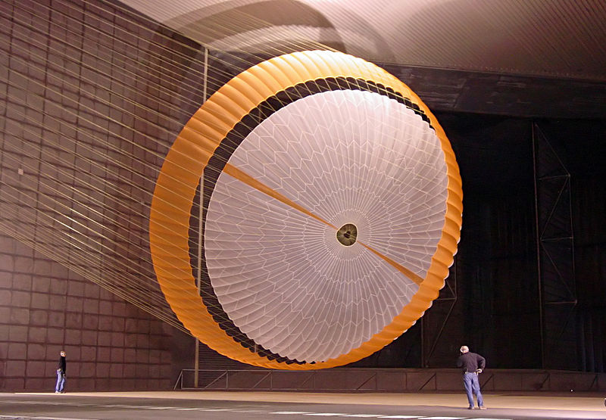  By NASA - http://photojournal.jpl.nasa.gov/catalog/PIA10208, Public Domain, https://commons.wikimedia.org/w/index.php?curid=15477610  (Courtesy NASA/JPL-Caltech) | 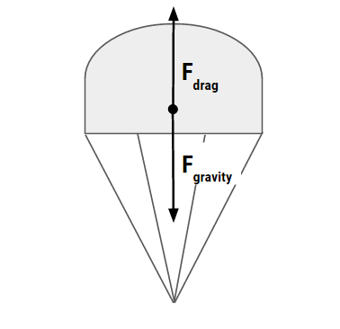

Video
Watch the video of the design process of the Mars Rover’s parachute. Type: bit.do/marsparachute into the address bar of your browser.


Background
Spacecraft designed for re-entry on a planet that has an atmosphere such as Mars can deploy a parachute to slow the craft’s rate of descent. The spacecraft falls at constant speed when the magnitude of the upward acting drag force (caused by “air” resistance) equals the magnitude of the downward acting force of gravity. The parachute is designed to minimise the speed on impact.

To minimise the force on impact you need to minimise the speed before impact. When the parachute is falling at constant (terminal) speed:
, so {with “s” constant}
As the relationship between and drop time is inversely proportional, you can minimise by maximising the drop time.

Useful Terms
Payload: The carrying capacity of a parachute. Payload is measured in kg.
Drop time: The total time between parachute deployment and touchdown.
Suspension lines: These lines attach the parachute to the payload.
Canopy :The expanding, umbrella-like part of a parachute.
Vent :A hole in the apex to vent some air out of the canopy to reduce the oscillation.

BEFORE CONDUCTING THE EXPERIMENT
IAE1
RISK ASSESSMENT | Before conducting a test drop, you will write a comprehensive risk assessment and hand it in to your teacher.
INVESTIGATION DESIGN | After the test drop, you will deconstruct the question: What will affect drop time? Then design a detailed investigation to test the effect of one factor (variable) on drop time. Keep a record of your thinking during the deconstruction and annotate your design to justify the decisions you make about various aspects of the design, e.g. how and why to control variable, number of samples etc. Hand the deconstruction and design in to your teacher on ____________.

THE REPORT DUE AFTER THE EXPERIMENT  IAE2 - IAE3 - IAE4 - KA1 - KA4 |  | Done?
INTRODUCTION | Physics background, hypothesis, variables | □
METHOD | Step-by-step of the method you actually used | □
RESULTS | Present the data collected in a single Data Table of results. | □
 | Students will represent their data using a Line Graph for continuous data, or a Bar Graph for discontinuous data. | □
 | Describe the trends and relationships as shown by your data. | □
DISCUSSION  Interpretation  Analysis  Evaluation | Interpret your results with reference to science concepts. | □
 | Evaluate your data by discussing the precision (scatter) of your data, and by commenting on reliability. | □
 | Describe the sources of possible systematic and random exp. errors in order of greatest impact. | □
 | Evaluate your procedure. | □
CONCLUSION | Write a statement in relation to your original aim and hypothesis (supports, refutes or inconclusive). This includes justification. | □
 | Describe any relationship between the independent and dependent variables established. | □
The report should be a maximum of 1000 words if written, or a maximum of 6 minutes for an oral presentation, or the equivalent in multimodal form.
Evidence outlining the deconstruction and design process should be attached to the report. This evidence should outline the deconstruction process, the method chosen as most appropriate, and a justification of the plan of action, to a maximum of 4 sides of an A4 page. Suggested formats for the summary sheet include flow charts, concept maps, tables, or notes.
Only the following sections of the report are included in the word count:

- Introduction
- analysis of results
• evaluation of method/procedure
• conclusion.

Performance Standards for Stage 1 Physics
- | Investigation, Analysis and Evaluation | Knowledge and Application
A | Critically deconstructs a problem and designs a logical and coherent physics investigation with detailed justification.  Obtains, records, and represents data, using appropriate conventions and formats accurately and highly effectively.  Systematically analyses and interprets data and evidence to formulate logical conclusions with detailed justification.  Critically and logically evaluates procedures and their effect on data. | Demonstrates deep and broad knowledge and understanding of a range of physics concepts.  Applies physics concepts highly effectively in new and familiar contexts.  Critically explores and understands in depth the interaction between science and society.  Communicates knowledge and understanding of physics coherently, with highly effective use of appropriate terms, conventions, and representations.
B | Logically deconstructs a problem and designs a well-considered and clear physics investigation with reasonable justification.  Obtains, records, and represents data, using appropriate conventions and formats mostly accurately and effectively.  Logically analyses and interprets data and evidence to formulate suitable conclusions with reasonable justification.  Logically evaluates procedures and their effect on data. | Demonstrates some depth and breadth of knowledge and understanding of a range of physics concepts.  Applies physics concepts mostly effectively in new and familiar contexts.  Logically explores and understands in some depth the interaction between science and society.  Communicates knowledge and understanding of physics mostly coherently, with effective use of appropriate terms, conventions, and representations.
C | Deconstructs a problem and designs a considered and generally clear physics investigation with some justification.  Obtains, records, and represents data, using generally appropriate conventions and formats, with some errors but generally accurately and effectively.  Undertakes some analysis and interpretation of data and evidence to formulate generally appropriate conclusions with some justification.  Evaluates procedures and some of their effect on data. | Demonstrates knowledge and understanding of a general range of physics concepts.  Applies physics concepts generally effectively in new or familiar contexts.  Explores and understands aspects of the interaction between science and society.  Communicates knowledge and understanding of physics generally effectively, using some appropriate terms, conventions, and representations.
D | Prepares a basic deconstruction of a problem and an outline of a physics investigation.  Obtains, records, and represents data, using conventions and formats inconsistently, with occasional accuracy and effectiveness.  Describes data and undertakes some basic interpretation to formulate a basic conclusion.  Attempts to evaluate procedures or suggest an effect on data. | Demonstrates some basic knowledge and partial understanding of physics concepts.  Applies some physics concepts in familiar contexts.  Partially explores and recognises aspects of the interaction between science and society.  Communicates basic physics information, using some appropriate terms, conventions, and/or representations.
E | Attempts a simple deconstruction of a problem and a procedure for a physics investigation.  Attempts to record and represent some data, with limited accuracy or effectiveness.  Attempts to describe results and/or interpret data to formulate a basic conclusion.  Acknowledges that procedures affect data. | Demonstrates limited recognition and awareness of physics concepts.  Attempts to apply physics concepts in familiar contexts.  Attempts to explore and identify an aspect of the interaction between science and society.  Attempts to communicate information about physics.

