STAGE 2 ITALIAN (BEGINNERS)
ASSESSMENT TYPE 2: TEXT PRODUCTION
TASK

Purpose
Students create a text in written Italian in which they convey information and/or experiences and express ideas and/or opinions in response to a written text that is in Italian, thus demonstrating evidence of ideas and expression.
Purpose expressed clearly and succinctly.

Learning Requirements and Assessment Design Criteria highlighted.

Description of Assessment
Write a letter in Italian to Gianna in response to her letter. In your reply, respond personally to questions and/or information and/or cues.

Your response should demonstrate:

Ideas:
Explicit reference to performance standards at the highest level.
- Consistent relevance to context, purpose and audience
- Consistently appropriate detail, ideas, information, and/or opinions
- Ability to successfully engage the reader
- Breadth in the treatment of topics and elaboration of ideas
- Sufficient detail and support for opinions

Expression:
- A range of language and a high degree of accuracy
- Effective use of a range of cohesive devices
- Language appropriate for context, purpose, and audience
- Logical and coherent organisation of response
- Adherence to text type conventions

Assessment Conditions
Time: Two lessons
Length: 200 words
Dictionaries and/or word lists may be used.

Audience
Pen pal

Roma, il 3 febbraio, 2010

Caro Ashley,
grazie per la tua lettera. Sto bene e tu? Ho ripreso la scuola da due settimane. Per ora vado abbastanza bene. Mi piacciono molto la storia e la religione. La geografia invece, non la posso proprio soffrire (anche perché la professoressa è veramente antipatica!). Il latino è un po’ difficile. La settimana prossima ho il compito in classe. Speriamo bene! Ti faccio sapere com’è andato. Intanto, fammi sapere come vanno le cose da te, in particolare, come va la scuola. Ti piace studiare l’italiano? È facile per te?

Durante le vacanze natalizie ho fatto lo shopping e ho visto dei film con gli amici. E tu? Cosa hai fatto? Sei stato al cinema? Hai lavorato?

Fa molto freddo da noi adesso e ha nevicato tanto nel Nord, ma non sono andata a sciare. Fa ancora molto caldo da voi? Sei stato al mare?

Fra un mese compio diciotto anni. Il mio compleanno è il 10 marzo. Il mio segno zodiacale è Pesci e quindi mi piace molto andare al mare! Infatti, non vedo l’ora di passare una settimana al mare in agosto....ma deve ancora passare tanto tempo!!! ☹

Come sta la tua famiglia?

Ora ti lascio. Salutami i tuoi.
Con affetto,
Gianna

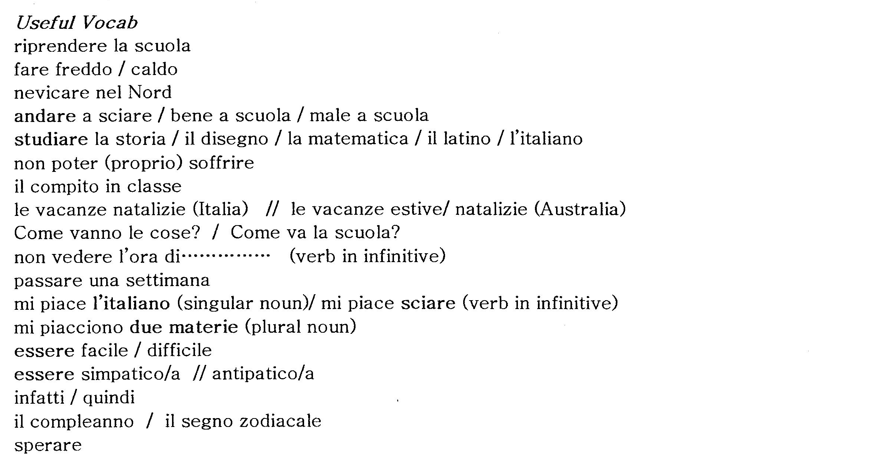

Learning Requirements | Assessment Design Criteria
1. Interact with others in Italian in interpersonal situations.  2. Create texts in Italian for specific audiences, purposes, and contexts.  3. Analyse texts that are in Italian to interpret meaning. | Ideas  The specific features are as follows:  I1 Relevance  - relevance to context, purpose, and audience  - conveying appropriate detail, ideas, information, and/or opinions  - engaging the audience.  I2 Treatment of ideas, information, or opinions  - breadth of content and communication of ideas, information, and/or opinions  - support of ideas, information and/or opinions with examples.  Expression  The specific features are as follows:  E1 Capacity to convey information accurately and appropriately  - range of expression (i.e. breadth of vocabulary and structures)  - accuracy of expression (i.e. word choice, grammar)  - use of cohesive devices  - appropriateness of expression, including cultural appropriateness  - clarity of expression, including fluency, pronunciation, and intonation.  E2 Coherence in structure and sequence  - organisation of information and ideas  - use of the conventions of text types.  E3 Capacity to interact and maintain a conversation  - interaction on topics (i.e. relating to interlocutor)  - use of communication strategies (i.e. comprehension strategies, responding to cues).  Interpretation and Reflection  The specific features are as follows:  IR1 Interpretation of meaning in texts  - the content (overall meaning, general and specific information)  - the context, purpose, and audience of the text.  IR2 Analysis of the language in texts  - for example, register, tone, linguistic and stylistic features, and cultural aspects.  IR3 Reflection  - reflection on how cultures, values, beliefs, practices, and/or ideas are represented or expressed in texts  - reflection on own values, beliefs, practices, and/or ideas in relation to those represented or expressed in the texts studied.

Performance Standards for Stage 2 Interstate Assessed Languages at Beginners Level

- | Ideas | Expression |  | Interpretation and Reflection
A | Relevance  Responses are consistently relevant to context, purpose, and audience  Responses consistently convey the appropriate detail, ideas, information, and/or opinions.  Responses successfully engage the audience or interlocutor.  Treatment of Ideas, Information, or Opinions  Breadth in the treatment of topics. Ideas, information, and/or opinions are developed and extended, and impressions are described effectively.  Ideas and/or opinions are supported, and information is provided in sufficient detail. | Capacity to Convey Information Accurately and Appropriately  A range of vocabulary and sentence structures are used with a high degree of accuracy.  More complex vocabulary and sentence structures are used, with some success. A few minor errors may be evident, but these errors do not impede meaning.  Effective use of a range of cohesive devices.  Language is highly appropriate for context, audience, and purpose.  Pronunciation is accurate. Intonation is used effectively to enhance communication. Responses are fluent.  Coherence in Structure and Sequence  Responses are organised logically and coherently.  Conventions of the text type are observed. | Capacity to Interact and Maintain a Conversation  Interaction is sustained on a range of familiar topics, with minimal input from the interlocutor. Interrogative devices are understood and used appropriately. Unexpected questions or unfamiliar topics are handled with confidence and flexibility.  A range of communication strategies are used to maintain interaction (e.g. using new vocabulary encountered during interaction, asking for repetition, affirming, self-correcting). | Interpretation of Meaning in Texts  Key ideas and relevant details are identified and explained, and connections are made within and between texts (e.g. comparing ideas, information, and opinions).  Conclusions are drawn about the purpose, audience, and message of the text, and supported with relevant evidence from the text.  Analysis of the Language in Texts  The function of particular linguistic features, the ways in which stylistic features are used for effect, and cultural references such as forms of address, location, and gender are identified and explained.  Reflection  The ways in which cultures, values, beliefs, practices, and/or ideas are represented in texts are articulated clearly.  Insightful reflection on own values, beliefs, practices, and/or ideas in relation to those represented in texts.
B | Relevance  Responses are mostly relevant to context, purpose, and audience.  Responses mostly convey the appropriate detail, ideas, information, and/or opinions.  Responses mostly engage the audience or interlocutor.  Treatment of Ideas, Information, or Opinions  Some breadth in the treatment of familiar topics. Responses go beyond basic facts, using brief descriptive phrases to extend meaning.  Ideas, information, and/or opinions are supported in some detail. | Capacity to Convey Information Accurately and Appropriately  A range of vocabulary and sentence structures are used with some accuracy to convey meaning effectively.  Some complex structures beyond familiar patterns are used to convey meaning, with some success. Errors may be evident but do not significantly impede meaning.  Mostly effective use of cohesive devices.  Language is mostly appropriate to social and cultural context.  Pronunciation and use of intonation generally facilitate communication. Responses are generally fluent.  Coherence in Structure and Sequence  Responses are mostly organised logically and coherently.  Most conventions of the text type are observed. | Capacity to Interact and Maintain a Conversation  Interaction is maintained on a range of familiar topics, with some reliance on input from the interlocutor to maintain interaction. Interrogative devices are understood and used with some confidence.  Some communication strategies are used to maintain interaction (e.g. asking for repetition, self-correcting). Well-rehearsed language is used to interact. | Interpretation of Meaning in Texts  Relevant ideas and details in texts on familiar topics are identified and explained with some clarity, and some connections are made within and between texts.  Some conclusions are drawn about the purpose, audience, and message of the text, and supported with some relevant examples from the text.  Analysis of the Language in Texts  The function of particular linguistic features, some of the ways in which stylistic features are used for effect, and some cultural references are identified and described.  Reflection  The ways in which cultures, values, beliefs, practices, and/or ideas are represented in texts is explained.  Some depth in reflection on own values, beliefs, practices, and/or ideas in relation to those represented in texts.
C | Relevance  Responses are generally relevant to the purpose and audience, and show some understanding of context.  Responses generally convey the appropriate detail, ideas, and information.  Responses generally engage the audience or interlocutor.  Treatment of Ideas, Information, or Opinions  Information, ideas, and/or opinions on familiar topics are conveyed. Modelled sentence patterns are generally used to communicate an idea or opinion.  Some details are provided to support ideas. Elaboration of ideas, information, and/or opinions often consists of listing items. | Capacity to Convey Information Accurately and Appropriately  Some variety of vocabulary and sentence structures is used, with reliance on familiar vocabulary and sentence structures to convey meaning. Structure often based on word order derived from first language when attempts are made to elaborate.  The language is generally comprehensible although some errors may impede meaning. Control of language is inconsistent.  Generally effective use of some simple cohesive devices.  Language not always appropriate to context, purpose, and audience.  Pronunciation is understandable. Some attention is given to intonation. Fluency is often confined to pre-learnt material.  Coherence in Structure and Sequence  Responses are generally organised.  Some conventions of the text type are observed. | Capacity to Interact and Maintain a Conversation  Well-rehearsed language is relied on to respond to simple questions on familiar topics, with frequent reliance on the interlocutor to take the lead and maintain interaction. Partial understanding of questions may lead to a response that is not relevant.  The sentence patterns of the interlocutor are often repeated in the response. Prepared phrases are used to indicate lack of comprehension. | Interpretation of Meaning in Texts  Some relevant information from texts on familiar topics containing predictable language structures is identified and extracted.  Simple conclusions are drawn about the purpose, audience, and message of the text, and supported with isolated examples from the text.  Analysis of the Language in Texts  Particular linguistic and stylistic features and one or more cultural references are identified.  Reflection  Some cultures, values, beliefs, practices, and/or ideas represented or expressed in texts are identified.  Some reflection on own values, beliefs, practices, and/or ideas in relation to those represented in texts.
D | Relevance  Responses are partially relevant to the purpose, and show some awareness of the audience or context.  Responses convey some simple details or information that may be appropriate.  Responses partially engage the audience or interlocutor.  Treatment of Ideas, Information, or Opinions  Some information relating to familiar topics is communicated.  Information is generally repetitive and responses often rely on keywords or formulaic expressions to communicate meaning, or attempt to support information. | Capacity to Convey Information Accurately and Appropriately  A limited range of simple structures and vocabulary are used.  The language produced contains frequent errors and only partially communicates what is intended. Responses may resemble literal translations from first language.  A cohesive device may be used.  Language is occasionally appropriate to the purpose or audience.  Pronunciation may impede meaning. Little attention is paid to intonation. Lack of comprehension impedes fluency.  Coherence in Structure and Sequence  Responses tend to be loosely connected sentences.  Inconsistent use of one or more conventions of the text type. | Capacity to Interact and Maintain a Conversation  Routine courtesy phrases and basic structures are used to respond to simple questions on familiar topics, with heavy reliance on the interlocutor to complete the interaction. Repetition, rephrasing of questions, and a slowed rate of speech are required for comprehension.  Utterances rarely consist of more than two or three words. A keyword or partial response is provided as a means of negotiating more time for processing, with reliance on paralinguistic devices to convey meaning. | Interpretation of Meaning in Texts  Keywords and some supporting detail are identified in texts containing simple, well-rehearsed language dealing with familiar situations.  Specific information in the text is transcribed rather than interpreted.  Analysis of the Language in Texts  One or more basic linguistic and stylistic features of the text are identified.  Reflection  Some cultural elements expressed in texts are identified.  One or more of own values, beliefs, practices, or ideas in relation to those represented in texts are identified.
E | Relevance  Responses have limited relevance to the purpose or audience.  Responses are often incomplete.  Responses may include an element that attempts to engage the audience or interlocutor.  Treatment of Ideas, Information, or Opinions  Responses are brief and often rely on a keyword or formulaic expression to convey meaning.  Some basic information relating to familiar topics is communicated, using single words. | Capacity to Convey Information Accurately and Appropriately  Single words and brief formulaic expressions are used to convey basic information on familiar topics. Rehearsed simple sentences are used out of context.  There is a high incidence of basic errors that impede meaning, with evidence of the influence of the syntax of English and/or other languages.  Attempted use of a cohesive device.  Limited appropriateness of language to the purpose or audience.  Pronunciation impedes meaning and may be strongly influenced by first language.  Coherence in Structure and Sequence  Conventions of the text type are ignored.  Responses consist of disconnected sentences. | Capacity to Interact and Maintain a Conversation  Interaction is limited to rehearsed repetitive vocabulary and one-word answers, with assistance from the interlocutor needed to complete sentences or to interpret intended meanings. There are misunderstandings of simple questions.  A keyword is used to convey a whole message. There are frequent long pauses to process questions, and heavy reliance on paralinguistic devices to convey meaning. | Interpretation of Meaning in Texts  Isolated items of information are identified in texts on familiar topics containing simple language.  Understanding is limited to occasional isolated words, such as borrowed words.  Analysis of the Language in Texts  Attempted identification of one or more linguistic or stylistic features.  Reflection  Attempted identification of isolated cultural elements.  One or more of own values, beliefs, practices, or ideas are identified.

