Interaction
For the Media Interaction task, I organised a visit to XXXXX studio and sit in on a segment, XXXX Weekend – with special thanks to AAAA, Junior Producer of weekend radio.
Whilst I was there I observed AAAA while she hosted and asked her a few questions regarding her position and how she got to where she is today. In particular, I wanted to find out her personal reaction to the world of radio. I am a regular listener to XXXX and I was keen to discover what happens at the radio station.
INTERVIEW
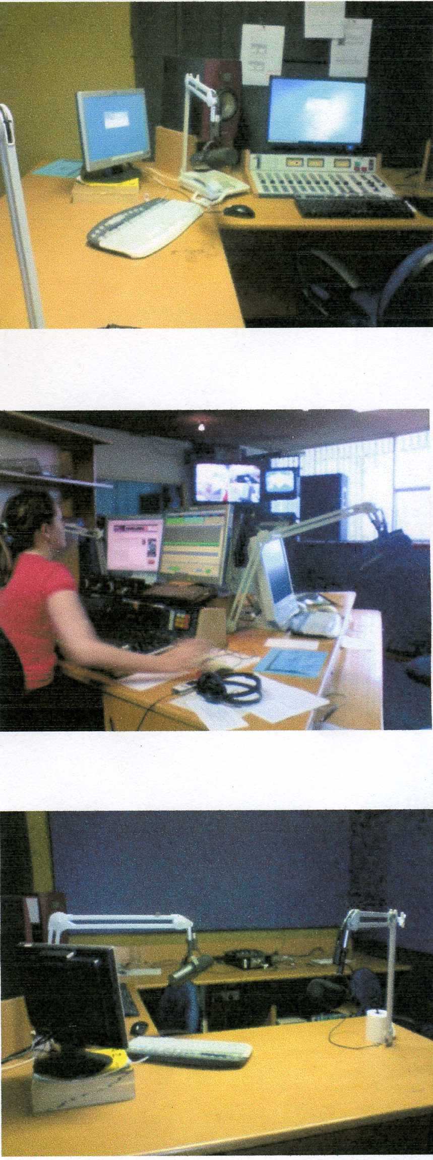
The first I asked was how did AAAA get involved with XXXXX?
She told me about meeting one of the DJs/Producers who worked for the commercial station ZZZZZ and from there he got AAAA involved with administration work, which luckily led to being noticed by an executive who ran the station. She started co-hosting and worked her way up until she was hosting solo! A little later AAAA was noticed by XXXXX, which is a community station, she was offered the position she now has.
Reflection
I learned from this that the best way of gaining a position in radio is to show people what you can do. Of course, I realise from speaking with AAAA that the individual needs to suit the audience which the station is aiming at. AAAA is young and is interested in the same things which interest her audience. Radio, even community radio, is a competitive environment. It is necessary to have a clear understanding of your audience. There is no point in doing what suits you and forget about your audience.
Knowledge and Understanding
Evidence of dealing with the world of community radio indicates a well-considered and informed understanding of facts, opinions, and bias in media texts or products.
The second question I asked was if AAAA was happy with her achievements at XXXXX.
The highlight for her was to host her own weekend show where she could talks to tons of people and listen to her favourite music while doing it. However, AAAA did tell me about things which can go wrong such as the time when there was three minutes of material which was not planned when she forgot to turn off her microphone. Instead of listening to music the audience got to listen to her phone conversation with her partner.
Reflection: It was clear to me that AAAA enjoys her job and is a natural communicator. When we spoke she was really interested in what was doing and appeared to be a very engaging person. I got a really strong impression that her love of music is very important reason for working in radio.
AAAA pointed out that all occupations have their pressure and radio is no different. Working in community radio can be quite different to working in a large commercial radio station – the announcer has to do many of the jobs such as – answering phones, cuing and playing music, conducting on air interviews, sending out promotional materials. Despite the pressure AAAA believes that working with a group of ‘awesome’ people in a job which is so enjoyable is really rewarding.
Before I went to XXXX my only experience with radio was as a listener. I had no idea about the complex behind the scenes jobs that have to be completed. As an occupation there are real opportunities for work right across Australia in community, commercial and government radio stations.
Research and Analysis
Evidence in the reflection shows a perceptive analysis of interactions with media.
Why Community Radio?
From my research and in speaking with AAAA I have come to understand a little more about the way that community radio fits into the Adelaide media scene. Stations such as XXXX cater for audiences that are not always being served by commercial media. These stations allow ordinary people to be part of delivering rather than just consuming it. As AAAA commented ‘it’s like democracy – everyone gets to have their say.’
Knowledge and Understanding
In describing the role of community radio, evidence shows well-considered and mostly sustained knowledge and understanding of media structures, issues, concepts, and interactions.
XXXX has to follow the federal government’s broadcasting regulations however because everybody, including volunteers has a say in what is broadcast there is a lot of content that is not found on mainstream radio. Community radio does not always follow a strict format. When I listened to a number of other community stations I noticed that the content can change from classical music, to news and then to dance music. A commercial station could not survive with such a wide diverse range of programming. With community radio particular audiences make a deliberate choice to listen rather than having the radio playing in the background. Often the music and viewpoints expressed on community radio can be too challenging for commercial broadcasting.
Knowledge and Understanding
Describing the response of the community radio audience shows an insightful and informed understanding of facts, opinions, and bias in media texts or products.
Community radio depends on donations and sponsorships to survive. There is always a need to get people to subscribe to be members. So like commercial stations they still need to appeal to their target audience – but in the case of community radio the audience has a say – as long as they subscribe.

Additional comments
- On balance, the evidence demonstrates insightful and informed understanding of facts, opinions, and bias in media texts or products. (Knowledge and Understanding)
- The communication displays fluent expression, using consistently clear and appropriate media terminology. (Communication)
- The interview report shows evidence of considered and informed research into and analysis of different points of view, bias, values, or intent across a range of media texts. (Research and Analysis)

Performance Standards for Stage 2 Media Studies

 | Knowledge and Understanding | Research and Analysis | Producing | Communication
A | Comprehensive and sustained knowledge and understanding of media structures, issues, concepts, and interactions.  Perceptive knowledge and informed understanding of how audiences influence, and are influenced by, forms and content of media texts.  Insightful and informed understanding of facts, opinions, and bias in media texts or products. | Thorough and well-informed research into and analysis of different points of view, bias, values, or intent across a range of media texts and in the media investigation.  Comprehensive research into and analysis of the ways in which groups and individuals are represented in media.  Perceptive analysis of interactions with media. | Comprehensive design and planning of media products for selected audiences.  Highly proficient use of appropriate production techniques and technologies, and media conventions. | Comprehensive reproduction of the structural and conventional features of media texts, to clearly and consistently convey meaning.  Fluent expression, using consistently clear and appropriate media terminology.
B | Well-considered and mostly sustained knowledge and understanding of media structures, issues, concepts, and interactions.  Well-considered knowledge and informed understanding of how audiences influence, and are influenced by, forms and content of media texts.  Well-considered and informed understanding of facts, opinions, and bias in media texts or products. | Well-informed research into and analysis of different points of view, bias, values, or intent across a range of media texts and in the media investigation.  Well-considered research into and informed analysis of the ways in which groups and individuals are represented in media.  Well-considered analysis of interactions with media. | Thorough design and planning of media products for selected audiences.  Proficient use of appropriate production techniques and technologies, and media conventions. | Sound reproduction of the structural and conventional features of media texts, to clearly convey meaning.  Mostly fluent expression, using clear and appropriate media terminology.
C | Considered knowledge and understanding of media structures, issues, concepts, and interactions.  Considered knowledge and informed understanding of how audiences influence, and are influenced by, forms and content of media texts.  Considered and informed understanding of facts, opinions, and bias in media texts or products. | Considered and informed research into and analysis of different points of view, bias, values, or intent across a range of media texts and in the media investigation.  Considered and informed research into and analysis of the ways in which groups and individuals are represented in media.  Considered analysis of interactions with media. | Considered design and planning of media products for selected audiences.  Competent use of appropriate production techniques and technologies, and media conventions. | Competent reproduction of the structural and conventional features of media texts, to convey meaning.  Generally fluent expression, using appropriate media terminology.
D | Partial knowledge and basic awareness of media structures, issues, concepts, and interactions.  Basic awareness and some understanding of how audiences influence, and are influenced by, forms and content of media texts.  Recognition and some understanding of facts, opinions, and bias in media texts or products. | Basic consideration and recognition of different points of view, bias, values, or intent in one or more media texts and in the media investigation.  Identification of some of the ways in which groups or individuals are represented in media.  Description of one or more interactions with media. | Partial design and some planning of media products for a selected audience.  Basic use of some simple and appropriate production techniques and technologies, and some basic media conventions. | Some reproduction of the structural and conventional features of one or more media texts, to convey basic meaning.  Occasionally clear expression and use of basic media terminology.
E | Limited awareness of media structures, issues, concepts, or interactions.  Limited awareness of how audiences influence, and are influenced by, forms and content of media texts.  Limited recognition of facts, opinions, or bias in a media text or product. | Attempted description of a point of view, bias, value, or intent in a media text, and/or the investigation.  Attempted recognition of one way in which a group or individual is represented in media.  Attempted description of an interaction with media. | Attempted design or planning of media products.  Attempted use of a production technique or technology, and one or more basic media conventions, which may be appropriate. | Attempted reproduction of the structural and conventional features of one media text.  Limited expression or use of basic media terminology.

