Stage 2 Information Processing and Publishing
Assessment Type 3: Product and Documentation
Documentation Response 2

Foreword on materials presented:

The materials that are presented in this documentation have had most of the images removed due to copyright. The materials presented are to illustrate the layout of the documentation. In particular, the summaries for the Investigating, Devising and Evaluation.

These summaries form the 1500 maximum word limit for the documentation. The other materials support the summaries, but do not form part of the word limit.

Due to extensive editing to remove all copyright material the presentation of the materials may not be of the standard that were presented by the student.

The product will not be made available due to copyright of the materials used in the creation of the magazine front cover and the emagazine pages.
Investigation
Summary

The software is accessible at home although some issues include, getting viruses on hard the hard
drive that I will be saving my work to and that I may be not too good with the software. Slow school
computers/Internet content filtering and speed could also slow me down from the work as well as
other assignments/tests for other subjects may also affect the time to work on the task. Seeing, as
there are only two lessons of IPP a week that may not be enough lessons in order to complete the
task in an effective manner.
Development and Application
Basic application of some aspects of the design process is demonstrated in the brief Investigation Summary.

Hardware and software for the task

Hardware:
- Hp laser jet printer (final magazine product)
- Ricoh, Afcio printer MP C3300 (print runs)
- Apple MacBook Pro 13" (home)
- HP Compaq 8100 elite small form factor (school)
- WD 1 terabyte Portable Hard Drive

Software:
- Adobe Photoshop CS4/CSS (image manipulation, creating titles)
- Adobe Dreamweaver CS4/CSS (web authoring)
- Adobe In design CS4/CSS (placing elements and creating magazine cover)
- Adobe Flash CS4/CSS (creating animations)
- Snipping tool/MacBook Screenshot
- Microsoft Word 2008 (documentation)
Understanding
Informed understanding of appropriate hardware and software is demonstrated in this listing of possible uses for each hardware item and piece of software.
To support a higher level of understanding an indication of the selection of Hardware and Software used to produce the response should be presented in the Devising section, and further detail provided in the Evaluation.

Magazine Cover Annotation
Magazine Cover

Image of magazine cover
removed due to copyright
Contrast
The bold silver title contrasts the dark
background image and is the biggest text on
the front cover. The silver shape at the bottom provides contrast for the text.

Repetition
Use of capital letters has been repeated
throughout the front cover as well as the font
styles. The silver colour is repeated with the
title and the same colour is used for the strip
at the bottom.

Alignment
The text is centre aligned and the text
associated with it is left aligned. The article
titles are right aligned.

Proximity
The text is left aligned and the colour of the
text contrasts with the image, as it dark
Analysis and Evaluation
Competent evaluation of text-based products against design principles is demonstrated in the way examples of each of the design principles are dealt with here. There is evidence of more than a basic understanding of all design principles except Proximity.
colour. White space is also used to separate
the title from the featured articles.

Contrast
Image of magazine cover
removed due to copyright
The title 'Aviator' is in a simple white bold
font, which stands out and is the largest text
on the cover. A white box has been placed
beneath the barcode to provide contrast.

Repetition
The colour white has been repeated
throughout the cover as well as the fonts and
the font sizes.

Alignment
The title ' Aviator' the text beneath it have
been centre aligned. The rest of the text has
been left aligned although the magazine
website has been right aligned.

Proximity
White space is used between the title and the
articles, which separates the irrelevant
content.

Index pages
E-Magazine
Image of E-magazine Home page
removed due to copyright
Image of E-magazine Home page
removed due to copyright

Mag X and Mag Y index pages summarises the current issue of their magazine and have links within the page as well as the navigation bars. A swap image gallery is used in the Mag X index page where the different numbers link to different pages related to the large image that appears Mag Y have links to their articles, which would take them to the page if clicked on.

Understanding
Competent understanding of the design process is demonstrated by the presence of the Investigation, Devising and Evaluation sections, but could be improved with better headings (e.g. section headings).
Skyway

The name {SKYWAY' has been chosen because it is a recognized route followed by aircrafts or an elevated highway (to information) in this case. As it is an aviation-related magazine, this would be a suitable title to communicate to the audience the genre of the magazine.

Out of the possible names, SKYWAY seemed to be the most appealing and looks more balanced with its six letter giving me ideas on how the title or logo can be designed
Magazine cover design plan
Magazine cover

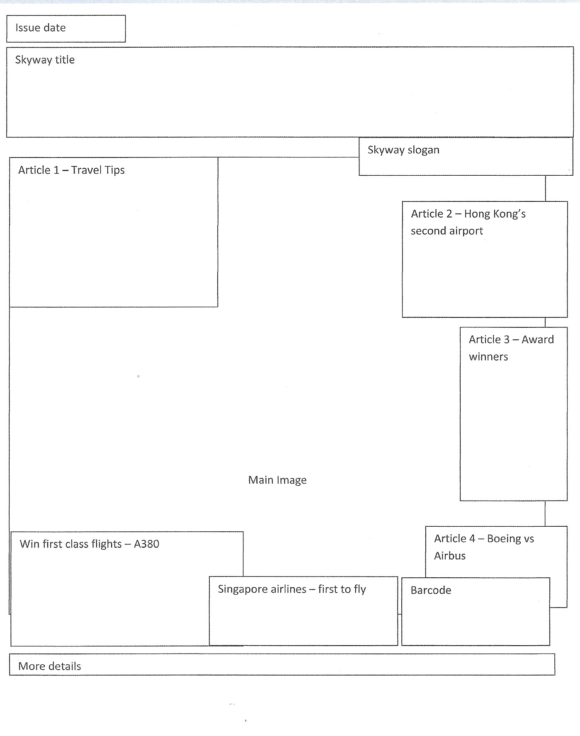
Development and Application
Competent application of the design process is demonstrated in the level of detail in the Design Plans. However there is not enough detail provided to enable the final product to be reproduced from the design plans themselves.
To obtain a higher level of achievement the plan could include details of fonts to be used, including sizes and colours, and a description of the main image.
Magazine colour scheme
Magazine cover

Hex #e0fcff
R: 224
G: 252
B: 255

Hex #0c0b10
R: 12
G: 11
B: 16

The shades of blue represent the sky and aviation-related theme and will be repeatedly used throughout the magazine cover.

The main title on the cover will be using the light shade of blue while the darker shade of blue will be used alternatively with the lighter shade for the 'featured' articles on the cover.

Hex #00bff3
R: 224
G: 252
B: 255

The black will be the main background colour as well as being used for some text written on coloured shapes for good contrast while the white will also be used for text but also used for shapes for text to be placed on.

Hex #ffffff
R: 255
G: 255
B: 255
Development and Application
Well-considered application of the design process is demonstrated in the descriptions of where and why colours and fonts will be used on pages 24, 26 and 35.
Fonts
Magazine cover

GENOCIDE | The font GENOCIDE will be used for the  SKYWAY title.
STRASUA – REGULAR | STRASUA- REGULAR and BITSUMISHI will  be used for headings while JUST REALIZE  will be used to break the continuous use  of the same fonts, providing contrast  from the heading and subheading.
Bitsumishi

Just realize

Arial | ARIAL will be used as the main body text as  it is a reader-friendly text when used for  larger chunks of text.

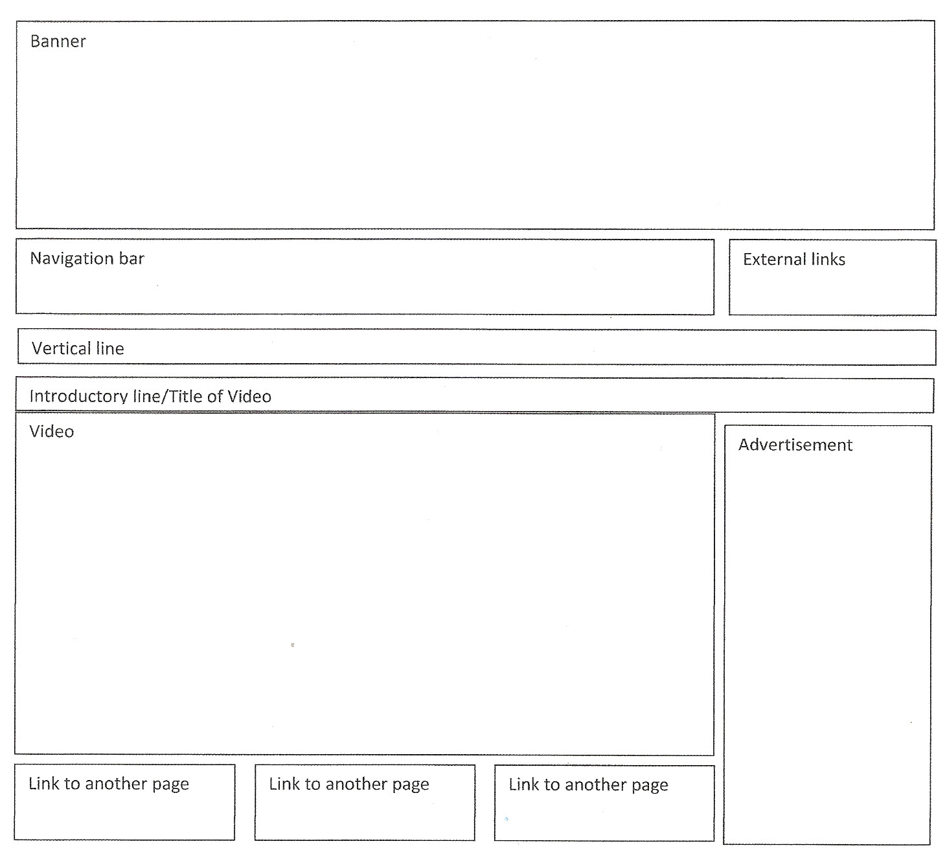

News page
E-Magazine

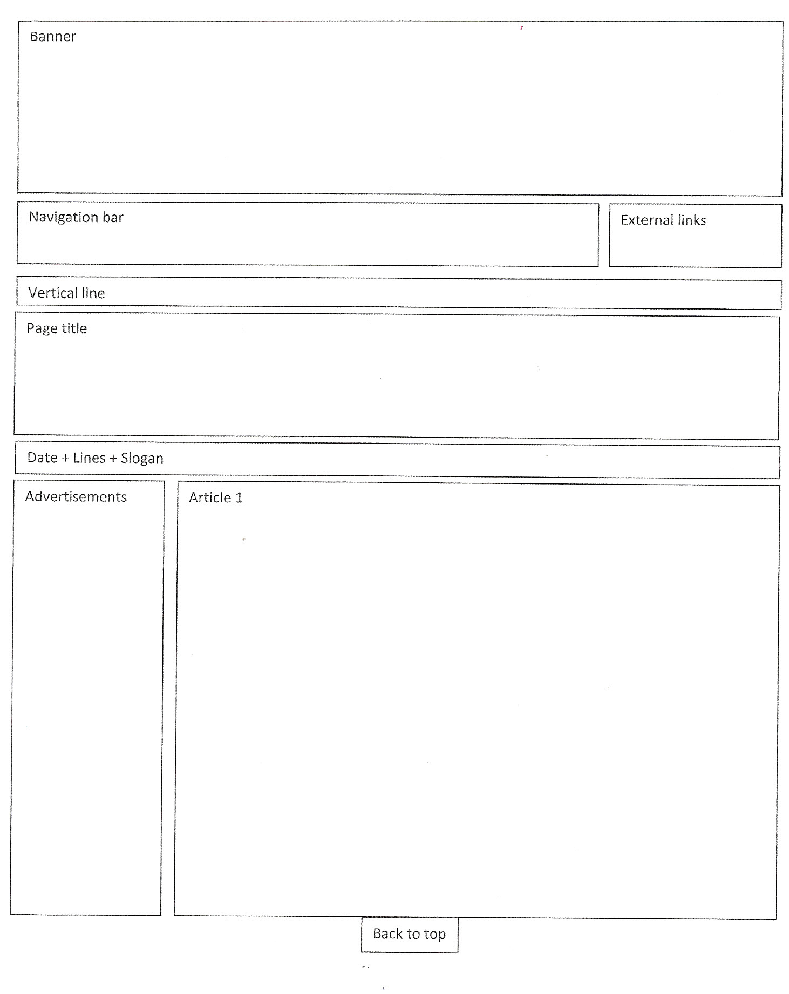

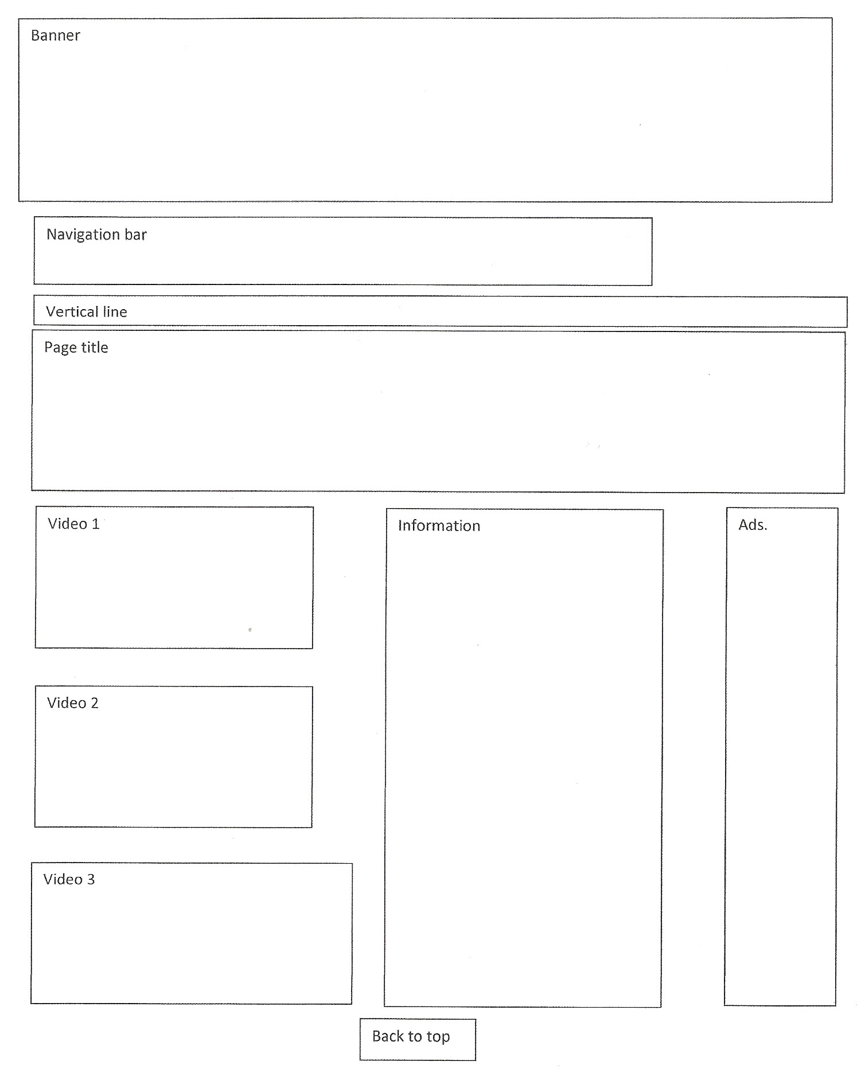
Subscription page
E-Magazine

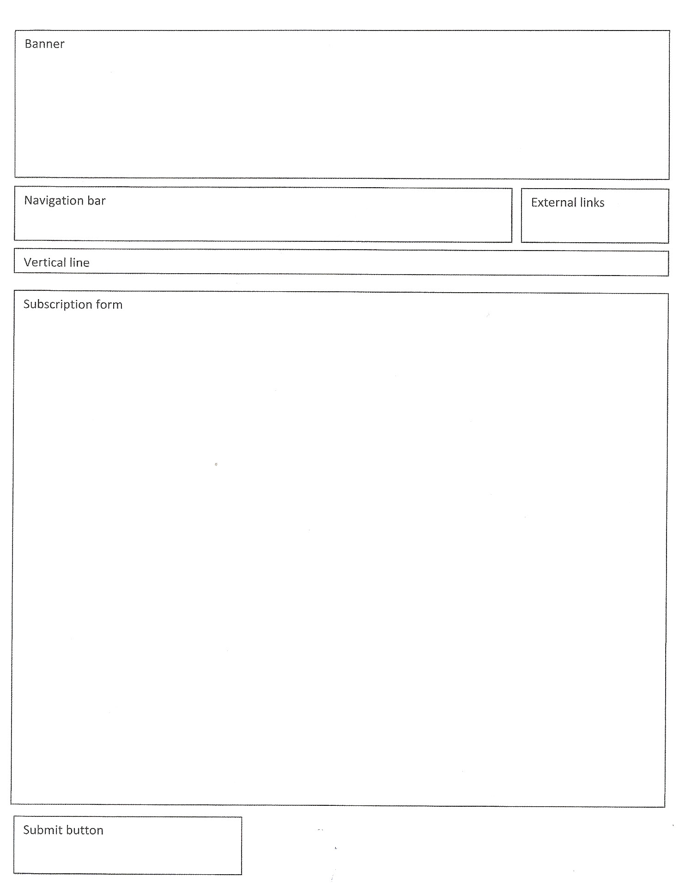

About page
E-Magazine

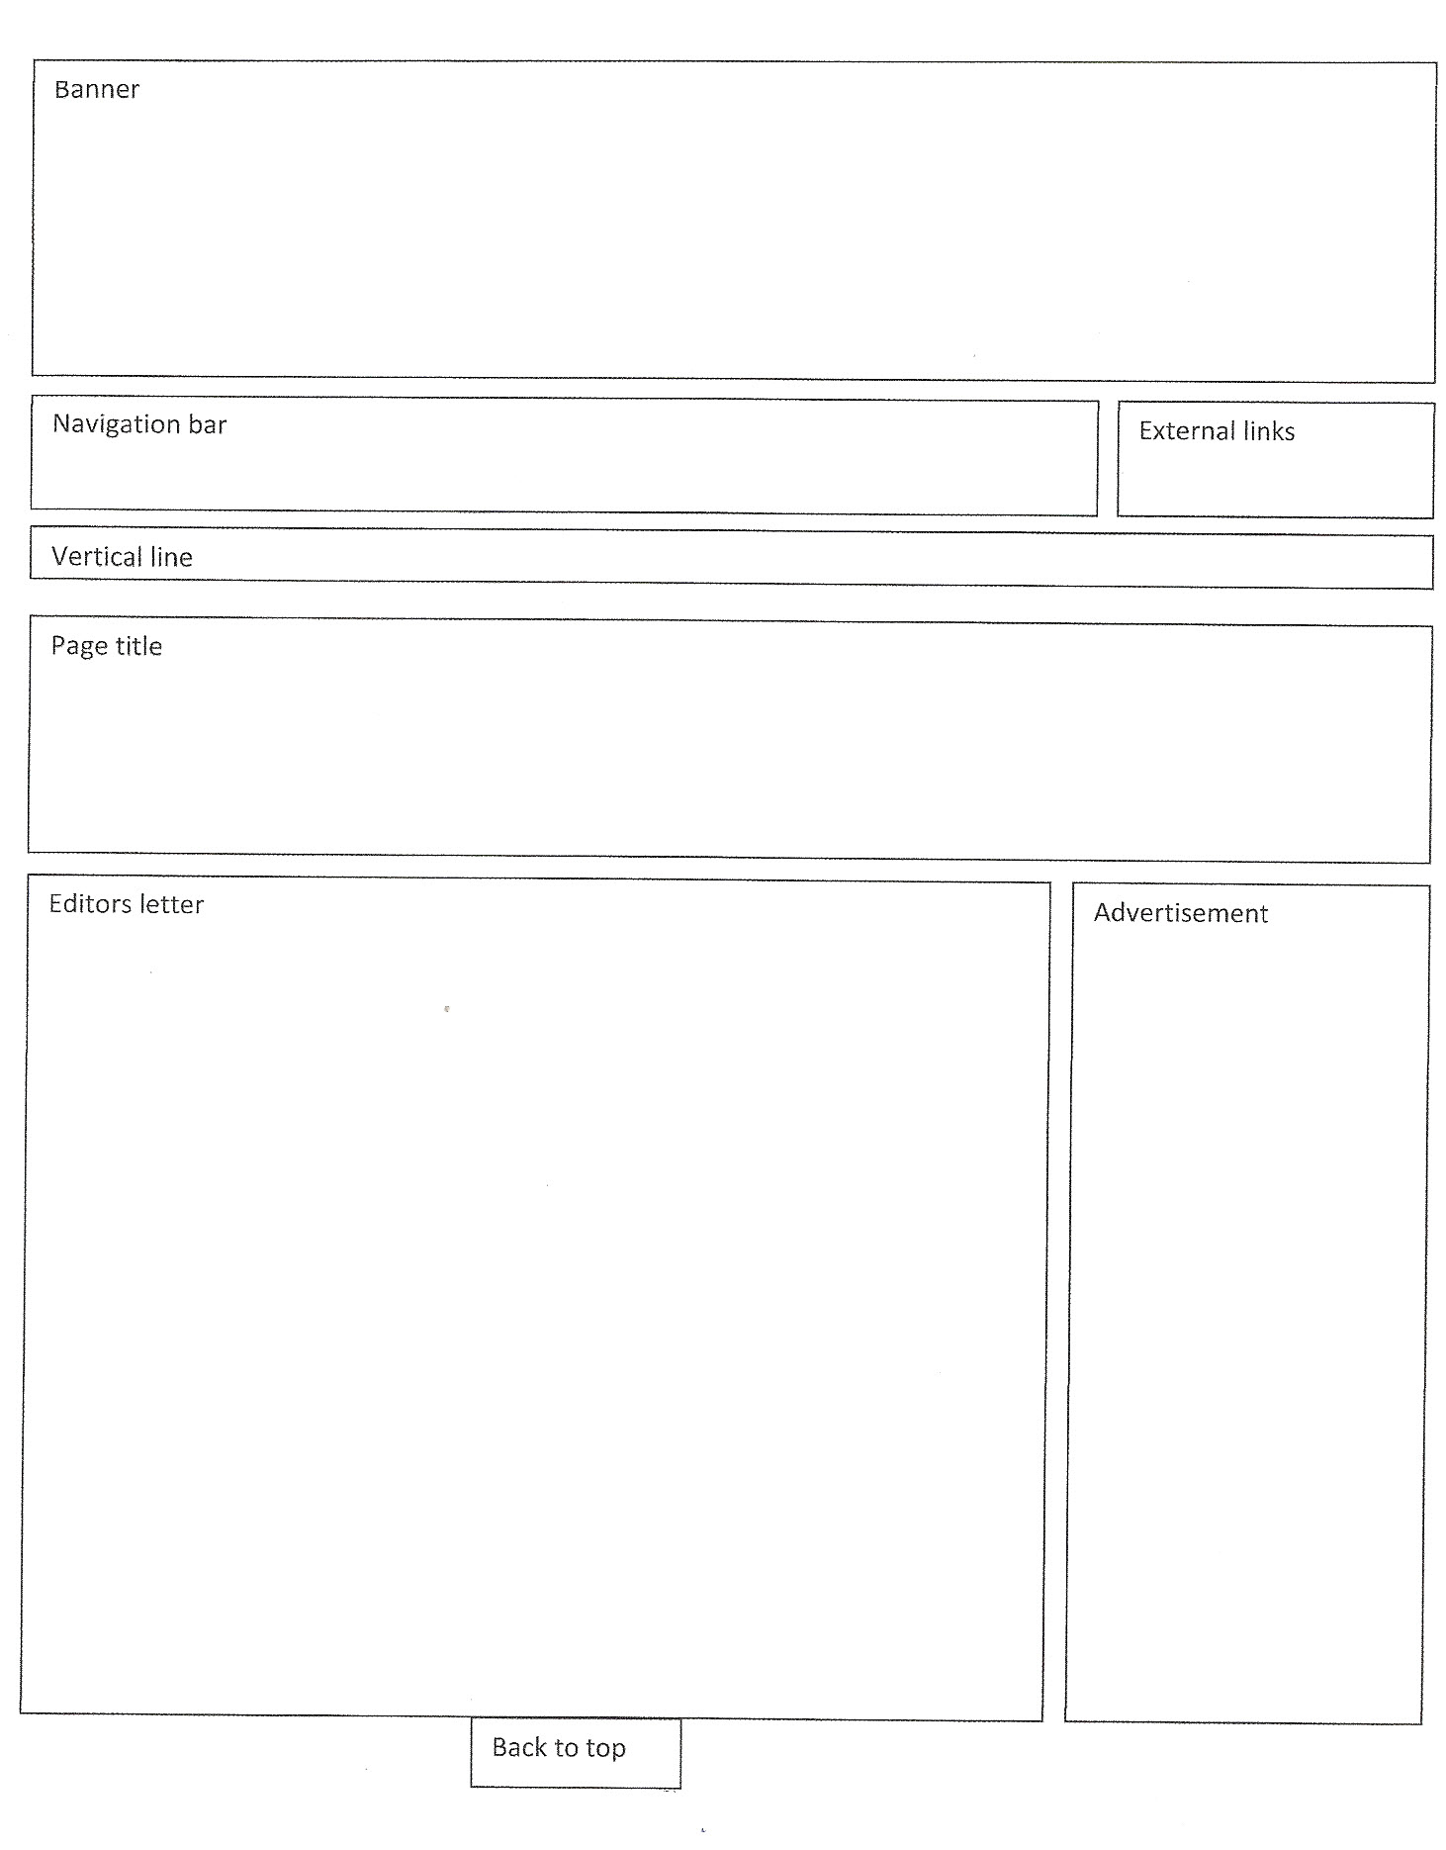

Colour Schemes
E-Magazine

Hex #40AEFA
R: 64
G: 174
B: 234

These 3 colours will be used to create the background as well as the banner and is going to be used throughout the whole webpage.

Hex #ffffff
R: 255
G: 255
B: 255

Hex #000000
R: 0
G: 0
B: 0

Hex #9FD7F6
R: 159
G: 215
B: 246z

Black and white will mainly be used for texts or shapes for text to be placed on.

Development and Application
Well-considered application of the design process is demonstrated in the descriptions of where and why colours and fonts will be used on pages 24, 26 and 35.
However the colour samples in these boxes are not correct as described.

Hex #C27477
R: 194
G: 116
B: 119

This shade of red will be used as a divider, which will provide good contrast on a background with the colour below.

Hex #D5D2D2
R: 213
G: 210
B: 210

Images/brushes/shapes used
E-Magazine

Image removed due to copyright
Image removed due to copyright

This image has been used as the main image for the Magazine cover and has been
manipulated by using the clone stamp tool using Adobe PS to cover up the
watermark and bar at the bottom of the page as well as changing the smoke trails.

Image removed due to copyright
Image removed due to copyright
This image has been manipulated by cropping out the background and converted to a
PNG file resulting in a transparent background. The image has also been rotated where
the aircraft is now at a different angle. This image appears on the main advertisement

Image removed due to copyright
Image removed due to copyright

- WIP = Work in Progress
In this case, the teacher required that the WIP folder not be included as part of the website.
It is up to the teacher to decide whether the WIP folder is to be included. The teachers must then ensure that students and markers know what is required.

How well does the product communicate the message to the intended audience?
The image and the title communicate the message, as they are aviation related making it
obvious to the intended audience.

How well does the product meet the specifications of the task? The final product produced was
a front cover of an aviation magazine and the creation of the online version of the magazine (6
pages) achieves the specifications of the task.

How effective was your investigating? The investigation process allowed me to discover and
explore elements, gave ideas for pages such as the subscription page and looks at different
colour schemes seeing what would suit each other and provide good contrast.

What changes did you need to make and why? 'After printing, it appeared different, so changes
were needed to be made'. (Use language of CRAP)

How easy was it to follow the plan when producing? My design plan was well thought out,
there was a lot of detail in it, which made it easy to follow.

How appropriate was the choice of hardware? The hardware I chose to use was suitable for the
task.

How effectively did you use your time? Too much time spent on producing, not enough on
documentation. Files weren't converted before coming to school, therefore was unable to work
on it and improve. I procrastinated half the time and when things went wrong such as the
crashing of my laptop with the Adobe suite, panicking did not help.

What have you learned by undertaking this task? Learnt how to use software, understand web
design and printing makes a difference and that web design resolution is important.

What would you change if you were to do this task again?
Documentation (more time to Investigation and devising.) I should have documented as I went
along instead of leaving it last. I would have stopped focusing on one thing and move on the next
and should just come back later if there is time.

According to the surveys, I have received positive feedback about my webpage.

Analysis and Evaluation
Competent evaluation of text-based products against design principles is shown in the Evaluation which, though seeming to cover all areas, needs further detail. Formal feedback from the target audience could be obtained and used within the evaluation to further support the summary.

Response 2 Additional comments
Most images have been removed from the documentation of this task due to copyright. The evidence for the various levels in the Performance Standards is therefore not available. However, the indicators that were used to assess this piece of work appear below:
- Competent understanding of the design process in is shown by presence of Investigation, Devising and Evaluation sections , all lacking depth, but no use of drafting. (Understanding 2)
- Considered selection and use of appropriate hardware and software is evident in that the web pages and the magazine cover have been produced, however:
-some graphics are pixelated
-some hyperlinks do not work
-pages need to have appropriate titles. (Development and Application 1)

- Competent application of manipulative and organisational skills is shown by the fact that the required products were handed up demonstrating:
-use of a file naming convention
-separate Images folder
-an efficient navigation system
-mainly third person writing
-approximately 1500 words in product.
However:
-the design and layout of the web was incomplete
-the magazine page was incomplete
-text was cut off when the magazine page printed
-WIP* process folder was included (impacts on download time)
-unpublished Flash files should not have been included. (Development and Application 2)

- Competent application of layout and design principles is shown in the layout of the magazine front page and the electronic documents which display some good use of:
-Contrast
-Repetition
-Alignment
-Proximity.
Evidence included:
-repetition of magazine banner and other design elements in magazine and emagazine
-repetition of page layout, colour schemes, fonts throughout site
-navigation repeated throughout the website.
However:
-Index.htm is not appropriate for emagazine (too long and too wide)
-page anchors are needed to make finding of information easier
-some pages lack balance. (Development and Application 3)

- Consistent and thoughtful application of layout and design principles was displayed in the layout of web pages including:
-repetition of magazine title and other design elements in the magazine cover and emagazine
-repetition of page layout, colour schemes, fonts throughout site
-repeated use of horizontal rules to separate unrelated items
-excellent navigation which includes use of anchors and top-bottom navigation (Repeated)
-Index.htm fits completely on screen
-use of shapes to contain related information. (Proximity) (Development and Application 3)

- Competent application of the design process is shown in the inclusion of Investigation, Devising and Evaluation in the documentation
However:
-there is no Devising summary/statement
-the absence of drafts means there is no evidence of the information flow from Devising
-a bibliography was not included (Development and Application 4)

Performance Standards for Stage 2 Information Processing and Publishing
 | Understanding | Development and Application | Analysis and Evaluation
A | Comprehensive understanding of the most appropriate hardware and software for the completion of text-based communication tasks.  Comprehensive understanding of the design process in planning, producing, and evaluating text-based products.  In-depth understanding of the impact of social, ethical, and/or legal issues related to information-processing and publishing technologies. | Discerning selection and highly proficient use of appropriate hardware and software in the completion of text-based communication tasks.  Highly proficient application of manipulative and organisational skills in the use of information-processing technology.  Consistent and thoughtful application of layout and design principles to the production of text-based documents or presentations.  Comprehensive and well-considered application of the design process in planning and producing text-based products. | Perceptive and thorough analysis and evaluation of the impact of social, ethical, and/or legal issues most closely related to information-processing and publishing technologies.  Discerning and thorough evaluation of text-based products and the design process used.
B | Well-informed understanding of appropriate hardware and software for the completion of text-based communication tasks.  Well-informed understanding of the design process in planning, producing, and evaluating text-based products.  Well-considered understanding of the impact of social, ethical, and/or legal issues related to information-processing and publishing technologies. | Well-considered selection and proficient use of appropriate hardware and software in the completion of text-based communication tasks.  Proficient application of manipulative and organisational skills in the use of information-processing technology.  Thoughtful application of layout and design principles to the production of text-based documents or presentations.  Well-considered application of the design process in planning and producing text-based products. | Well-considered analysis and evaluation of the impact of social, ethical, and/or legal issues closely related to information-processing and publishing technologies.  Well-considered evaluation of text-based products and the design process used.
C | Informed understanding of appropriate hardware and software for the completion of text-based communication tasks.  Competent understanding of the design process in planning, producing, and evaluating text-based products.  Informed understanding of the impact of social, ethical, and/or legal issues related to information-processing and publishing technologies. | Considered selection and use of appropriate hardware and software in the completion of text-based communication tasks.  Competent application of manipulative and organisational skills in the use of information-processing technology.  Competent application of layout and design principles to the production of text-based documents or presentations.  Competent application of the design process in planning and producing text-based products. | Considered analysis and evaluation of the impact of social, ethical, and/or legal issues related to information-processing and publishing technologies.  Competent evaluation of text-based products and the design process used.
D | Some recognition of hardware or software for the completion of basic text-based communication tasks.  Some understanding of basic aspects of the design process in planning, producing, and evaluating text-based products.  Awareness of some impacts of social, ethical, or legal issues that are partly related to information-processing and publishing technologies. | Partial use of basic hardware or software in the completion of basic text-based communication tasks.  Some application of basic manipulative and organisational skills in the use of information-processing technology.  Some application of basic layout and design principles to the production of text-based documents or presentations.  Basic application of some aspects of the design process in planning and producing one or more text-based products. | Some awareness of the impact of one or more social, ethical, or legal issues related to information-processing and publishing technologies.  Some basic assessment of text-based products, with some reference to the design process.
E | Identification of aspects of hardware or software related to text-based communication tasks.  Some recognition of limited aspects of the role of the design process in planning, producing, and evaluating text-based products.  Limited consideration of any issues that may be related to information-processing and publishing technologies. | Attempted use of basic hardware or software in attempting text-based communication tasks.  Limited application of manipulative and organisational skills in attempting to use information-processing technology.  Attempted use of elements of layout and design principles in the attempted production of a text-based document or presentation.  Attempted application of one or more aspects of the design process in planning and attempting to produce a simple text-based product. | Emerging awareness of one or more aspects of the impact of a social, ethical, or legal issue related to information-processing and publishing technologies.  Attempted description of one or more text-based products, with limited reference to the design process.

