Stage 2 Information Processing and Publishing
Assessment Type 1: Practical Skills
Package Design
Student Response 1
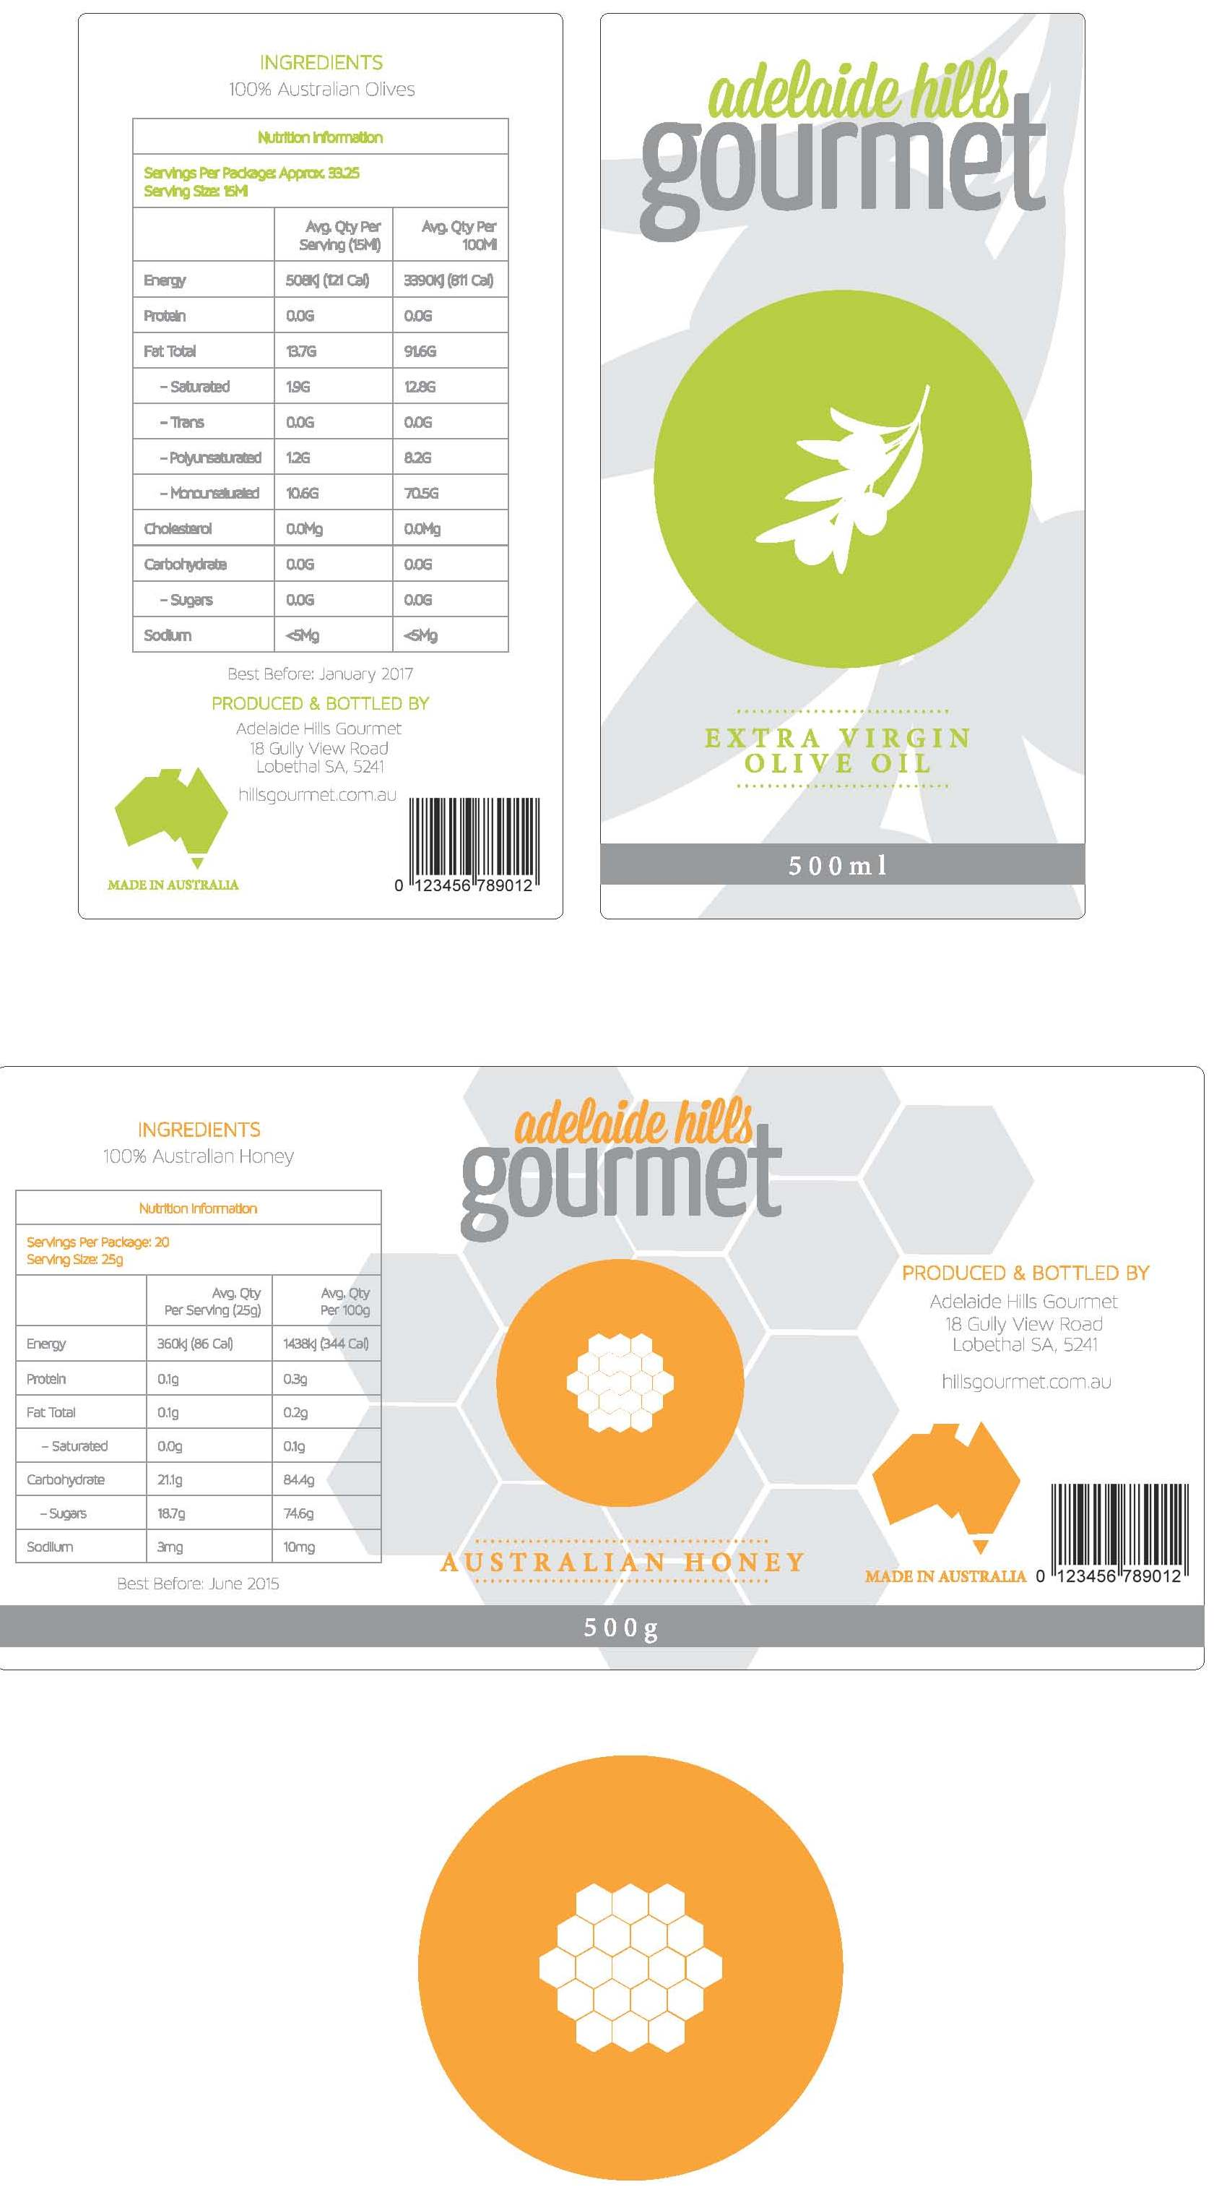
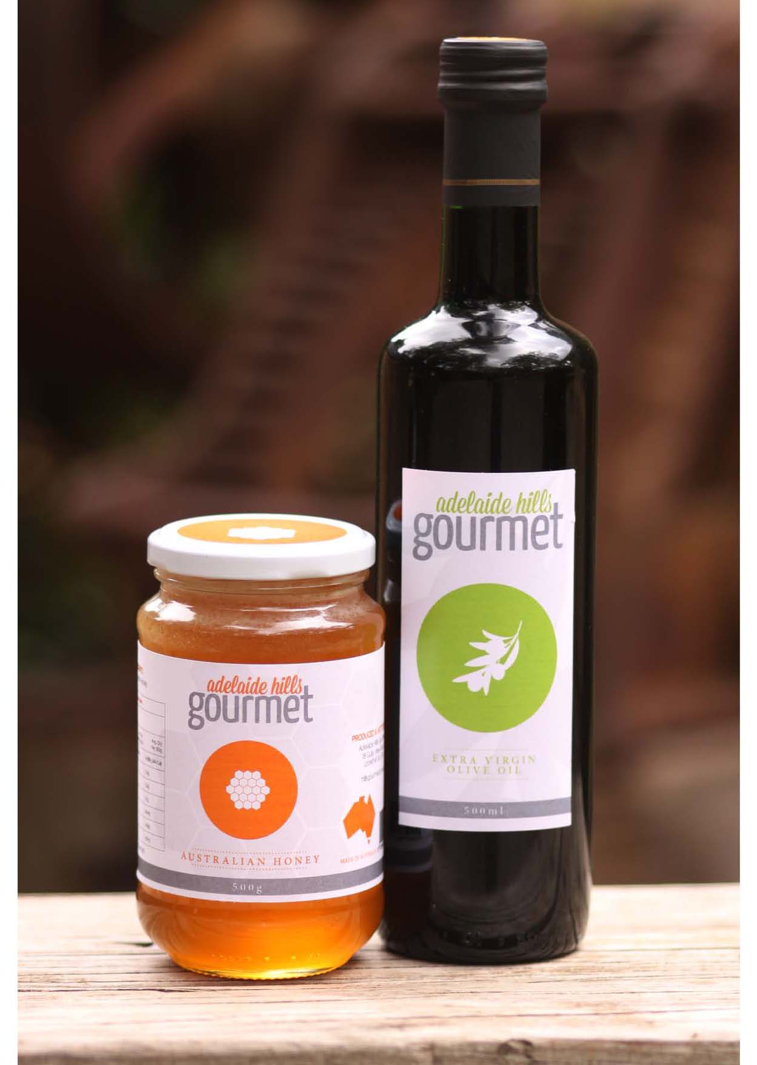
Assessment Comments
This response is illustrative of an A- grade.

Development and Application

DA1 Selection and use of appropriate hardware and software in the completion of text-based communication tasks:
- Appropriate hardware and software for the task have been chosen.
- Use of appropriate software for creation of graphics and keying in of text is evident.
- The response provides evidence of the use of page format tools e.g. tables.
- There is evidence of spelling and grammar checks having been undertaken.
- There is evidence the student created and edited own logos.
- Used document set up for correct document sizes. Evidence as per photographs where the labels have been cut to size.

DA2 Application of manipulation and organisational skills in the use of information-processing technology:
- Good use of contrast and repetition in use of colour for the headings and shapes etc. The watermark has been lowered in opacity to still provide good contrast.
- The use of complimentary colours provides contrast.
- There is evidence of effective use of white space.
- Reverse text has been used for contrast.
- The font styles are easy to read and not pixelated.
- A variety of software has been used.
- There is evidence the text has been formatted using acceptable conventions.
- The repetition of layout between labels provides evidence that all labels belong to the same company.

DA3 Application of layout and design principles to the production of text-based documents or presentations:
- The document sizes are appropriate for labels.
- Contrast is evident in bold text, different font styles and sizes, variation of colours, use of shapes and the colour scheme.
- Repetition is evident in font styles, colours, watermarks used relate to the product, Australian logo is evident in both labels, use of tables listing ingredients and shapes.
- The alignment is generally well done; however there are issues with alignment in the table (figures in the second and third columns could be right aligned). Alignment of text in tables is not always consistent e.g. a combination of left and right alignment has been used – for example alignment of “Adelaide Hills against Gourmet text”.
- Proximity is evident in table groups ingredient information, contact details are grouped together, watermark is grouped with logo and product name, Australia grouped with Australian made and barcode.
- Communication to the audience is evident and it is evident that the product is produced by the same company (e.g. consistency in the logos, design and layout).
- The formatting of text is not consistent with accepted business document formatting - suburbs should be in capitals, mixed punctuation.

DA4 Application of the design process in planning and producing text-based products:
- To achieve the final product it is evident that investigation has occurred. The level of detail provided in the nutritional information, ingredients and logo design provides evidence beyond that which would be seen in the classroom by the teacher.
- It is evident that there is a good understanding of the design principles and application of document layout in the products developed.
Performance Standards for Stage 2 Information Processing and Publishing
 | Understanding | Development and Application | Analysis and Evaluation
A | Comprehensive understanding of the most appropriate hardware and software for the completion of text-based communication tasks.  Comprehensive understanding of the design process in planning, producing, and evaluating text-based products.  In-depth understanding of the impact of social, ethical, and/or legal issues related to information-processing and publishing technologies. | Discerning selection and highly proficient use of appropriate hardware and software in the completion of text-based communication tasks.  Highly proficient application of manipulative and organisational skills in the use of information-processing technology.  Consistent and thoughtful application of layout and design principles to the production of text-based documents or presentations.  Comprehensive and well-considered application of the design process in planning and producing text-based products. | Perceptive and thorough analysis and evaluation of the impact of social, ethical, and/or legal issues most closely related to information-processing and publishing technologies.  Discerning and thorough evaluation of text-based products and the design process used.
B | Well-informed understanding of appropriate hardware and software for the completion of text-based communication tasks.  Well-informed understanding of the design process in planning, producing, and evaluating text-based products.  Well-considered understanding of the impact of social, ethical, and/or legal issues related to information-processing and publishing technologies. | Well-considered selection and proficient use of appropriate hardware and software in the completion of text-based communication tasks.  Proficient application of manipulative and organisational skills in the use of information-processing technology.  Thoughtful application of layout and design principles to the production of text-based documents or presentations.  Well-considered application of the design process in planning and producing text-based products. | Well-considered analysis and evaluation of the impact of social, ethical, and/or legal issues closely related to information-processing and publishing technologies.  Well-considered evaluation of text-based products and the design process used.
C | Informed understanding of appropriate hardware and software for the completion of text-based communication tasks.  Competent understanding of the design process in planning, producing, and evaluating text-based products.  Informed understanding of the impact of social, ethical, and/or legal issues related to information-processing and publishing technologies. | Considered selection and use of appropriate hardware and software in the completion of text-based communication tasks.  Competent application of manipulative and organisational skills in the use of information-processing technology.  Competent application of layout and design principles to the production of text-based documents or presentations.  Competent application of the design process in planning and producing text-based products. | Considered analysis and evaluation of the impact of social, ethical, and/or legal issues related to information-processing and publishing technologies.  Competent evaluation of text-based products and the design process used.
D | Some recognition of hardware or software for the completion of basic text-based communication tasks.  Some understanding of basic aspects of the design process in planning, producing, and evaluating text-based products.  Awareness of some impacts of social, ethical, or legal issues that are partly related to information-processing and publishing technologies. | Partial use of basic hardware or software in the completion of basic text-based communication tasks.  Some application of basic manipulative and organisational skills in the use of information-processing technology.  Some application of basic layout and design principles to the production of text-based documents or presentations.  Basic application of some aspects of the design process in planning and producing one or more text-based products. | Some awareness of the impact of one or more social, ethical, or legal issues related to information-processing and publishing technologies.  Some basic assessment of text-based products, with some reference to the design process.
E | Identification of aspects of hardware or software related to text-based communication tasks.  Some recognition of limited aspects of the role of the design process in planning, producing, and evaluating text-based products.  Limited consideration of any issues that may be related to information-processing and publishing technologies. | Attempted use of basic hardware or software in attempting text-based communication tasks.  Limited application of manipulative and organisational skills in attempting to use information-processing technology.  Attempted use of elements of layout and design principles in the attempted production of a text-based document or presentation.  Attempted application of one or more aspects of the design process in planning and attempting to produce a simple text-based product. | Emerging awareness of one or more aspects of the impact of a social, ethical, or legal issue related to information-processing and publishing technologies.  Attempted description of one or more text-based products, with limited reference to the design process.

