STAGE 2 SOCIETY AND CULTURE (10-CREDIT)
ASSESSMENT TYPE 3: INVESTIGATION
RESPONSE 3

Issue: Negative influences in the media increase eating disorders in adolescents.
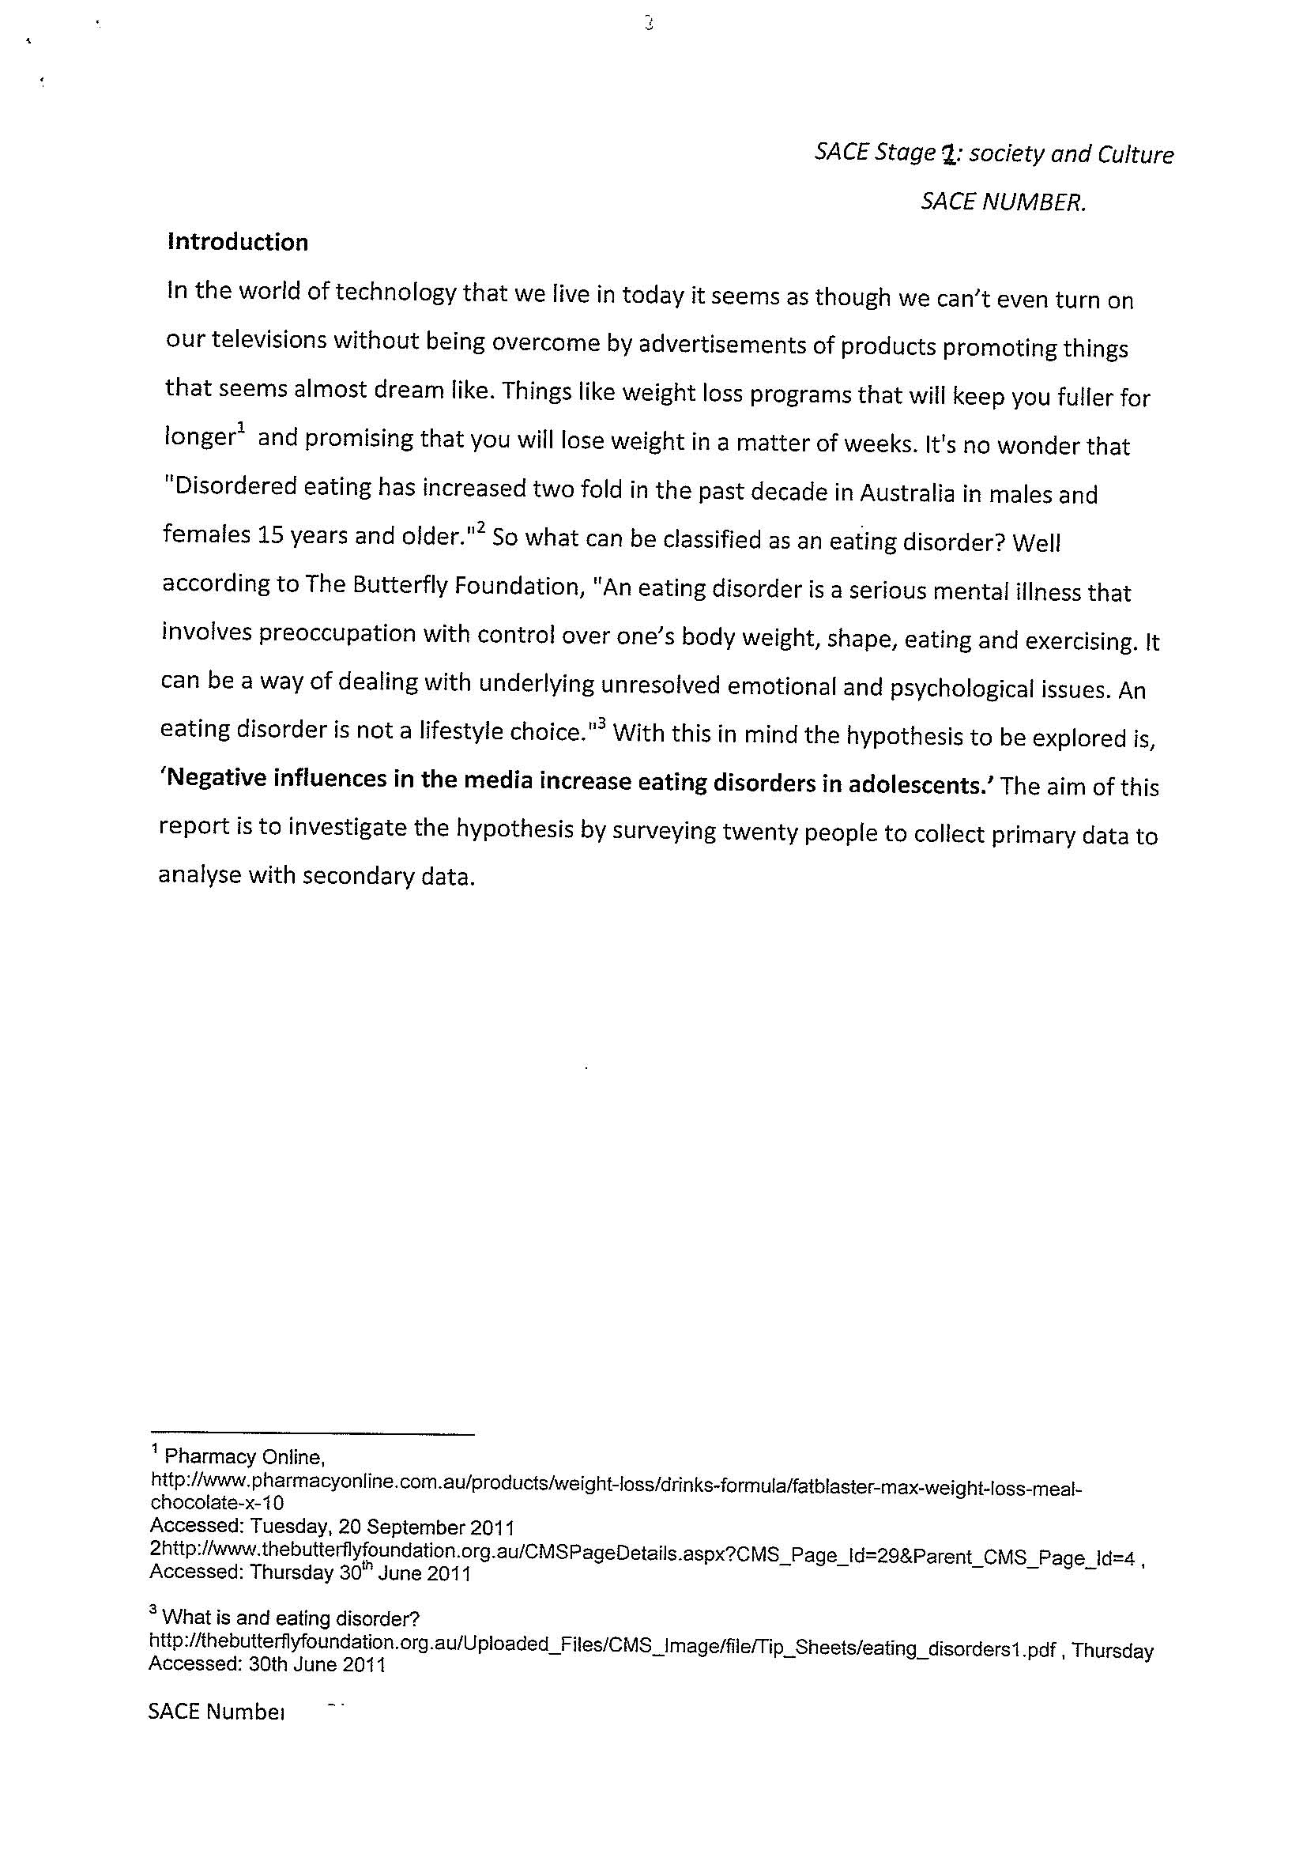
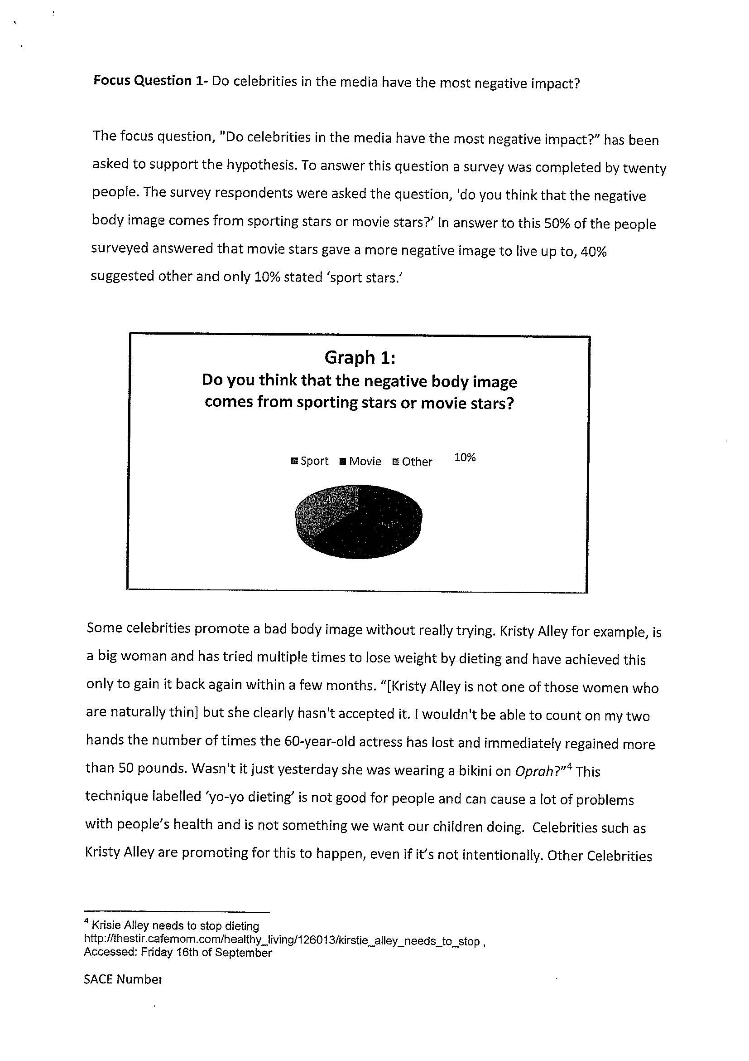
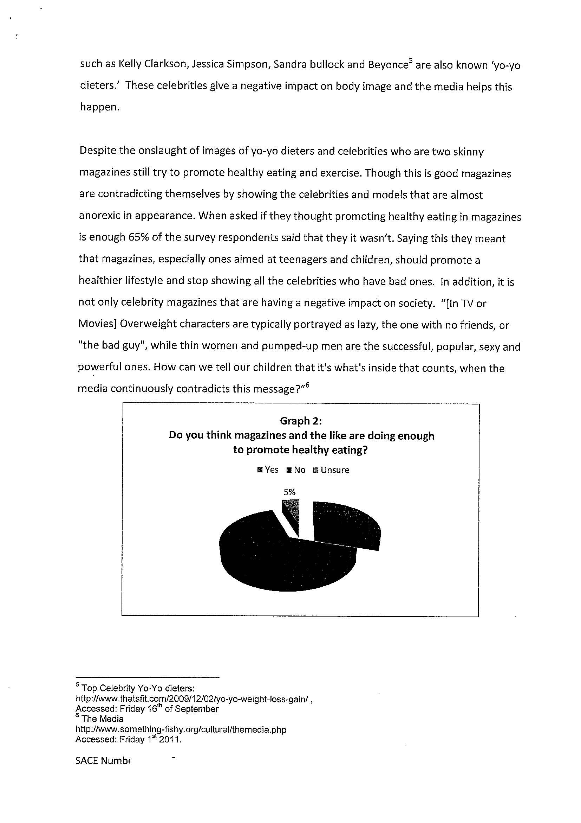
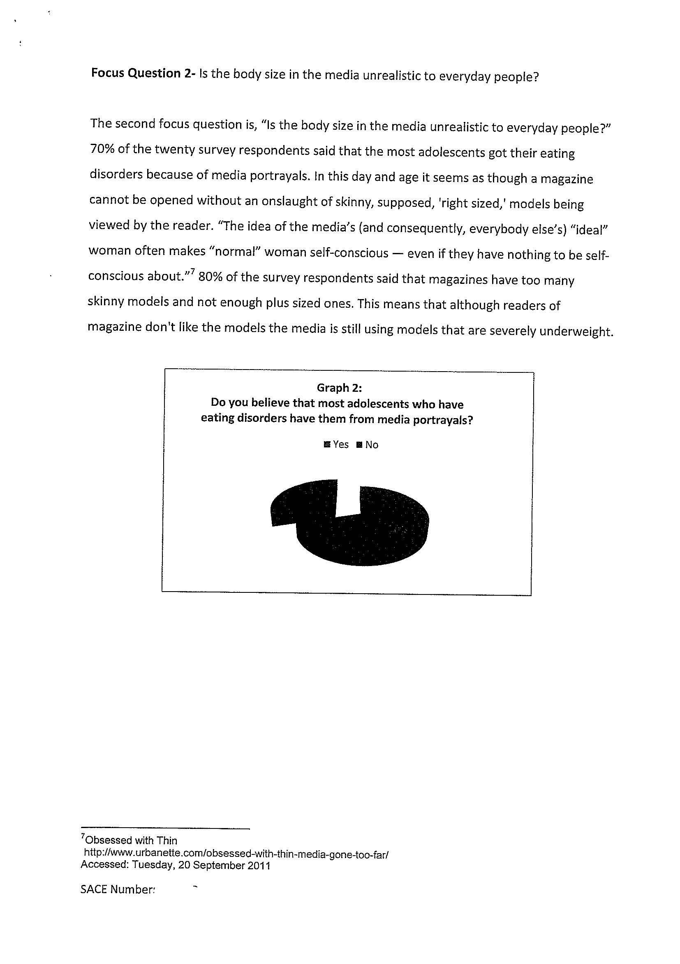
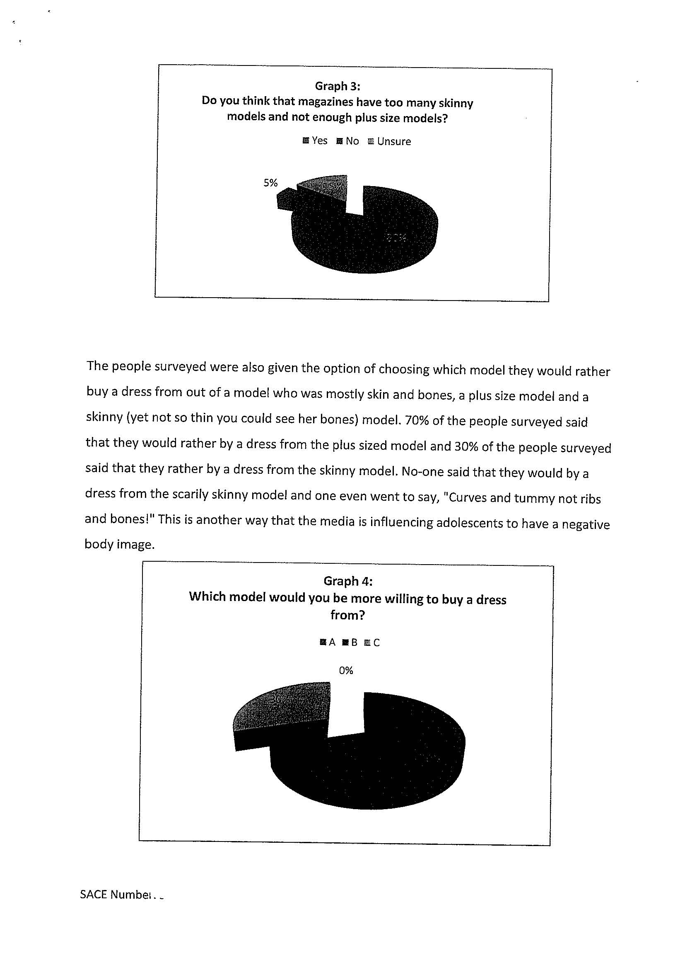
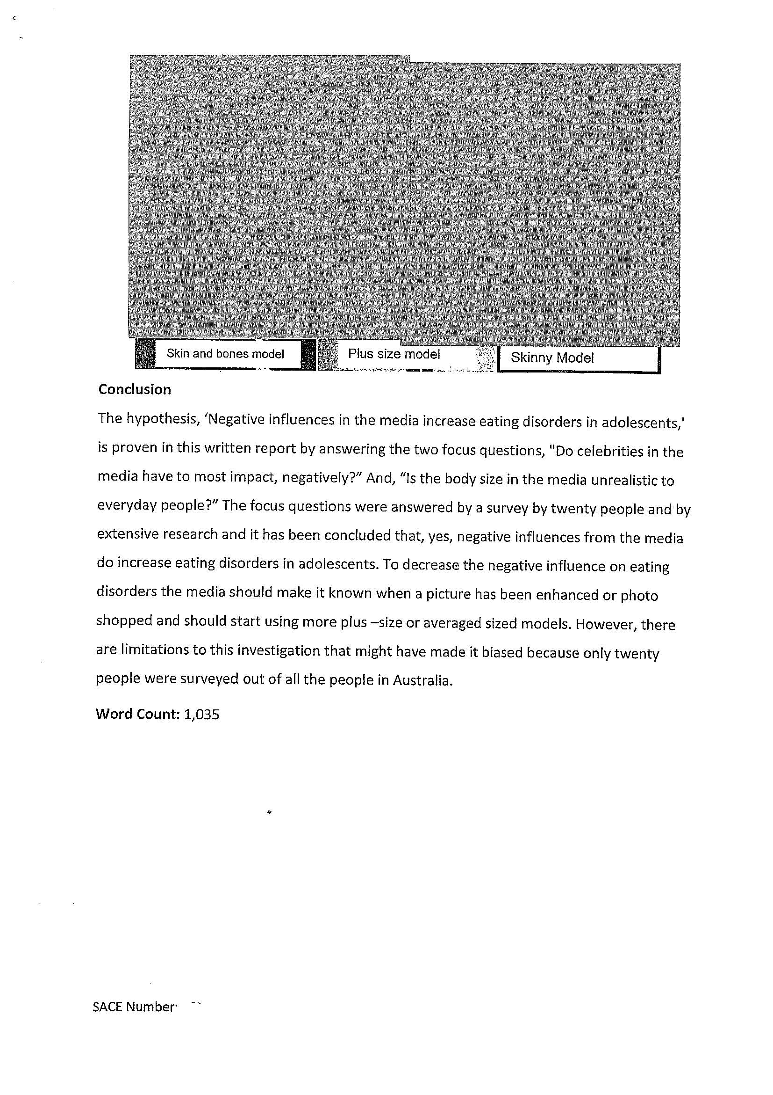

Comments

This investigation is from a 10 credit program.

The response demonstrates some knowledge of how media influences the development of eating disorders in adolescents but never really engages with the issue. The sources used are limited and skewed in one direction, i.e. towards agreeing that media personalities have a negative influence. The student’s own opinion is evident from early on in this investigation.

The response has demonstrated competent communication skills; however, a lack of conciseness in communication is evident. Choosing a much more “limited” topic for investigation may have resulted in a more focussed investigation.

The use of surveys shows superficial and limited use of evidence from easily accessible sources, with limited perspectives. Most of the conclusions are drawn from the 20 young people surveyed; respondents who would have limited knowledge of the topic.

The quality of communication and evaluation moves between D and C, that is, between being ‘basic’ and ‘informed’. The response demonstrates information has been accessed, but it assessed as authoritative without looking deeper.

The investigation is generally well organised and the reader can follow the line of argument.

There is some identification and exploration of how the media and young people in society are connected through celebrity lifestyles in magazines, showing connections between society and culture.

The conclusion is very generalised and stated as authoritative and there is no acknowledgment of limitations. There are references provided but no reference list or bibliography; the lack of sources limits the quality of analysis and evaluation.

Overall grade C-.
Performance Standards for Stage 2 Society and Culture – Investigation
 | Knowledge and Understanding | Investigation and Analysis | Collaboration | Evaluation and Communication
A | In-depth knowledge and perceptive understanding of a range of aspects of and issues related to contemporary societies and cultures, in local and global contexts.  In-depth knowledge and understanding of the nature and causes of social change.  Perceptive understanding of a variety of ways in which societies and cultures are connected and interdependent. | Focused investigation and insightful analysis of a range of aspects and issues related to contemporary societies and cultures, in local and global contexts.  Focused investigation and well-informed and critical analysis of ways in which power structures operate in societies. | Productive and inclusive planning and evaluation of collaborative social action related to an inquiry in a chosen topic.  Insightful and well-informed collaborative social action.  Constructive and well-focused individual contribution to group activities. | Insightful and focused evaluation and use of evidence from a range of sources and perspectives, with appropriate acknowledgment of sources.  Incisive and coherent communication of informed ideas about societies and social and cultural issues.
B | Some depth in knowledge and well-informed understanding of a range of aspects of and issues related to contemporary societies and cultures, in local and global contexts.  Some depth in knowledge and understanding of the nature and causes of social change.  Well-considered understanding of a variety of ways in which societies and cultures are connected and interdependent. | Well-organised investigation and well-considered analysis of a range of aspects and issues related to contemporary societies and cultures, in local and global contexts.  Well-organised investigation and informed and critical analysis of ways in which power structures operate in societies. | Productive planning and evaluation of collaborative social action related to an inquiry in a chosen topic.  Well-organised and informed collaborative social action.  Considered and active individual contribution to group activities. | Well-considered and informed evaluation and use of evidence from a range of sources and perspectives, with appropriate acknowledgment of sources.  Thoughtful and clear communication of informed ideas about societies and social and cultural issues.
C | Some detailed knowledge and informed understanding of different aspects of and issues related to contemporary societies and cultures, in local and global contexts.  Some detailed knowledge and understanding of the nature and causes of social change.  Considered understanding of some of the ways in which societies and cultures are connected and interdependent. | Generally organised investigation and considered analysis of different aspects of and issues related to contemporary societies and cultures, in local and global contexts.  Generally organised investigation and informed analysis of one or more ways in which power structures operate in societies. | Competent planning and evaluation of collaborative social action related to an inquiry in a chosen topic.  Generally organised and informed collaborative social action.  Appropriate individual contribution to group activities. | Evaluation and use of evidence from a range of sources and perspectives, with mostly appropriate acknowledgment of sources.  Competent communication of informed ideas about societies and social and/or cultural issues.
D | Identification and awareness of some aspects of and/or issues related to contemporary societies and cultures, in local and/or global contexts.  Some recognition and awareness of the causes of social change.  Identification and awareness of some of the ways in which societies and cultures are connected. | Partial investigation and description of some aspects of and/or issues related to contemporary societies or cultures, in local and global contexts.  Basic investigation and description of one of the ways in which power structures operate in societies. | Superficial contribution to planning and evaluation of collaborative social action related to an inquiry in a chosen topic.  Attempted engagement in collaborative social action.  Superficial individual contribution to group activities. | Superficial and limited use of evidence from easily accessible sources, with limited perspectives, and inconsistent acknowledgment of sources.  Communication of basic ideas about one or more social and/or cultural issues.
E | Some awareness of one or more aspects of or issues related to a contemporary society or culture, in a local or global context.  Limited awareness of any causes of social change.  Emerging awareness of one or more ways in which societies and cultures are connected. | Attempted investigation and brief description of an aspect of a contemporary society or culture, in a local or global context.  Emerging awareness of one of the ways in which power structures operate in societies. | Attempted contribution to planning and evaluation of collaborative social action related to an inquiry in a chosen topic.  Limited engagement in collaborative social action.  Limited individual contribution to group activities. | Attempted use of evidence from one or more easily accessible sources, with limited acknowledgment of sources.  Attempted communication about one or more social and/or cultural issues.

