STAGE 2 SOCIETY AND CULTURE
ASSESSMENT TYPE 3: INVESTIGATION
RESPONSE 2

Issue: To what extent is participation in Australian Rules Football and associated initiatives a legitimate way of improving the welfare of Indigenous Australians?
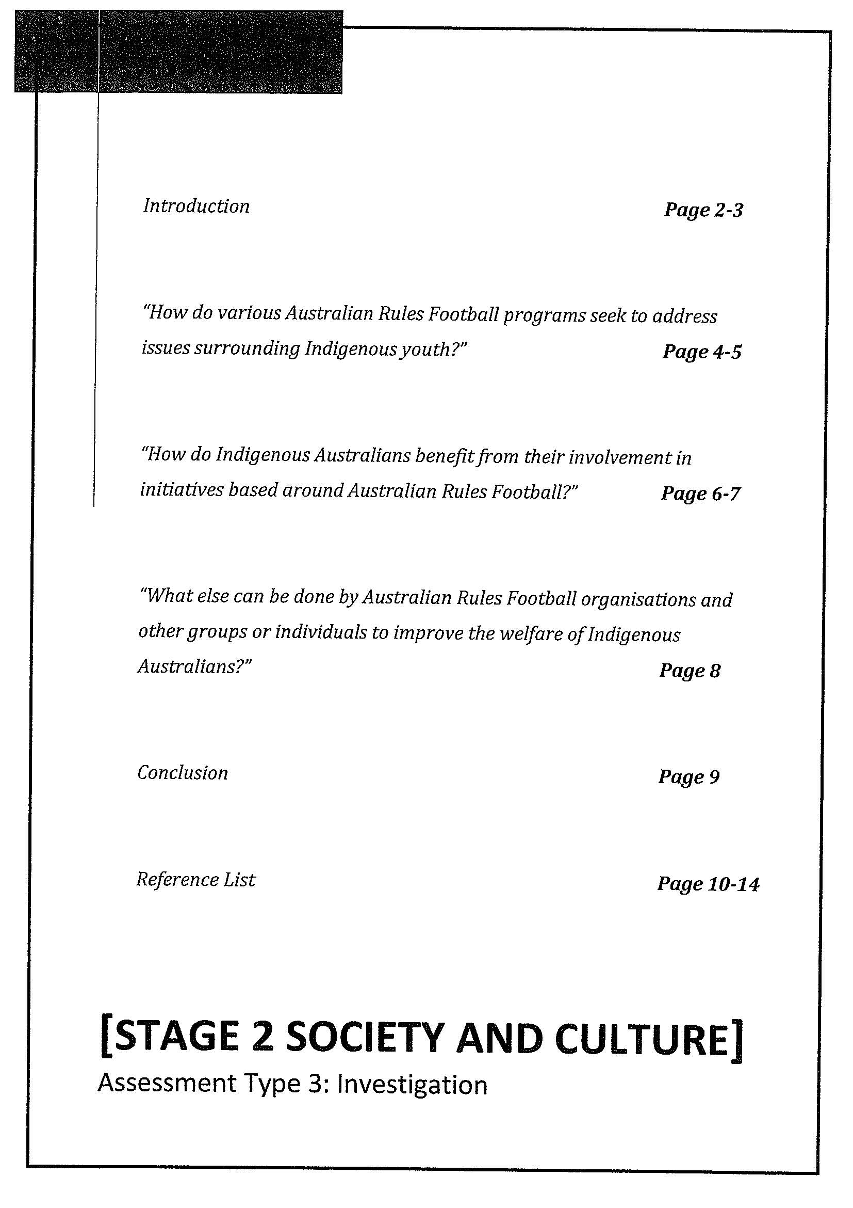

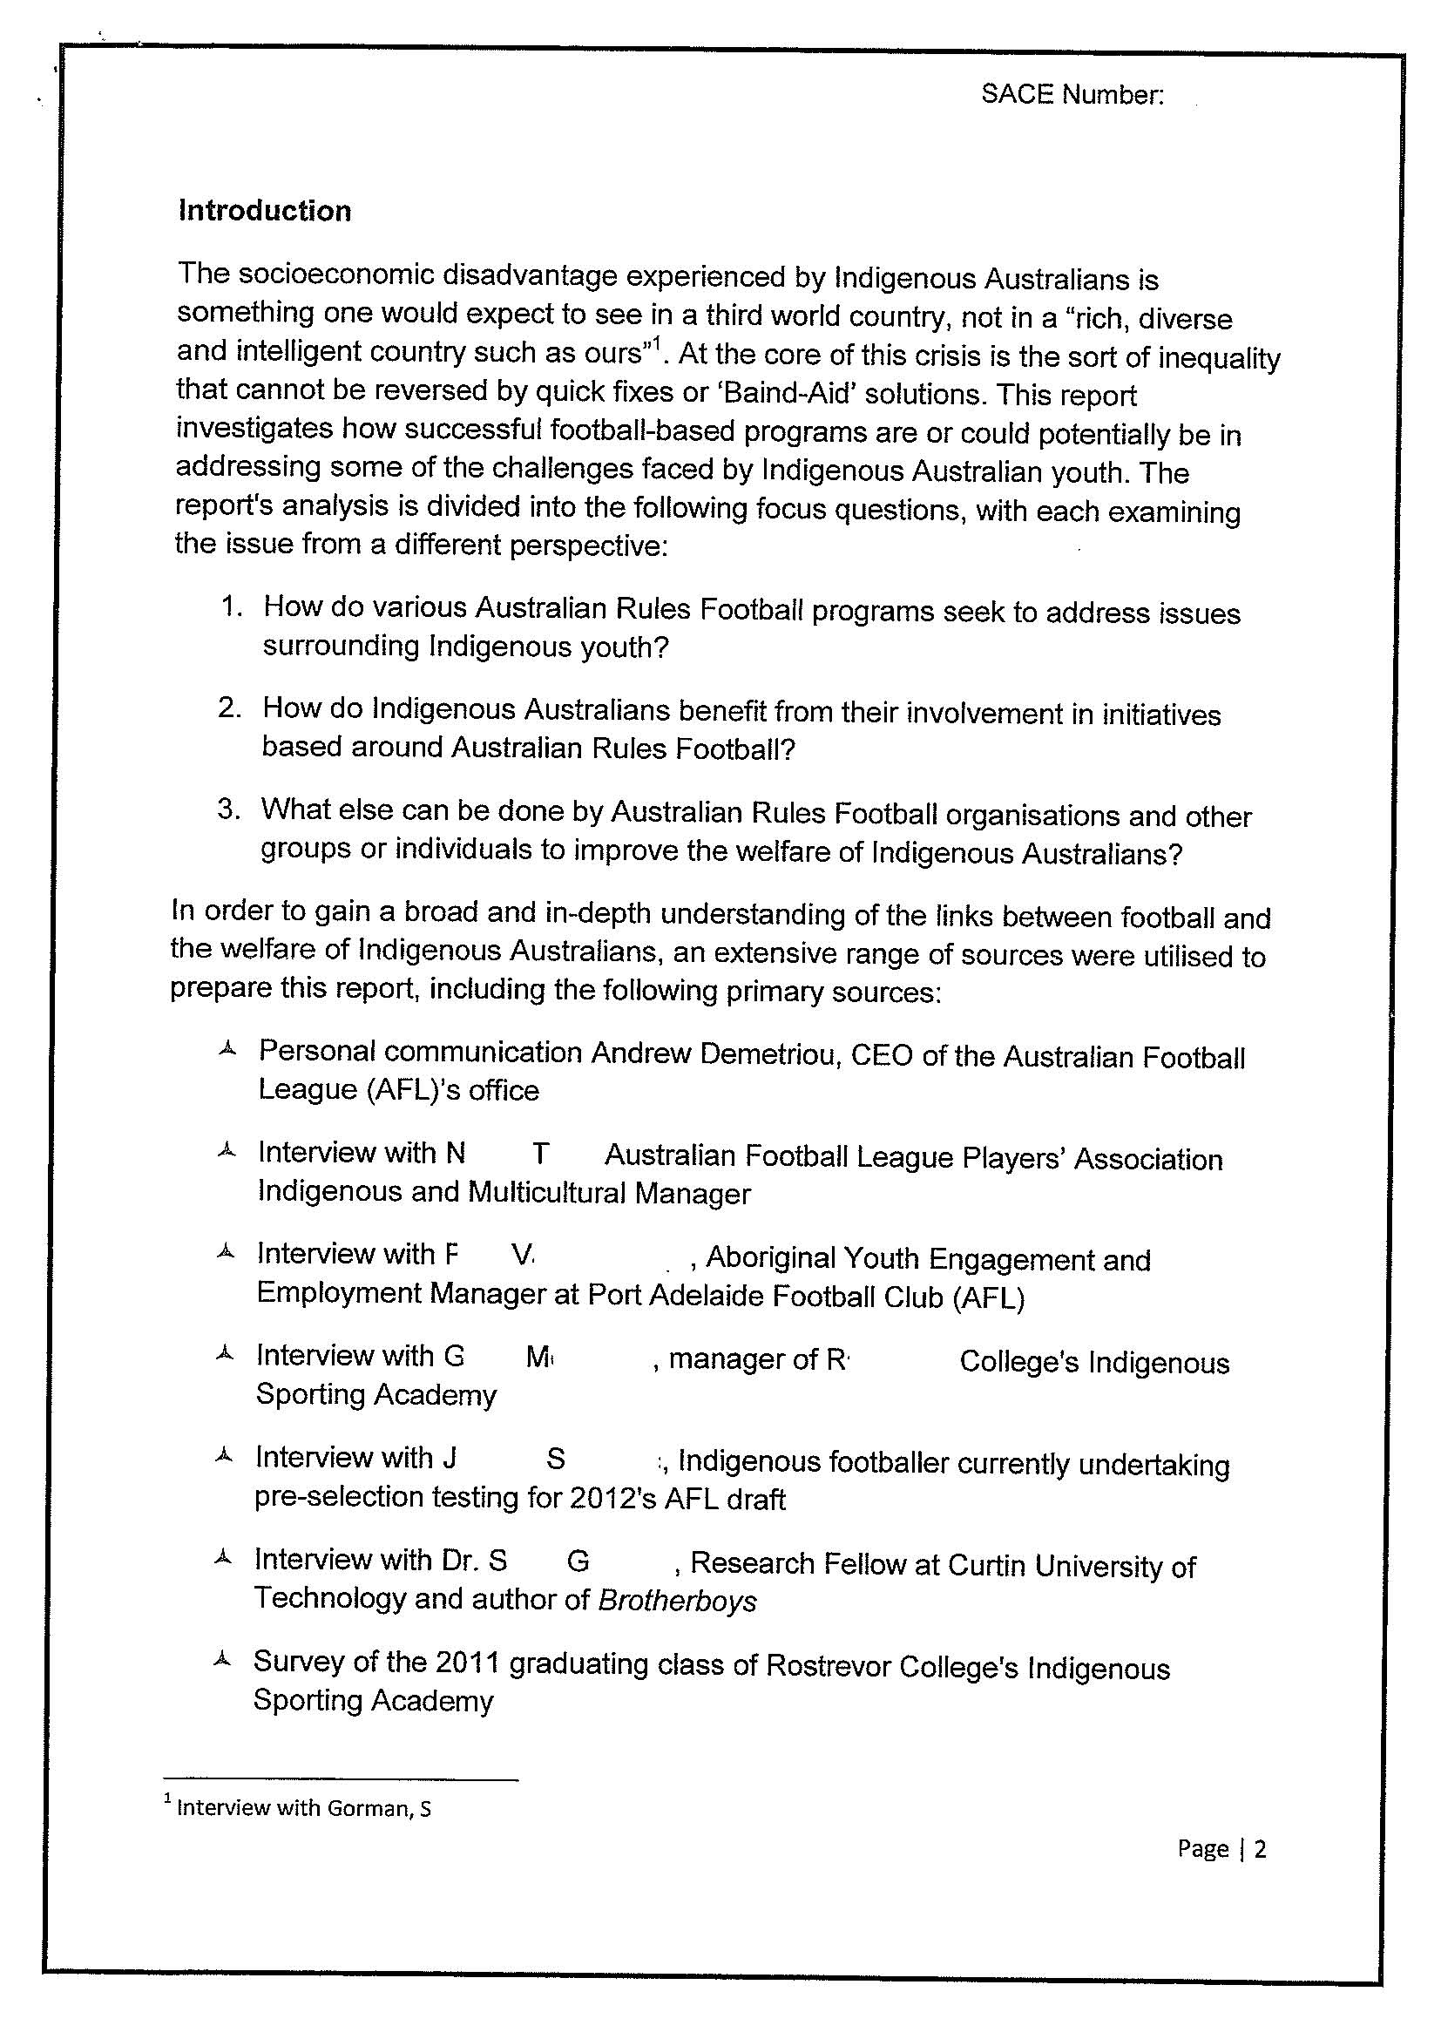

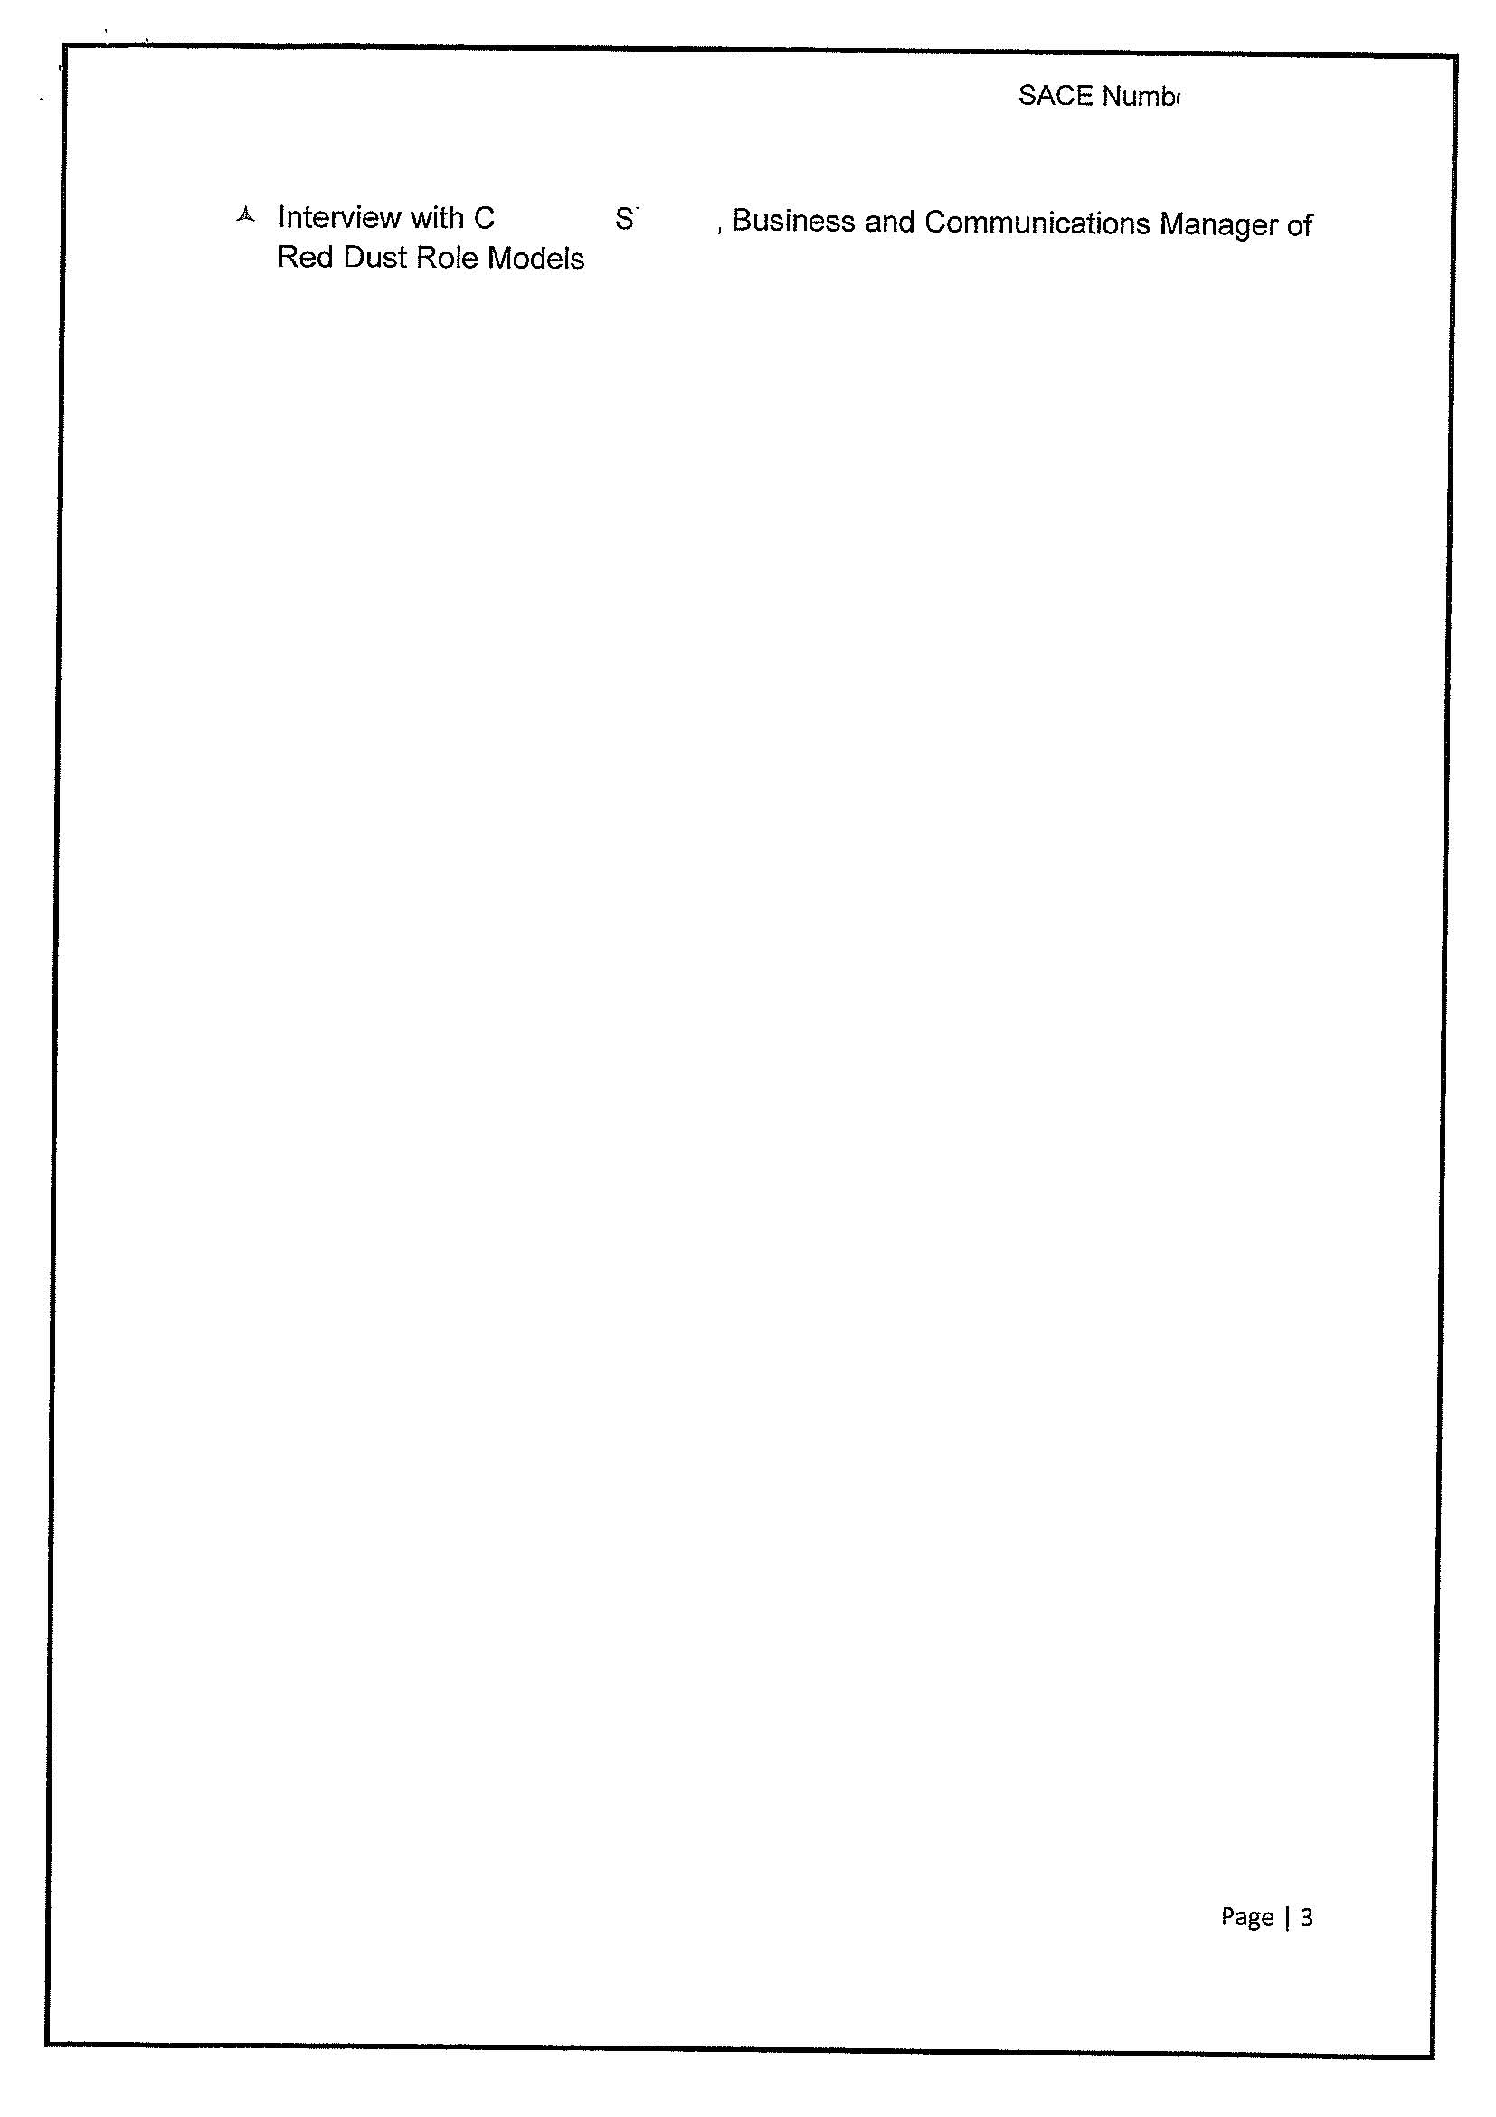
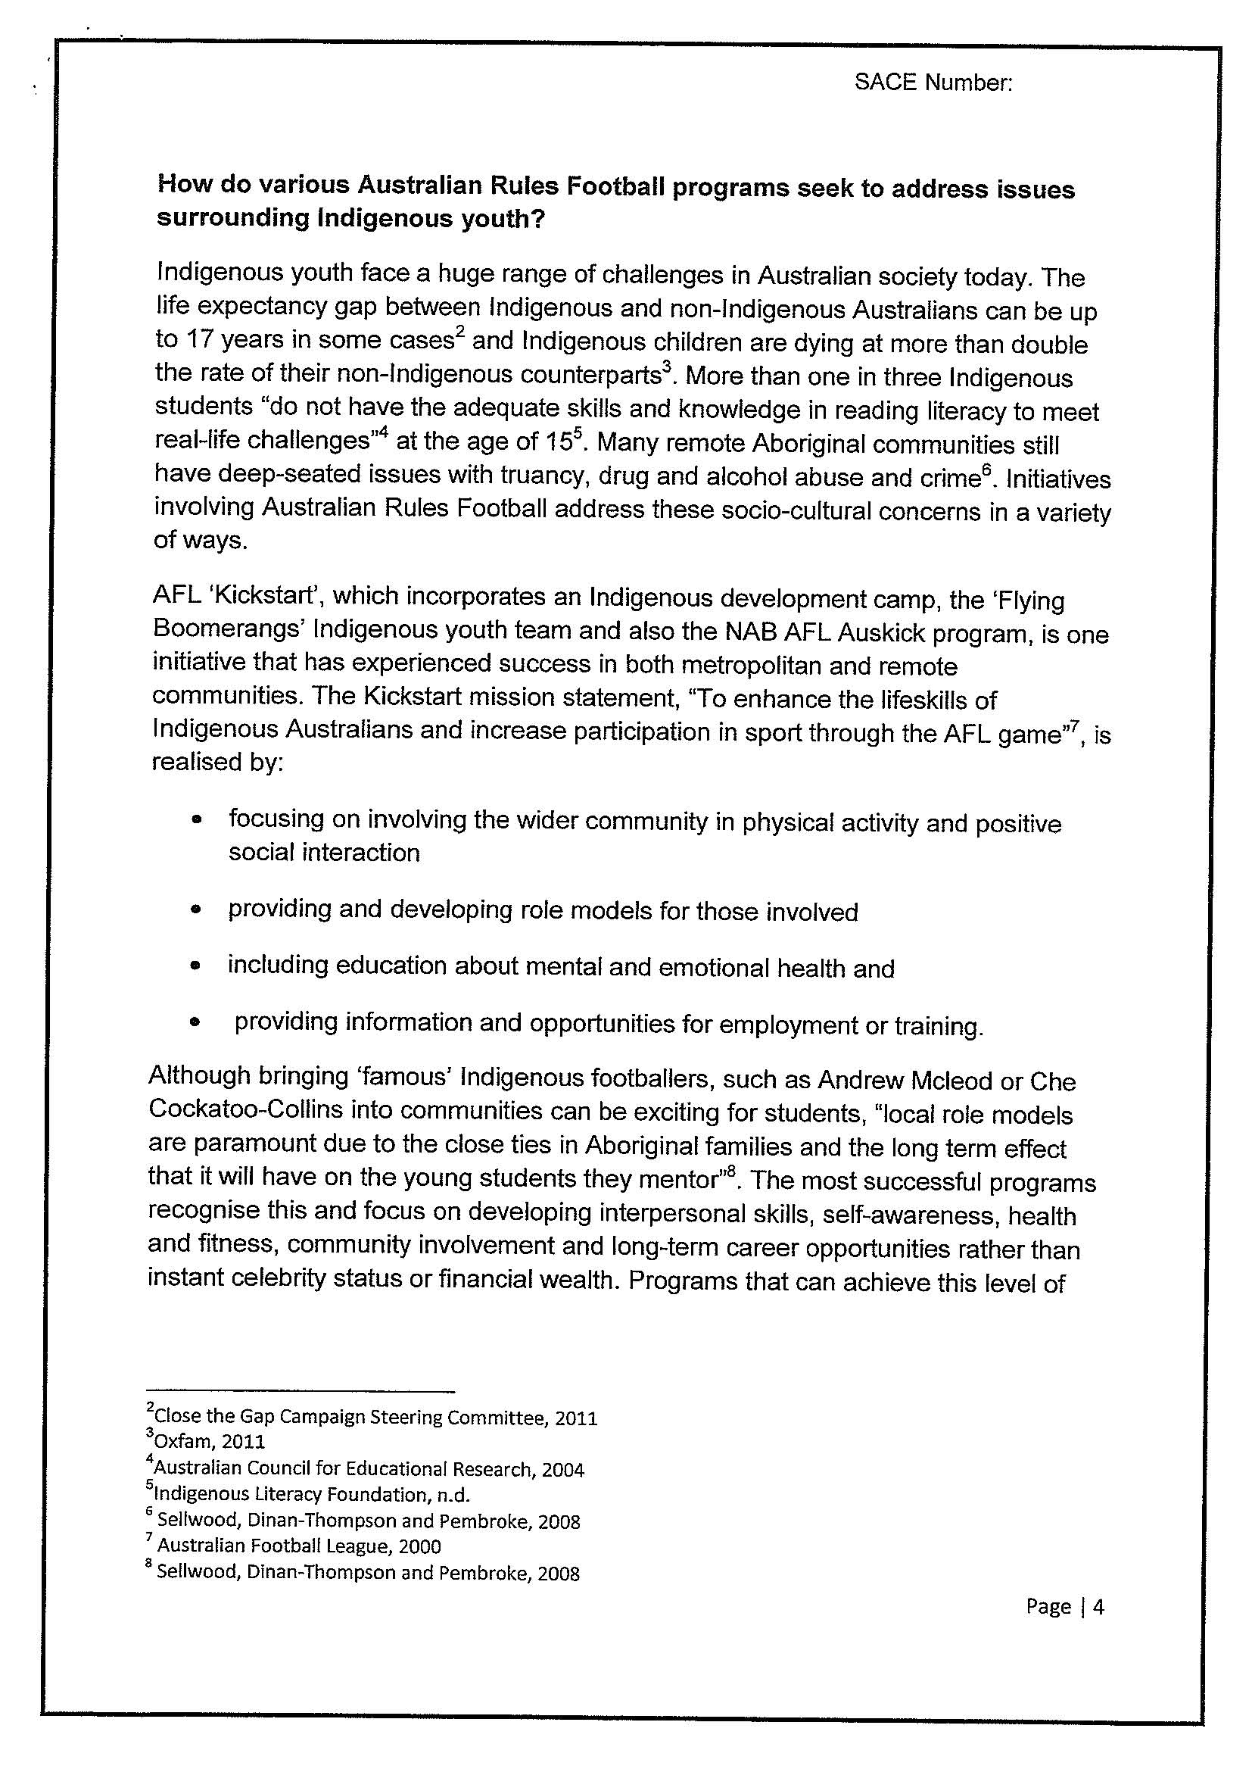

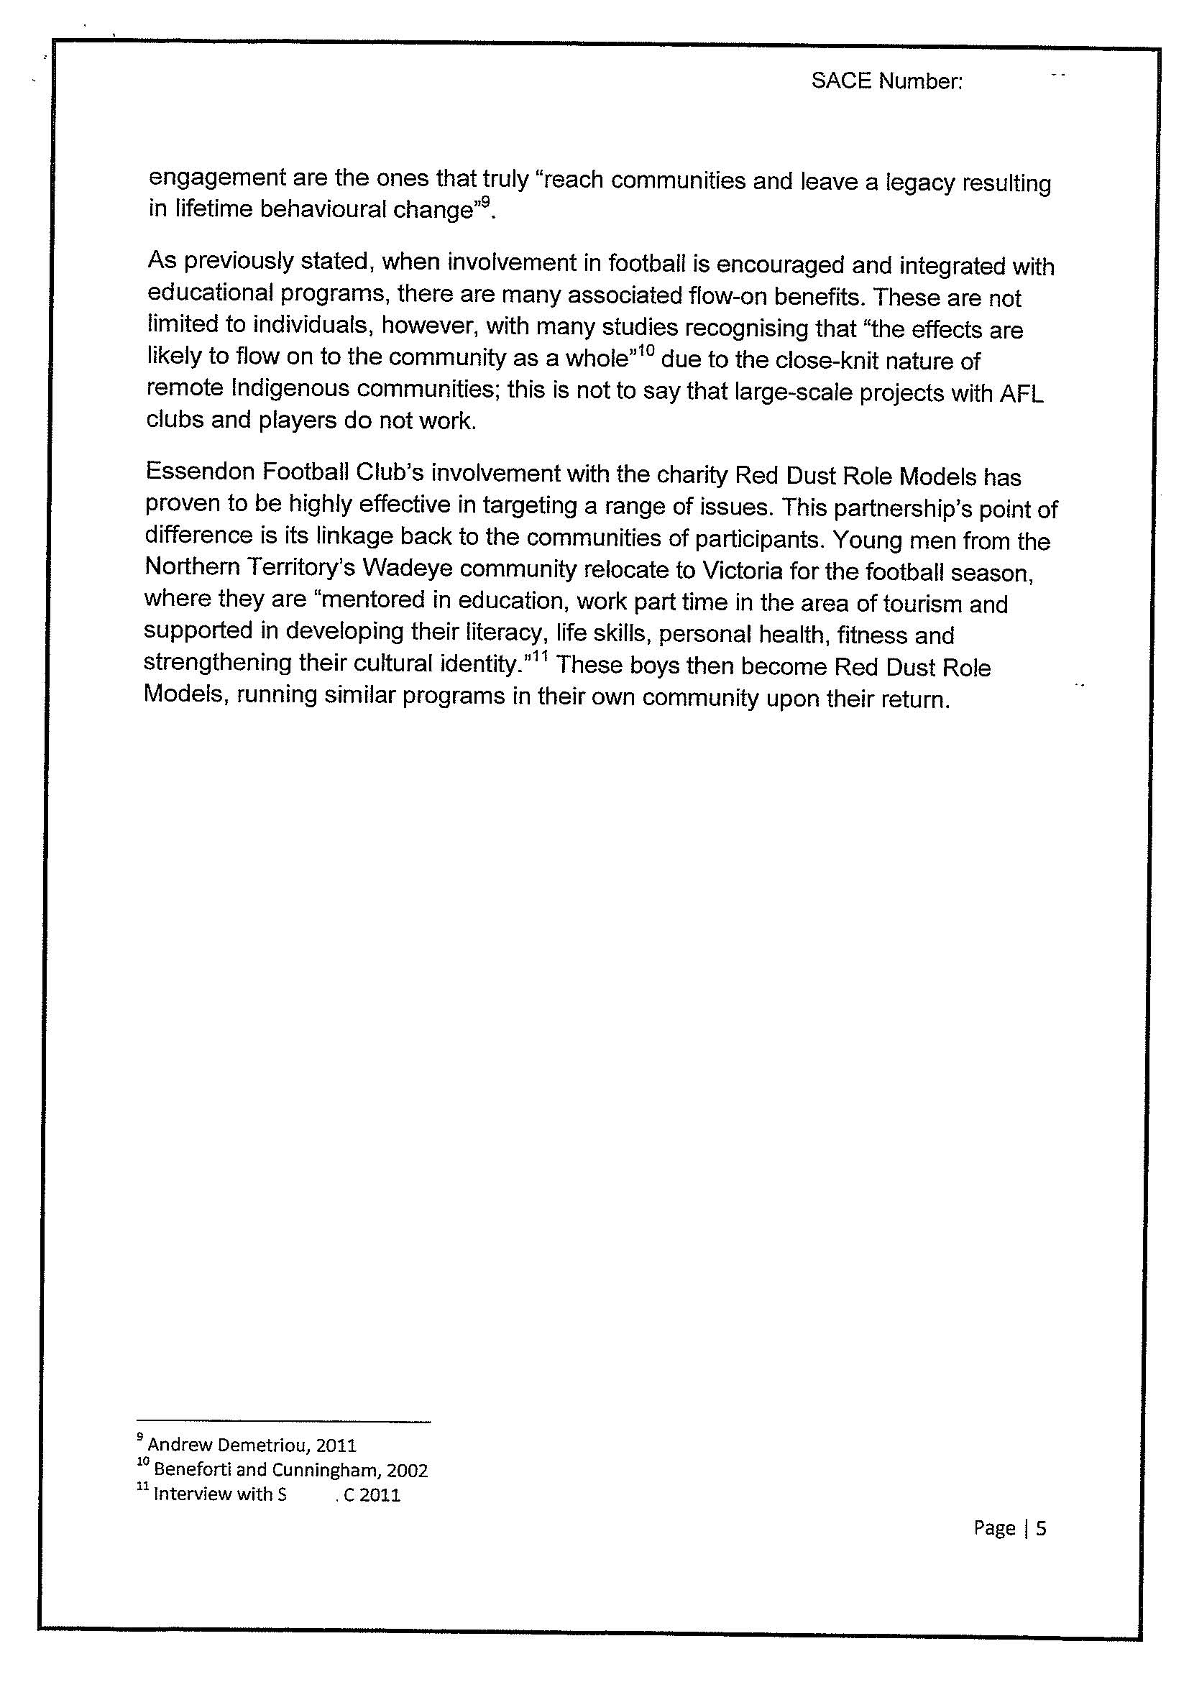

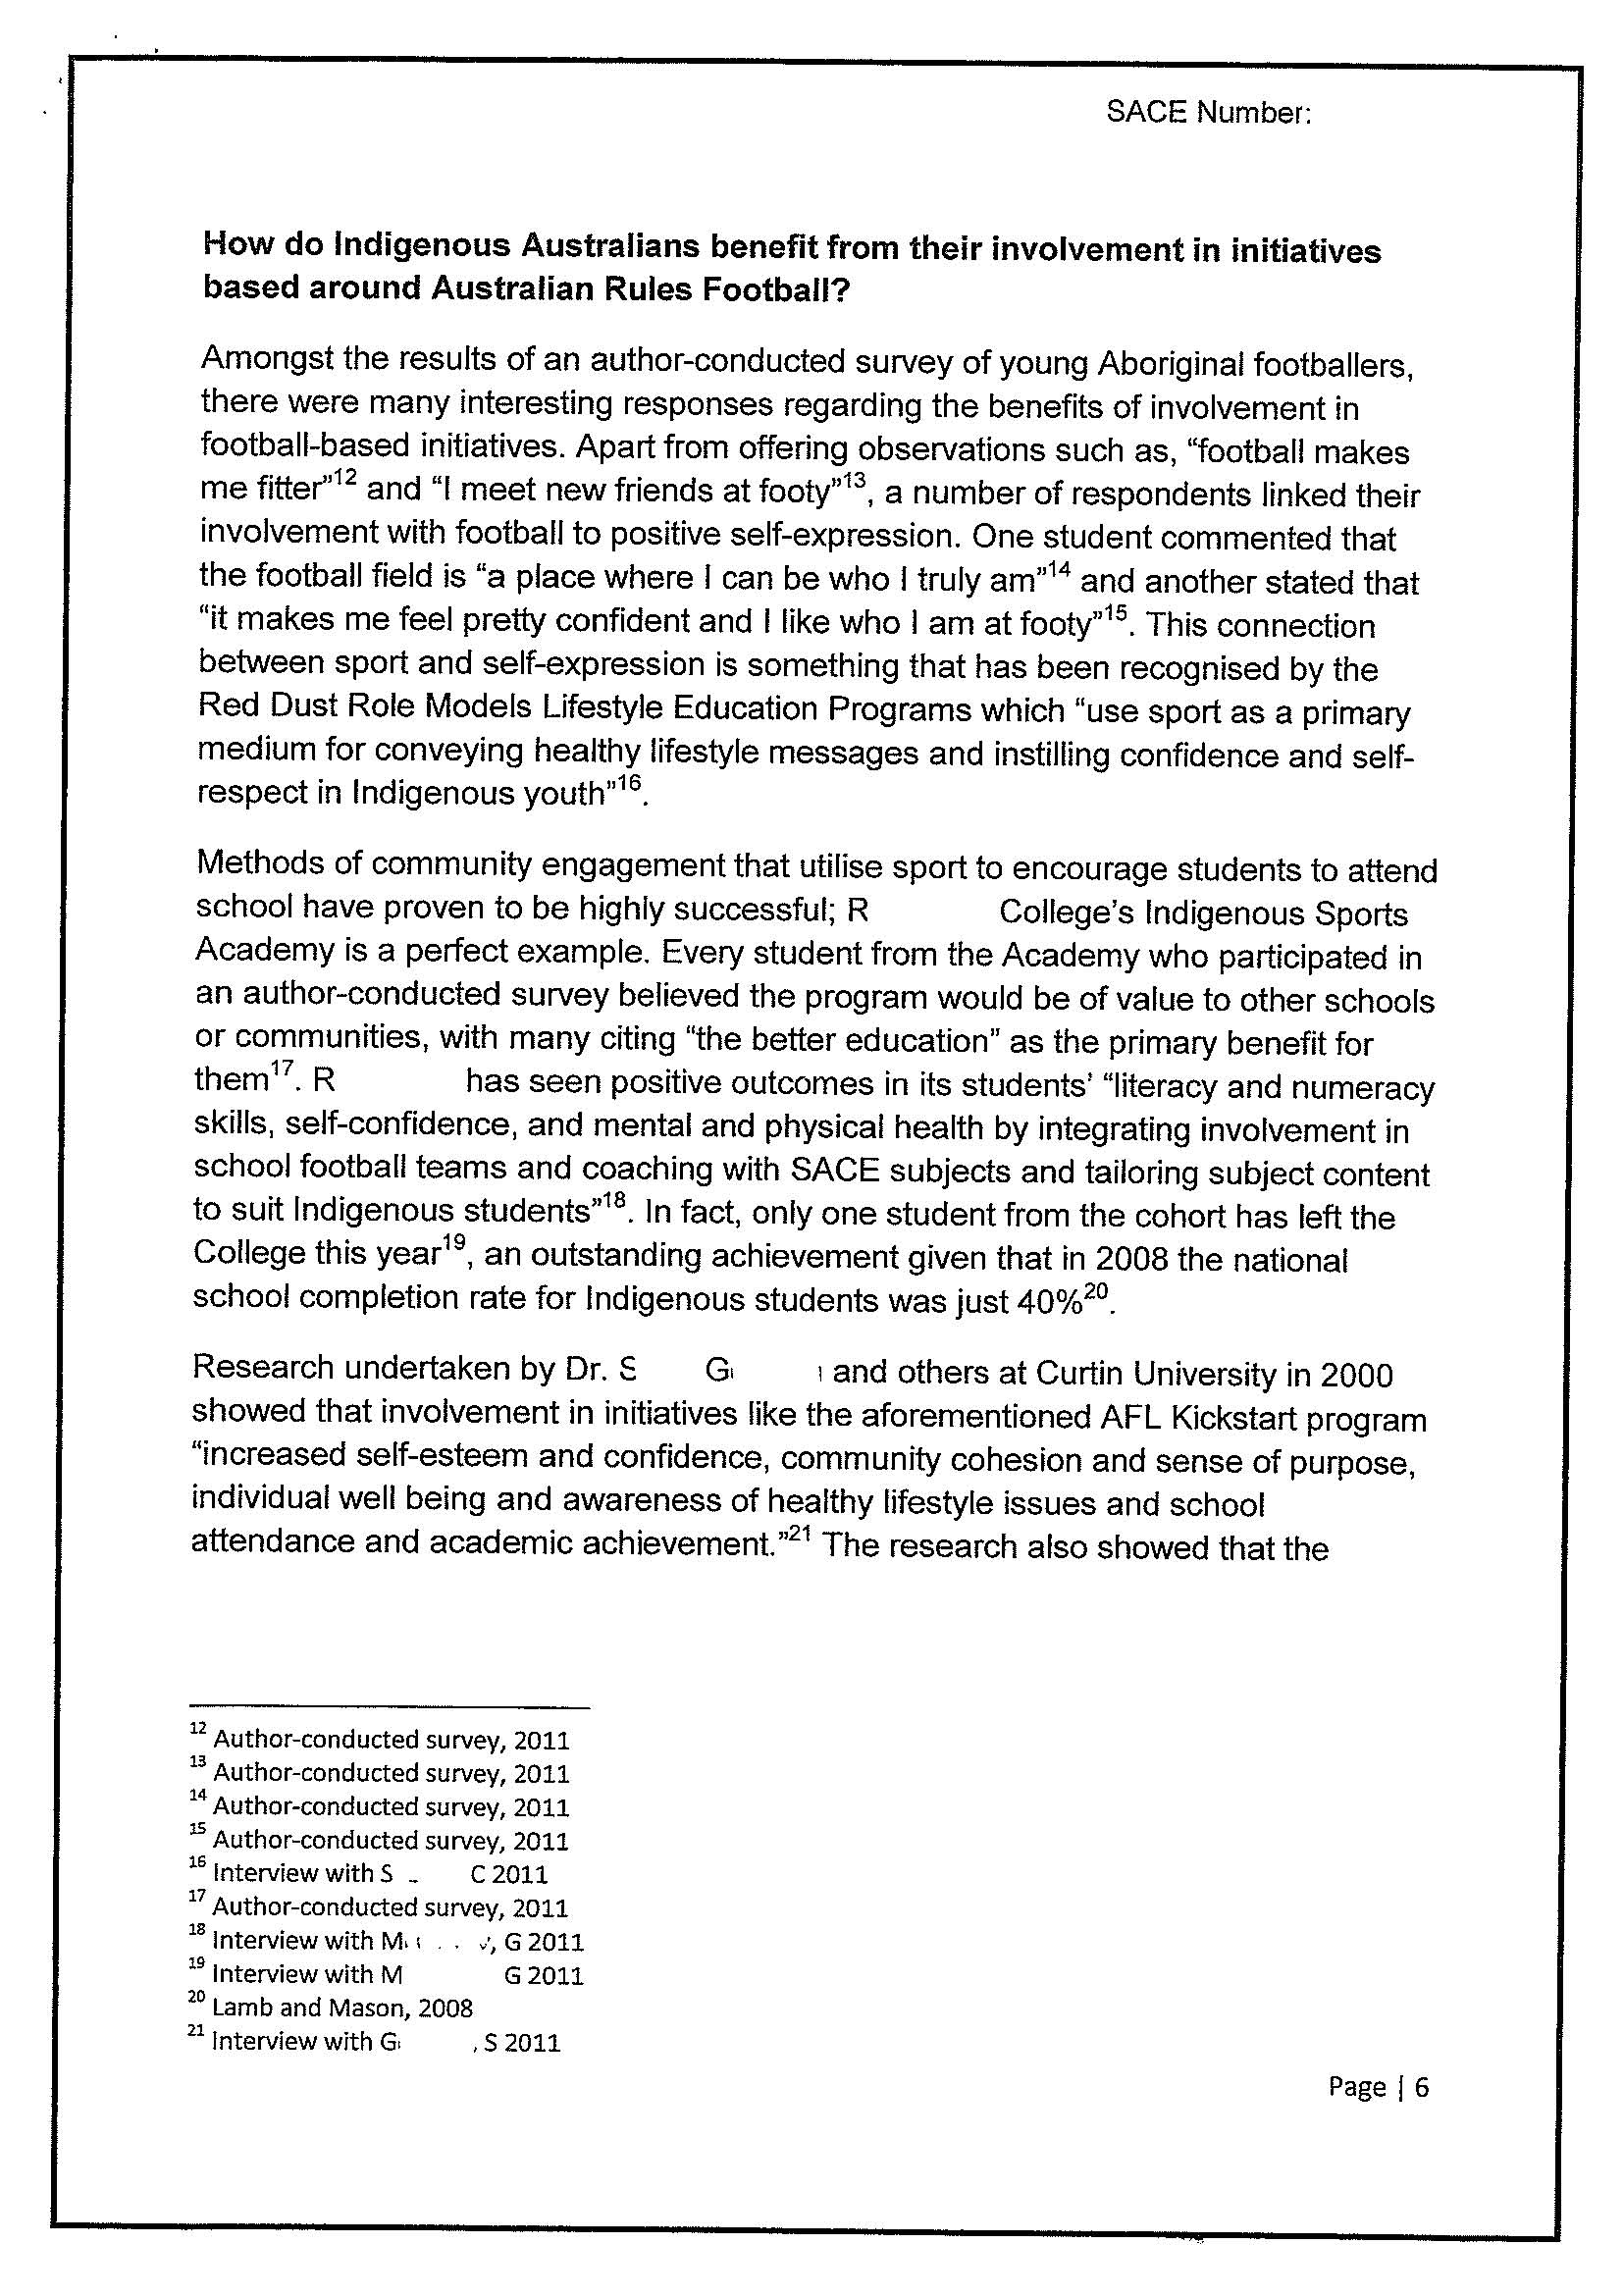

Comments
From the start of the investigation this response demonstrates use of a variety of sources and perspectives.

On page 4, the response clearly shows a perceptive understanding of a variety of ways in which societies and cultures are interconnected and interdependent. There is in depth knowledge of some of the issues that Indigenous communities have to deal with and an exploration of ways in which these issues can be addressed.

The response clearly explains the links between Indigenous culture and wider society and explains the way in which the Auskick program works. Each claim or statement is well supported with appropriate referencing.

The response explores a range of perspectives of the programs (interpersonal skills, self-awareness, community involvement and long term career opportunities). These are communicated concisely and in a thorough way. On page 5, the response goes on to explain that to be successful there must be integration of football and educational programs, showing a good understanding of the links between culture and social change and the causes of change.

Focus question 2 explores and supports the initial exploration of the benefits of the football program using authentic primary sources. Again there are perspectives explored beyond football e.g. the success of the SACE and school retention for the college’s Indigenous students. Authoritative sources (e.g. Curtin Uni) are used to back up the student’s claims. There is evidence of incisive and coherent communication of informed ideas about societies and social and cultural issues.

On page 8, the response clearly evaluates the football programs and asks what else can be done. There is evidence of perceptive understanding of a variety of ways in which societies and cultures are interconnected and interdependent.

The use of focus questions and coherent analysis related to each question provides evidence of a focussed investigation and an insightful analysis of a range of aspects and issues related to contemporary societies and culture in an Australian context at an A level.

The conclusion further demonstrates the high level of analysis where the findings are synthesised and the possible limitations of the investigation (last paragraph of page 9) are addressed. The response acknowledges that the football program is only part of a range of initiatives that are being undertaken to enhance the opportunities for Indigenous youth.

All sources used are Australian, appropriate and contemporary.

Overall grade A+.

Performance Standards for Stage 2 Society and Culture – Investigation
 | Knowledge and Understanding | Investigation and Analysis | Collaboration | Evaluation and Communication
A | In-depth knowledge and perceptive understanding of a range of aspects of and issues related to contemporary societies and cultures, in local and global contexts.  In-depth knowledge and understanding of the nature and causes of social change.  Perceptive understanding of a variety of ways in which societies and cultures are connected and interdependent. | Focused investigation and insightful analysis of a range of aspects and issues related to contemporary societies and cultures, in local and global contexts.  Focused investigation and well-informed and critical analysis of ways in which power structures operate in societies. | Productive and inclusive planning and evaluation of collaborative social action related to an inquiry in a chosen topic.  Insightful and well-informed collaborative social action.  Constructive and well-focused individual contribution to group activities. | Insightful and focused evaluation and use of evidence from a range of sources and perspectives, with appropriate acknowledgment of sources.  Incisive and coherent communication of informed ideas about societies and social and cultural issues.
B | Some depth in knowledge and well-informed understanding of a range of aspects of and issues related to contemporary societies and cultures, in local and global contexts.  Some depth in knowledge and understanding of the nature and causes of social change.  Well-considered understanding of a variety of ways in which societies and cultures are connected and interdependent. | Well-organised investigation and well-considered analysis of a range of aspects and issues related to contemporary societies and cultures, in local and global contexts.  Well-organised investigation and informed and critical analysis of ways in which power structures operate in societies. | Productive planning and evaluation of collaborative social action related to an inquiry in a chosen topic.  Well-organised and informed collaborative social action.  Considered and active individual contribution to group activities. | Well-considered and informed evaluation and use of evidence from a range of sources and perspectives, with appropriate acknowledgment of sources.  Thoughtful and clear communication of informed ideas about societies and social and cultural issues.
C | Some detailed knowledge and informed understanding of different aspects of and issues related to contemporary societies and cultures, in local and global contexts.  Some detailed knowledge and understanding of the nature and causes of social change.  Considered understanding of some of the ways in which societies and cultures are connected and interdependent. | Generally organised investigation and considered analysis of different aspects of and issues related to contemporary societies and cultures, in local and global contexts.  Generally organised investigation and informed analysis of one or more ways in which power structures operate in societies. | Competent planning and evaluation of collaborative social action related to an inquiry in a chosen topic.  Generally organised and informed collaborative social action.  Appropriate individual contribution to group activities. | Evaluation and use of evidence from a range of sources and perspectives, with mostly appropriate acknowledgment of sources.  Competent communication of informed ideas about societies and social and/or cultural issues.
D | Identification and awareness of some aspects of and/or issues related to contemporary societies and cultures, in local and/or global contexts.  Some recognition and awareness of the causes of social change.  Identification and awareness of some of the ways in which societies and cultures are connected. | Partial investigation and description of some aspects of and/or issues related to contemporary societies or cultures, in local and global contexts.  Basic investigation and description of one of the ways in which power structures operate in societies. | Superficial contribution to planning and evaluation of collaborative social action related to an inquiry in a chosen topic.  Attempted engagement in collaborative social action.  Superficial individual contribution to group activities. | Superficial and limited use of evidence from easily accessible sources, with limited perspectives, and inconsistent acknowledgment of sources.  Communication of basic ideas about one or more social and/or cultural issues.
E | Some awareness of one or more aspects of or issues related to a contemporary society or culture, in a local or global context.  Limited awareness of any causes of social change.  Emerging awareness of one or more ways in which societies and cultures are connected. | Attempted investigation and brief description of an aspect of a contemporary society or culture, in a local or global context.  Emerging awareness of one of the ways in which power structures operate in societies. | Attempted contribution to planning and evaluation of collaborative social action related to an inquiry in a chosen topic.  Limited engagement in collaborative social action.  Limited individual contribution to group activities. | Attempted use of evidence from one or more easily accessible sources, with limited acknowledgment of sources.  Attempted communication about one or more social and/or cultural issues.

