STAGE 2 SOCIETY AND CULTURE
ASSESSMENT TYPE 3: INVESTIGATION
RESPONSE 1

Issue: To what extent does the media influence the Australian public’s perception of the justice system?

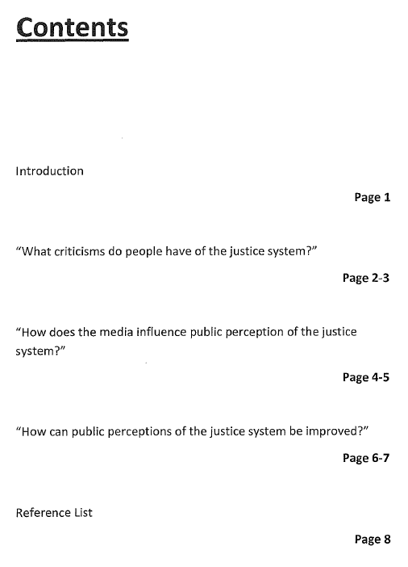
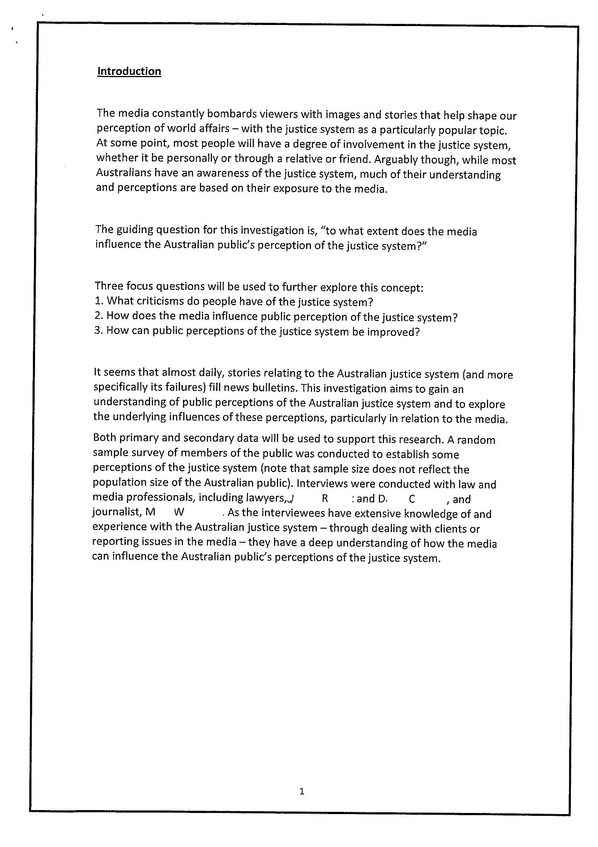
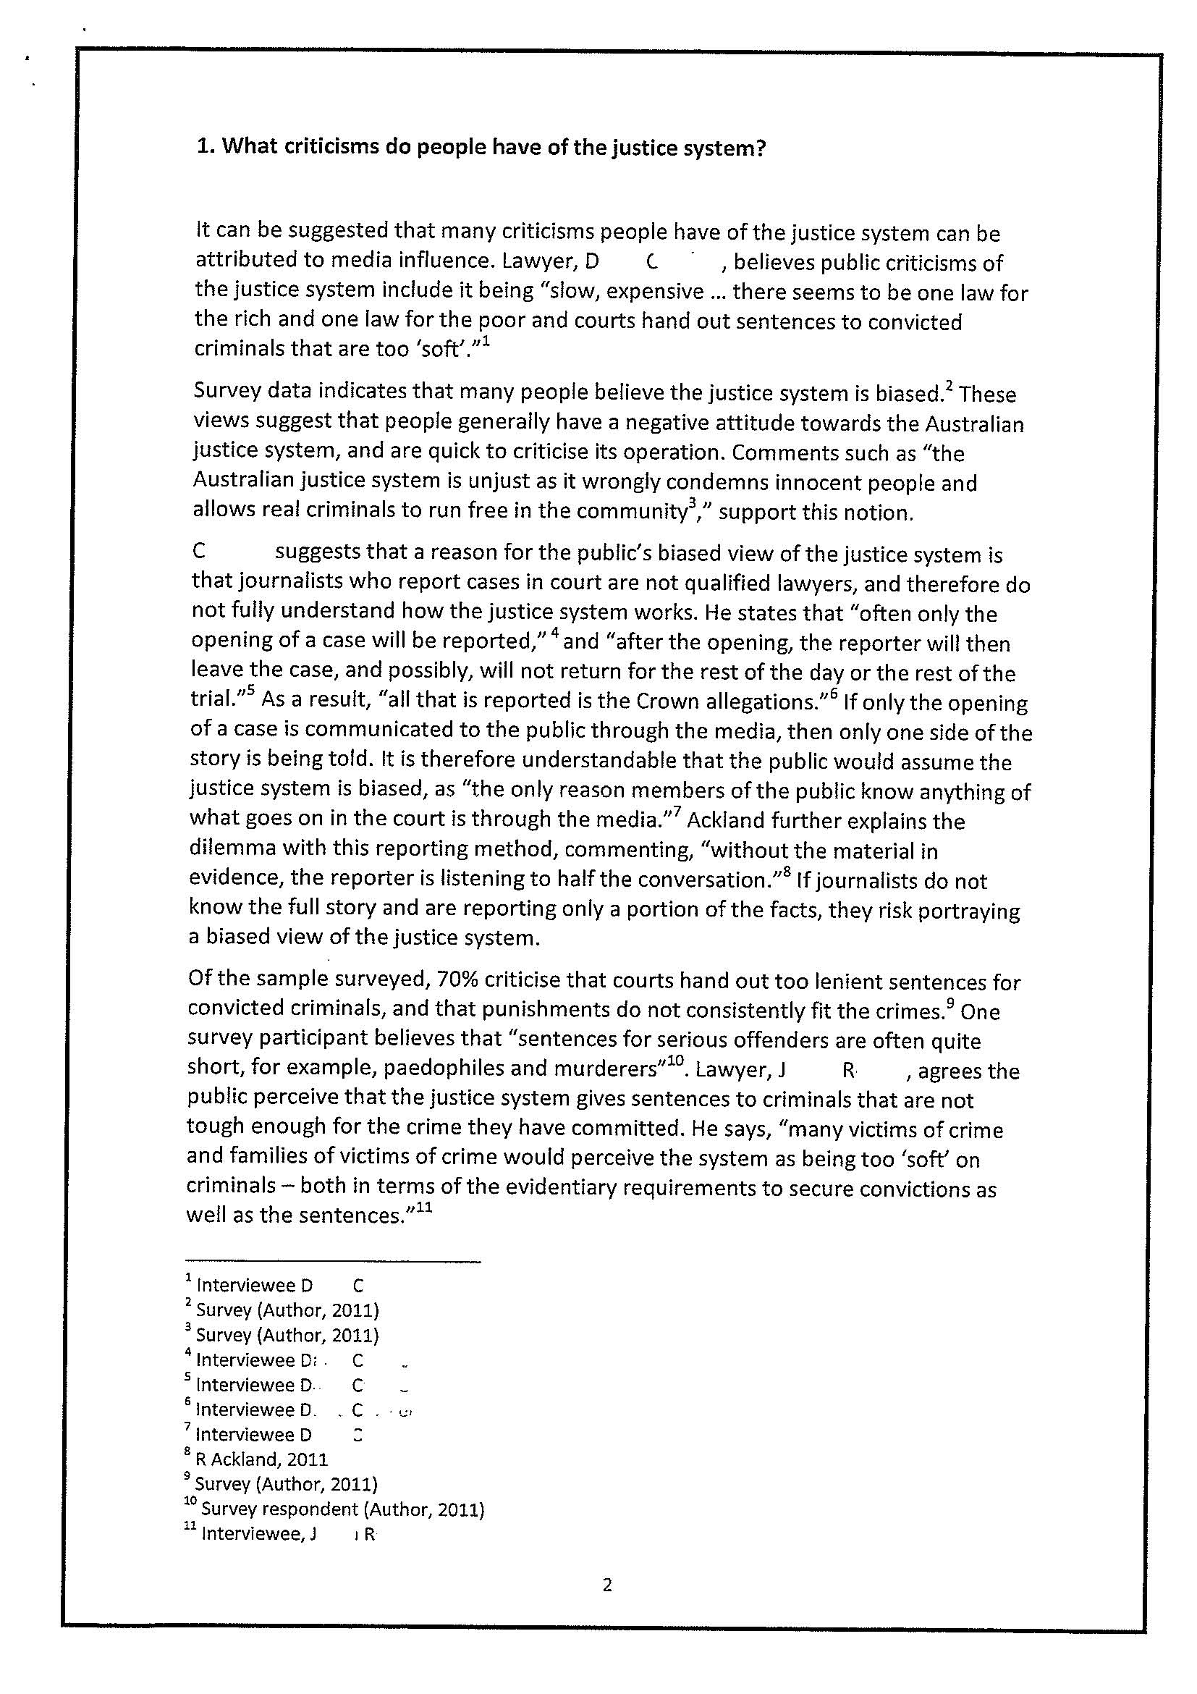
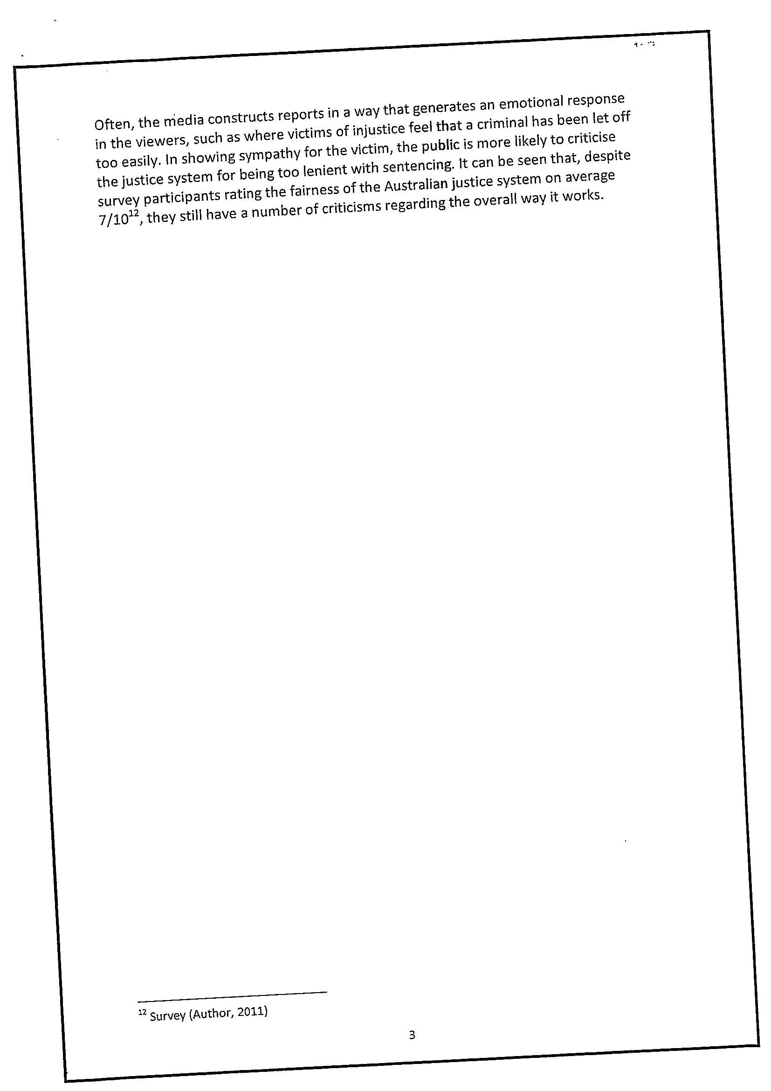
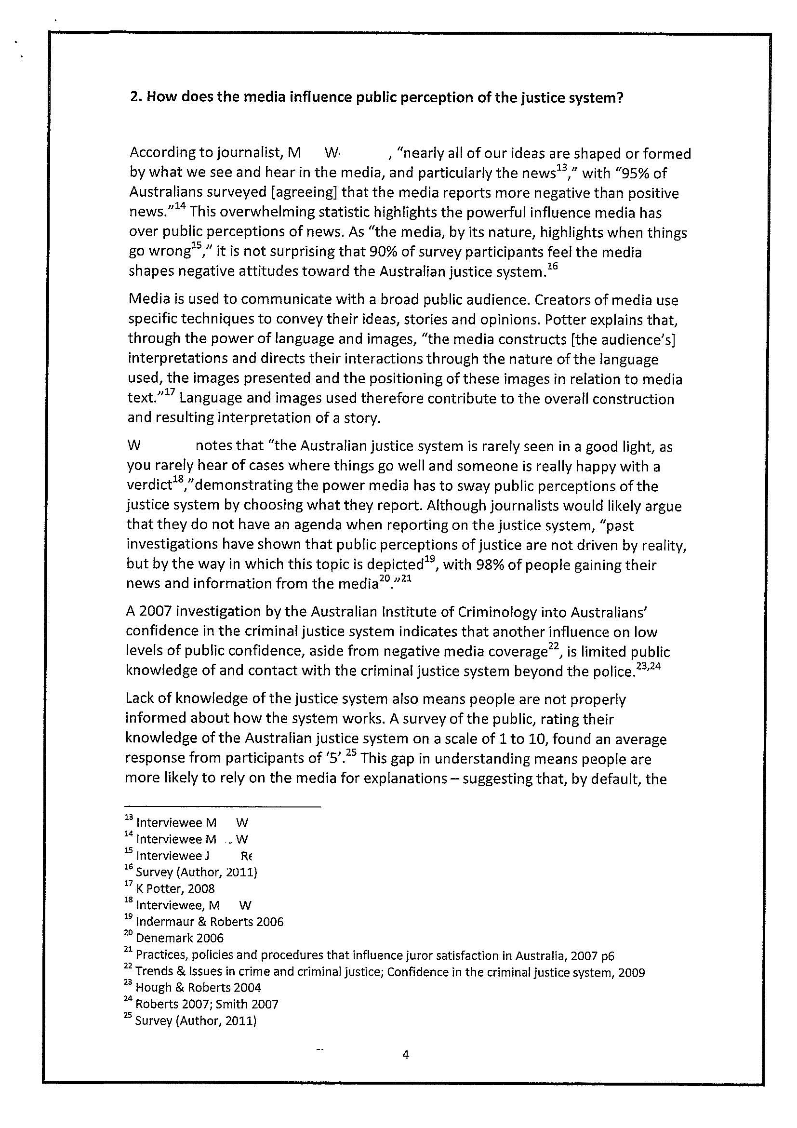
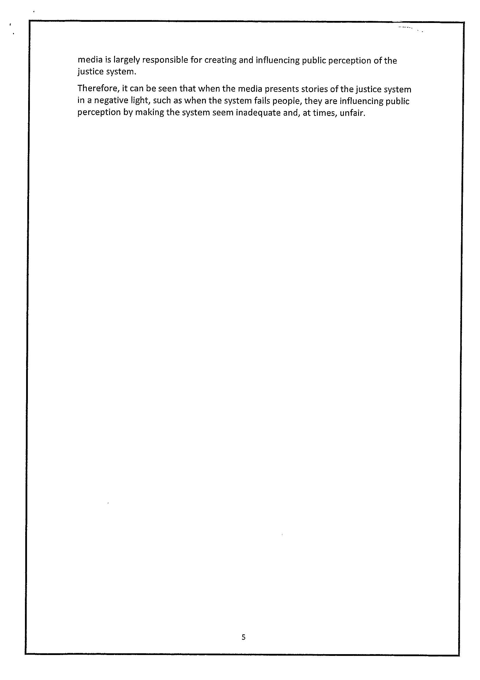
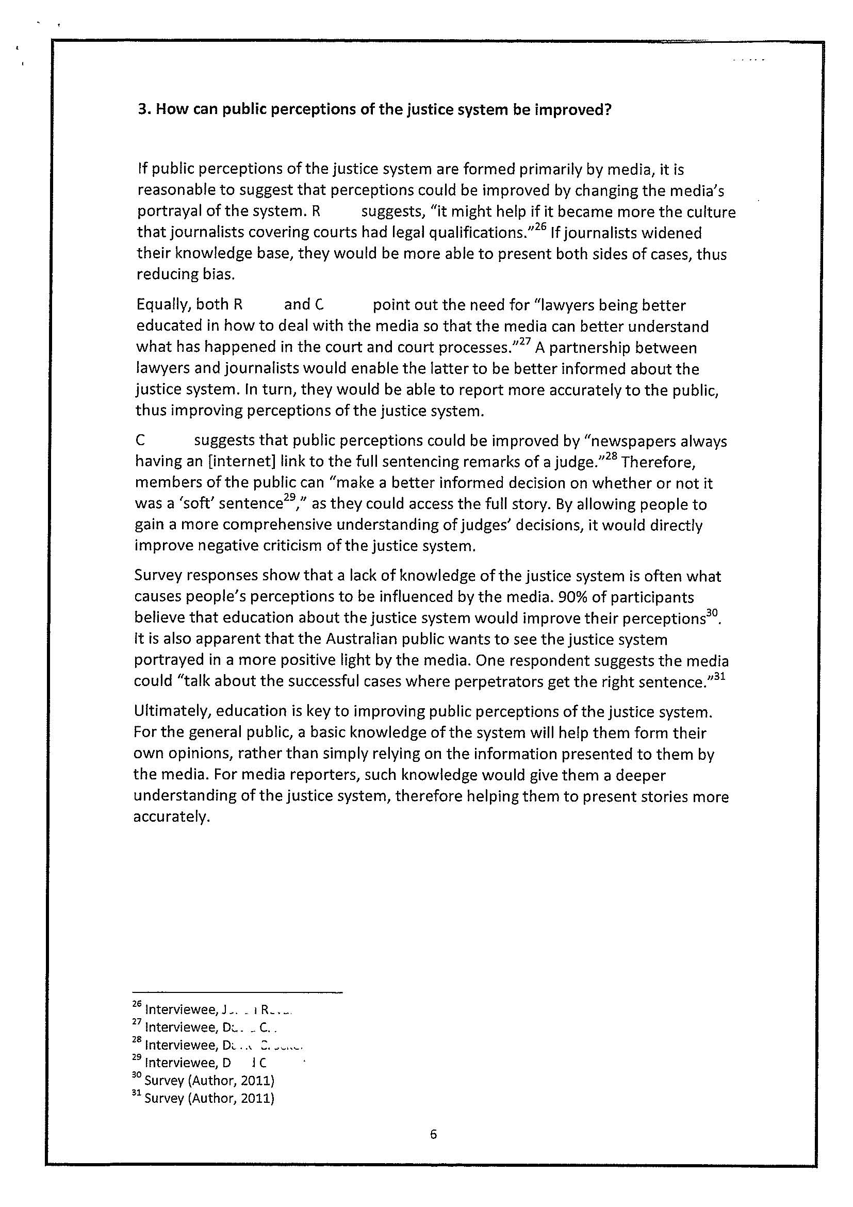
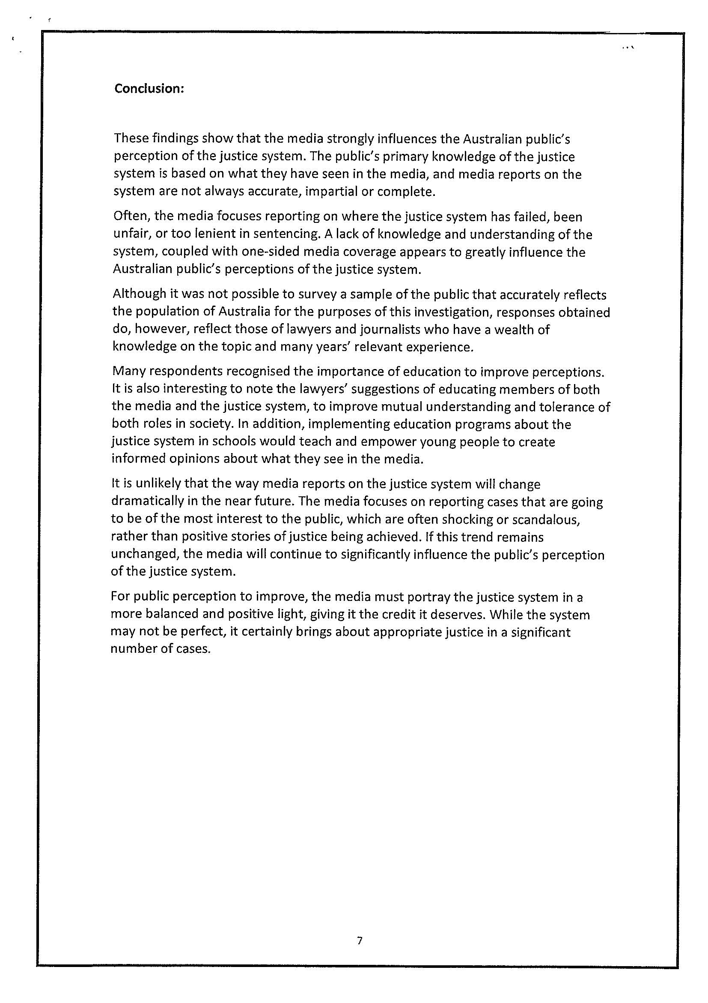
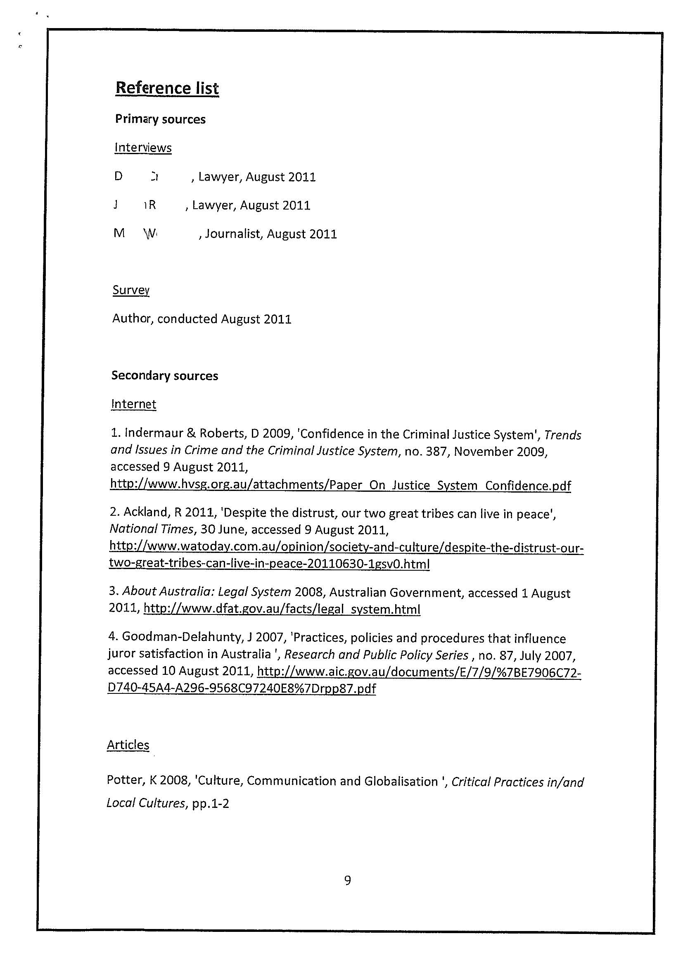
Comments

The choice of this topic for investigation shows perceptiveness about social issues, given that there have been several recent cases where there has been public concern over the way that individuals and “gangs” have been treated by the justice system. The media coverage supported a demand for justice to be seen to be done.

The evidence of knowledge and understanding ranges from being insightful and perceptive, to being well informed. There is evidence of well considered evaluation of sources of information. Despite the statement that the survey has been conducted on a random sample of the population we do not know if the sample consists of adults or not. As a consequence the data quoted is vague e.g. “Many people believe that the justice system is biased” and “the survey participants rating the fairness of justice system as 7/10”. (How many? All?) On page 5 there is another reference to “an average response” from survey participants. However, at times, the response does quote percentages of respondents and often backs up the information with quotes from interviewees.

There is evidence of some depth of knowledge and understanding of the ways in which society and culture are interconnected and of the causes of social change. For example, pages 2 and 3; page 4 and page 6.

The conclusion provides well considered evaluation of the use of evidence from a range of sources that have been appropriately acknowledged and there is acknowledgement of the limitations of the investigation.

Throughout the investigation there is evidence of insightful analysis of aspects and issues such as media bias and the influence of this bias on the public’s perception. In addition, the response discusses the public’s lack of knowledge of the law; the role of education; views of victims of crimes; selective reporting of news; public confidence in the criminal justice system; public reliance on media; and better partnerships between lawyers and the media etc.

The evidence is generally thoughtful and well considered.

Overall grade B+.

Performance Standards for Stage 2 Society and Culture – Investigation
 | Knowledge and Understanding | Investigation and Analysis | Collaboration | Evaluation and Communication
A | In-depth knowledge and perceptive understanding of a range of aspects of and issues related to contemporary societies and cultures, in local and global contexts.  In-depth knowledge and understanding of the nature and causes of social change.  Perceptive understanding of a variety of ways in which societies and cultures are connected and interdependent. | Focused investigation and insightful analysis of a range of aspects and issues related to contemporary societies and cultures, in local and global contexts.  Focused investigation and well-informed and critical analysis of ways in which power structures operate in societies. | Productive and inclusive planning and evaluation of collaborative social action related to an inquiry in a chosen topic.  Insightful and well-informed collaborative social action.  Constructive and well-focused individual contribution to group activities. | Insightful and focused evaluation and use of evidence from a range of sources and perspectives, with appropriate acknowledgment of sources.  Incisive and coherent communication of informed ideas about societies and social and cultural issues.
B | Some depth in knowledge and well-informed understanding of a range of aspects of and issues related to contemporary societies and cultures, in local and global contexts.  Some depth in knowledge and understanding of the nature and causes of social change.  Well-considered understanding of a variety of ways in which societies and cultures are connected and interdependent. | Well-organised investigation and well-considered analysis of a range of aspects and issues related to contemporary societies and cultures, in local and global contexts.  Well-organised investigation and informed and critical analysis of ways in which power structures operate in societies. | Productive planning and evaluation of collaborative social action related to an inquiry in a chosen topic.  Well-organised and informed collaborative social action.  Considered and active individual contribution to group activities. | Well-considered and informed evaluation and use of evidence from a range of sources and perspectives, with appropriate acknowledgment of sources.  Thoughtful and clear communication of informed ideas about societies and social and cultural issues.
C | Some detailed knowledge and informed understanding of different aspects of and issues related to contemporary societies and cultures, in local and global contexts.  Some detailed knowledge and understanding of the nature and causes of social change.  Considered understanding of some of the ways in which societies and cultures are connected and interdependent. | Generally organised investigation and considered analysis of different aspects of and issues related to contemporary societies and cultures, in local and global contexts.  Generally organised investigation and informed analysis of one or more ways in which power structures operate in societies. | Competent planning and evaluation of collaborative social action related to an inquiry in a chosen topic.  Generally organised and informed collaborative social action.  Appropriate individual contribution to group activities. | Evaluation and use of evidence from a range of sources and perspectives, with mostly appropriate acknowledgment of sources.  Competent communication of informed ideas about societies and social and/or cultural issues.
D | Identification and awareness of some aspects of and/or issues related to contemporary societies and cultures, in local and/or global contexts.  Some recognition and awareness of the causes of social change.  Identification and awareness of some of the ways in which societies and cultures are connected. | Partial investigation and description of some aspects of and/or issues related to contemporary societies or cultures, in local and global contexts.  Basic investigation and description of one of the ways in which power structures operate in societies. | Superficial contribution to planning and evaluation of collaborative social action related to an inquiry in a chosen topic.  Attempted engagement in collaborative social action.  Superficial individual contribution to group activities. | Superficial and limited use of evidence from easily accessible sources, with limited perspectives, and inconsistent acknowledgment of sources.  Communication of basic ideas about one or more social and/or cultural issues.
E | Some awareness of one or more aspects of or issues related to a contemporary society or culture, in a local or global context.  Limited awareness of any causes of social change.  Emerging awareness of one or more ways in which societies and cultures are connected. | Attempted investigation and brief description of an aspect of a contemporary society or culture, in a local or global context.  Emerging awareness of one of the ways in which power structures operate in societies. | Attempted contribution to planning and evaluation of collaborative social action related to an inquiry in a chosen topic.  Limited engagement in collaborative social action.  Limited individual contribution to group activities. | Attempted use of evidence from one or more easily accessible sources, with limited acknowledgment of sources.  Attempted communication about one or more social and/or cultural issues.

