

Product and Documentation

Stage 1
Information Processing and Publishing

Stage 1
SACE
Contents

Investigating 2

Devising 3&4

Producing 5

Evaluating 6

Bibliography 7

Investigating

Product

The document to be produced is a menu for the Principal’s Dinner.

The specifications for the menu include:
- One A4 page – can be folded
- Written text (simplified)
- Appropriate font/size
- Appropriate school logo
- Appropriate graphics.

Audience

Cammy’s Cafe Menu

Front Page
- Large graphic gives good idea of what they sell
- Big writing is clear
- Mainly done without capital letters
- I like the colours

Inside Pages
- Keeps colour scheme the same
- Prices nicely lined up
- Clear headings

Back cover
Understanding
Demonstrates understanding of the basic layout principles. However, does not use terminology appropriate to design principles i.e. contrast, repetition, alignment and proximity, when identifying effective elements to be used or avoided in the final product.
- Not much info on there

Fred’s Food Menu

Front Page
- Photo shows it is a classy cafel
- Writing doesn’t show up on photo

Inside Pages
- I like this colour scheme too
- Prices down the left is different
- Clear headings

Back cover
- Drinks listed here
- Another classy photo
- Same colour scheme as inside
Pg 2
Devising

Font ideas

Alba black 25 pt
Aardvark café 20 pt red or 36 pt
Aardvark café 20 pt Yellow or 12 pt
Application
Demonstrates some application of elements of the design process and layout principles by providing examples of font size and colour.
BIP purple 20 pt
Caflisch Script Pro Regular purple 20 pt
French Script MT pink 20 pt

Colour ideas
Red: 255
Green: 56
Blue: 0
Red: 0
Green: 51
Blue: 204
Red: 255
Green: 255
Blue: 0
Red: 13
Green: 143
Blue: 0

Software
MS Word 97-2003
Application
Demonstrates an understanding of choosing the appropriate software for the task.

MS Publisher 2003

Adobe Photoshop CS3

Layout idea
Application
Demonstrates competent application of the design process and layout principles appropriate to the task.
Understanding
Demonstrates informed understanding of the devising section of the design process by producing annotated design plans, more detail needed about fonts used.
Front and back cover
Front page

College logo

Back
page
Application
Shows competent application of layout principles for front and back cover e.g. use of space, balance and relevant graphics.

blue background
college logo
xxxxxxxxxxxxxxxxxxxxxxxx
SACE College principal’s dinner-aardvark café red 20pt

Picture of principal
Menu- yellow 36pt
Inside

xxxx
xxxxxxxxxxxxxxxxxxxxxxxxxxxxxxxxxxxxxxxxxxxxxxxxxxxxxxxxxxxxxxxxxxxxxxxxxxxxxxxxxxxxxxxxxxxxxxxxxxxxxxxxxxxxxxxxxxxxxxxxxxxxxxxxxxxxxxxxxxxxxxxxxxxxxxxxxxxxxxxxxxxxxxxxxxxxxxxxxxxxxxxxxx
Application
Demonstrates some application of elements of layout principles e.g. provides alignment of text blocks and placement of pictures but not a balanced design overall.

blue background
xxxx
Food-yellow 12pt
Beverages-yellow 12pt
Pictures of students
Program-yellow 12pt
xxxxxxxxxxxxxxxxxxxxxxxxxxxxxxxxxxxxxxxxxxxxxxxxxxxxxxxxxxxxxxxxxxxxxxxxxxxxxxxxxxxxxxxxxxxxxxxxxxxxxxxxxxxxxxxxxxxxxxxxxxxxxxxxxxxxxxxxxxxxxxxxxxxxxxxxxxxxxxxxxxxxxxxxxxxxxxxxxxxxxxxxxx
Pg 4
Producing

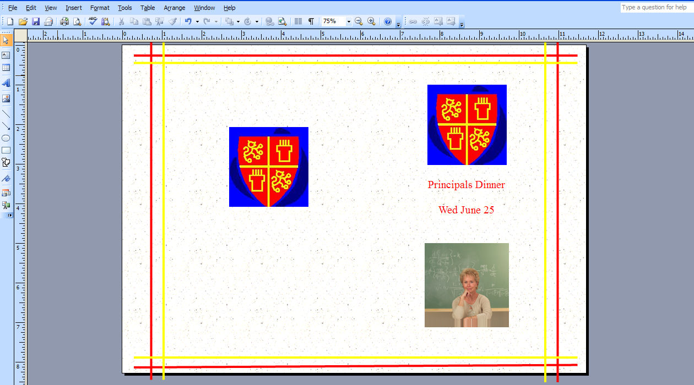

Application
Screen shot demonstrates competent application of:
- appropriate hardware and software i.e. Publisher
- effective application of manipulative skills appropriate to the use of Publisher
- the design process and layout principles i.e. contrast, repetition, alignment and proximity
- acquired skills to produce front and back page of menu accurately.

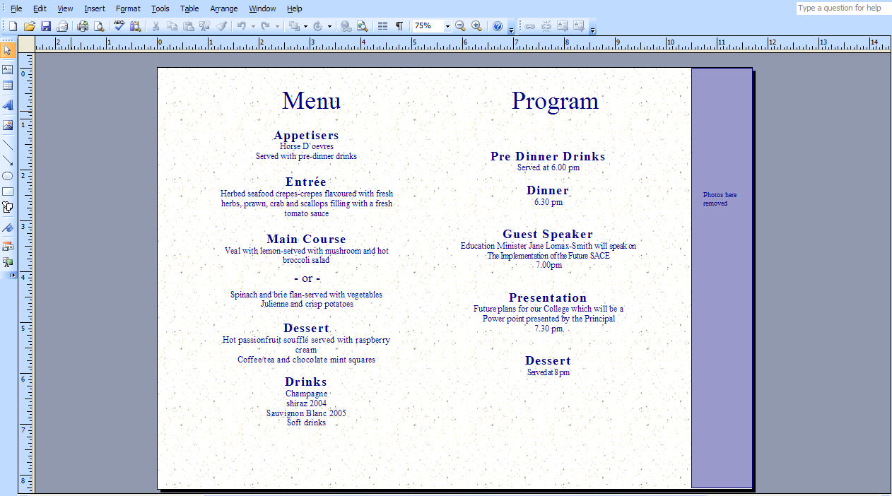

Application
Displays some acquired skills to produce the menu with some inconsistencies e.g., ‘Drinks’ heading a different sized font to ‘Menu’ heading, spelling errors.

Pg 5
Evaluating
Back page

The aim of this assignment was to design and create a menu for the Principal’s dinner.

I looked at a couple of menus and found some things I didn’t like and some things I did especially consistent clear colour schemes and big clear writing on the front. This helped me to produce a good clear design plan showing both the inside and outside of the menu. It was such a good design plan that I used it to make my final product.

I had a few problems with my menu such as colour choices, pictures and layout. I overcame most of these problems by changing my font size and colour and by coming up with a better layout plan. This gave better contrast on the inside page. I used centre alignment for the menu which looked really good.

If I had the chance to repeat this task I would create my menu completely different. I would use a different style of menu or use the same style but have each side of the page the same length.

Feedback
It’s really good but the text could be a bit clearer because it can be difficult to read.
Pg 6
Analysis and Evaluation
Provides some basic assessment of the task against some design principles in the evaluation, using mostly description. More detailed reflection of the design principles needed e.g. used a bold colour for headings to highlight them (contrast and alignment), reference to the use of repetition and proximity.

Bibliography
Pg 7

Word count: 351 words

Performance Standards for Stage 1 Information Processing and Publishing
 | Understanding | Analysis and Evaluation | Application
A | Comprehensive understanding of the design process and layout principles as they relate to text-based tasks.  Insightful and well-informed understanding of the impact of social and/or ethical issues closely related to information-processing and publishing technologies. | Perceptive and thorough evaluation of a text-based product and the design process used.  Perceptive analysis and evaluation of the impact of social and/or ethical issues related to information-processing and publishing technologies. | Highly proficient application of appropriate hardware and software in the completion of text-based communication tasks.  Highly effective application of manipulative skills appropriate to the use of information-processing hardware and software.  Comprehensive application of the design process and layout principles appropriate to a text-based task.  Highly proficient application of acquired skills to produce text-based information accurately.
B | Well-informed understanding of the design process and layout principles as they relate to text-based tasks.  Well-informed understanding of the impact of social and/or ethical issues related to information-processing and publishing technologies. | Well-considered evaluation of a text-based product and the design process used.  Well-considered analysis and evaluation of the impact of social and/or ethical issues related to information-processing and publishing technologies. | Proficient application of appropriate hardware and software in the completion of text-based communication tasks.  Effective application of manipulative skills appropriate to the use of information-processing hardware and software.  Well-considered application of the design process and layout principles appropriate to a text-based task.  Proficient application of acquired skills to produce text-based information accurately.
C | Informed understanding of the design process and layout principles as they relate to text-based tasks.  Informed understanding of the impact of social and/or ethical issues related to information-processing and publishing technologies. | Competent evaluation of a text-based product and the design process used.  Considered analysis and evaluation of the impact of social and/or ethical issues related to information-processing and publishing technologies. | Competent application of appropriate hardware and software in the completion of text-based communication tasks.  Generally consistent application of manipulative skills appropriate to the use of information-processing hardware and software.  Competent application of the design process and layout principles appropriate to a text-based task.  Competent application of acquired skills to produce text-based information accurately.
D | Some understanding of basic aspects of the design process and layout principles as they relate to text-based tasks.  Some recognition of the impact of social and/or ethical issues related to information-processing and publishing technologies. | Some basic assessment of a text-based product, with some reference to the design process, using mostly description.  Recognition of aspects of the impact of social or ethical issues related to information-processing and publishing technologies. | Application of some basic appropriate hardware and software in undertaking text-based communication tasks.  Some application of basic manipulative skills appropriate to the use of some information-processing hardware and software.  Some application of elements of the design process and layout principles appropriate to a text-based task.  Application of some acquired skills to produce some simple text-based information with some inconsistencies.
E | Identification of one or more aspects of the design process and layout principles as they relate to text-based tasks.  Emerging awareness of a social or ethical issue that may have little relationship to information-processing and publishing technologies. | Attempted description of aspects of a text-based product, with limited reference to the design process.  Emerging awareness of one or more aspects of the impact of a social or ethical issue related to information-processing and publishing technologies. | Limited application of basic hardware and software in attempting text-based communication tasks.  Limited application of simple manipulative skills in attempting to use some information-processing hardware or software.  Attempted application of few elements of the design process and layout principles appropriate to a text-based task.  Attempted application of one or more skills to produce elements of simple text-based information with limited accuracy.

