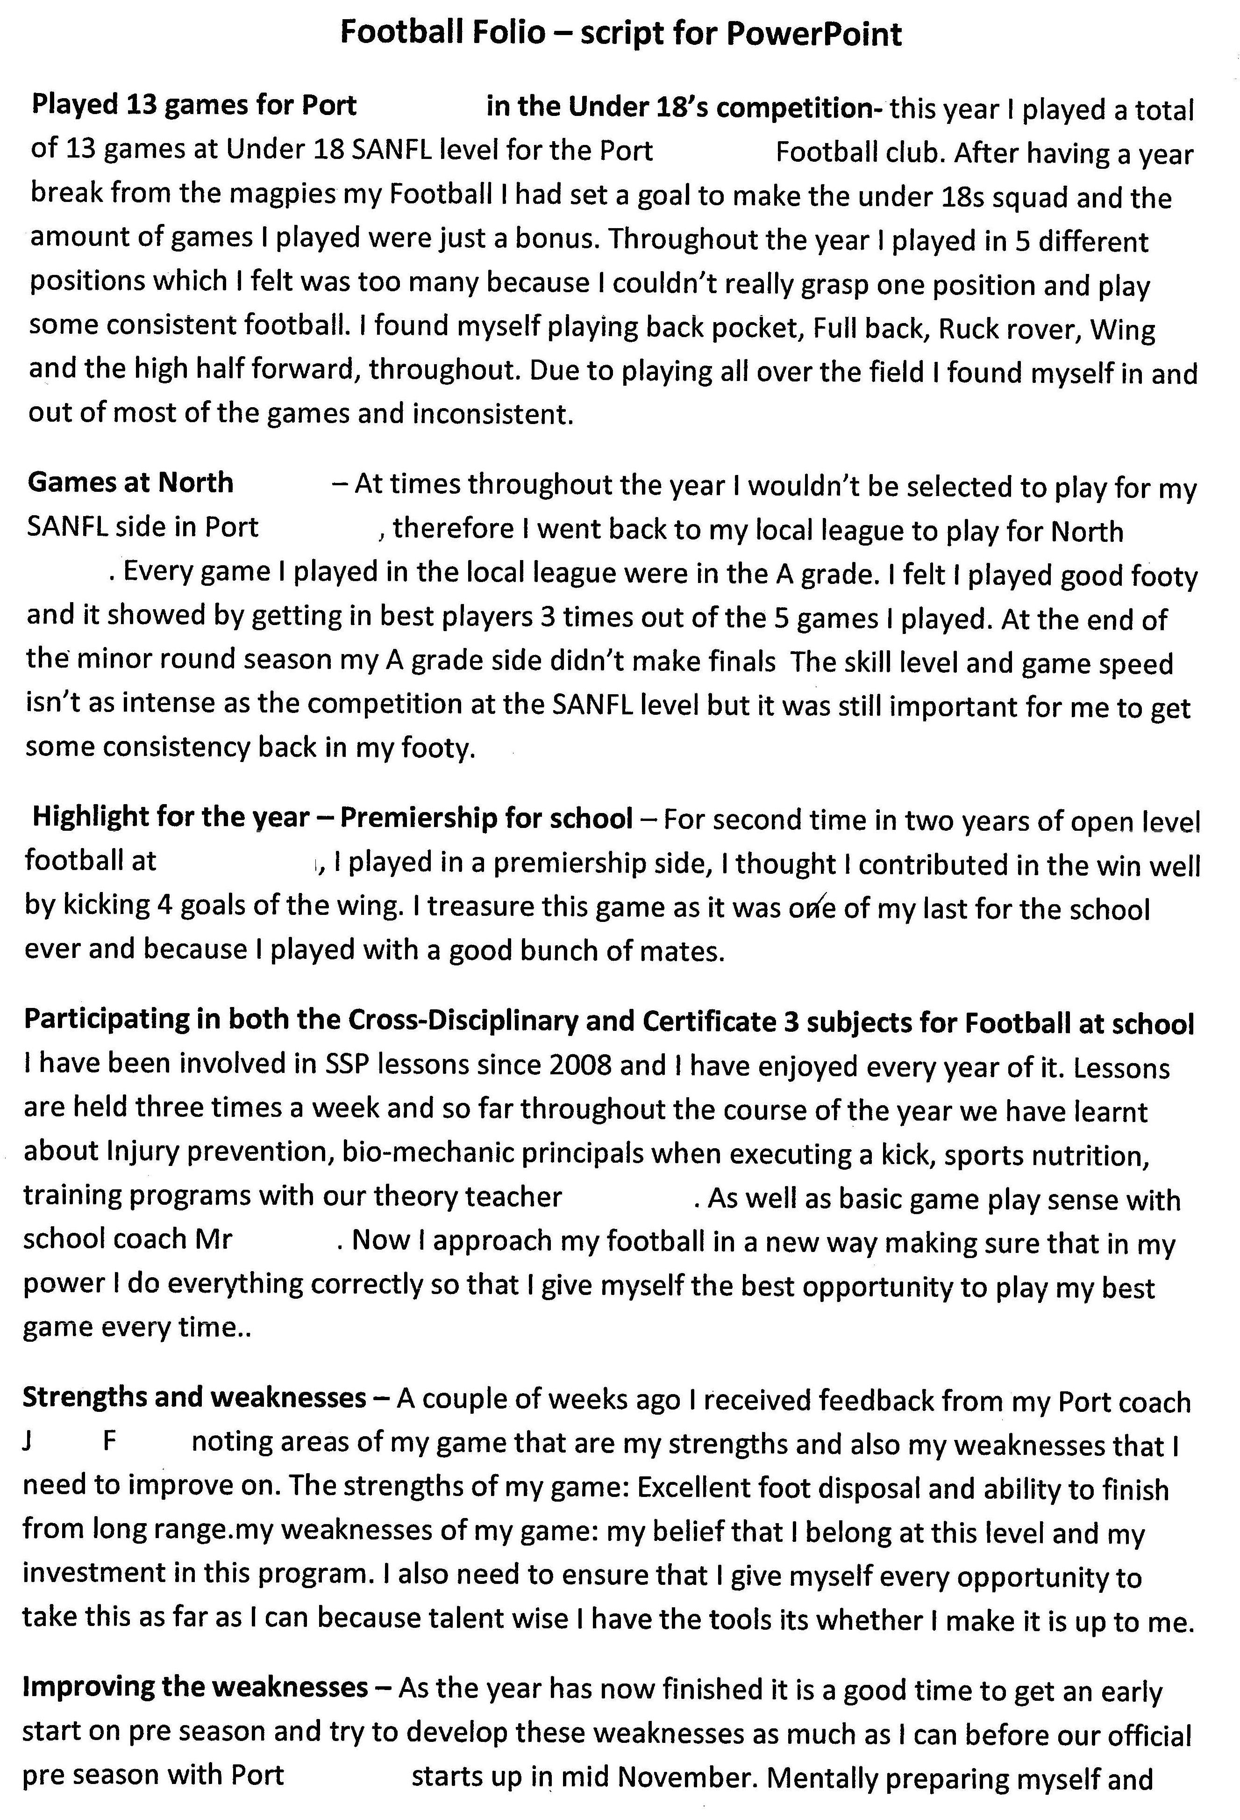
Stage 2 Cross-disciplinary Studies
Assessment Type 3: Presentation and Discussion

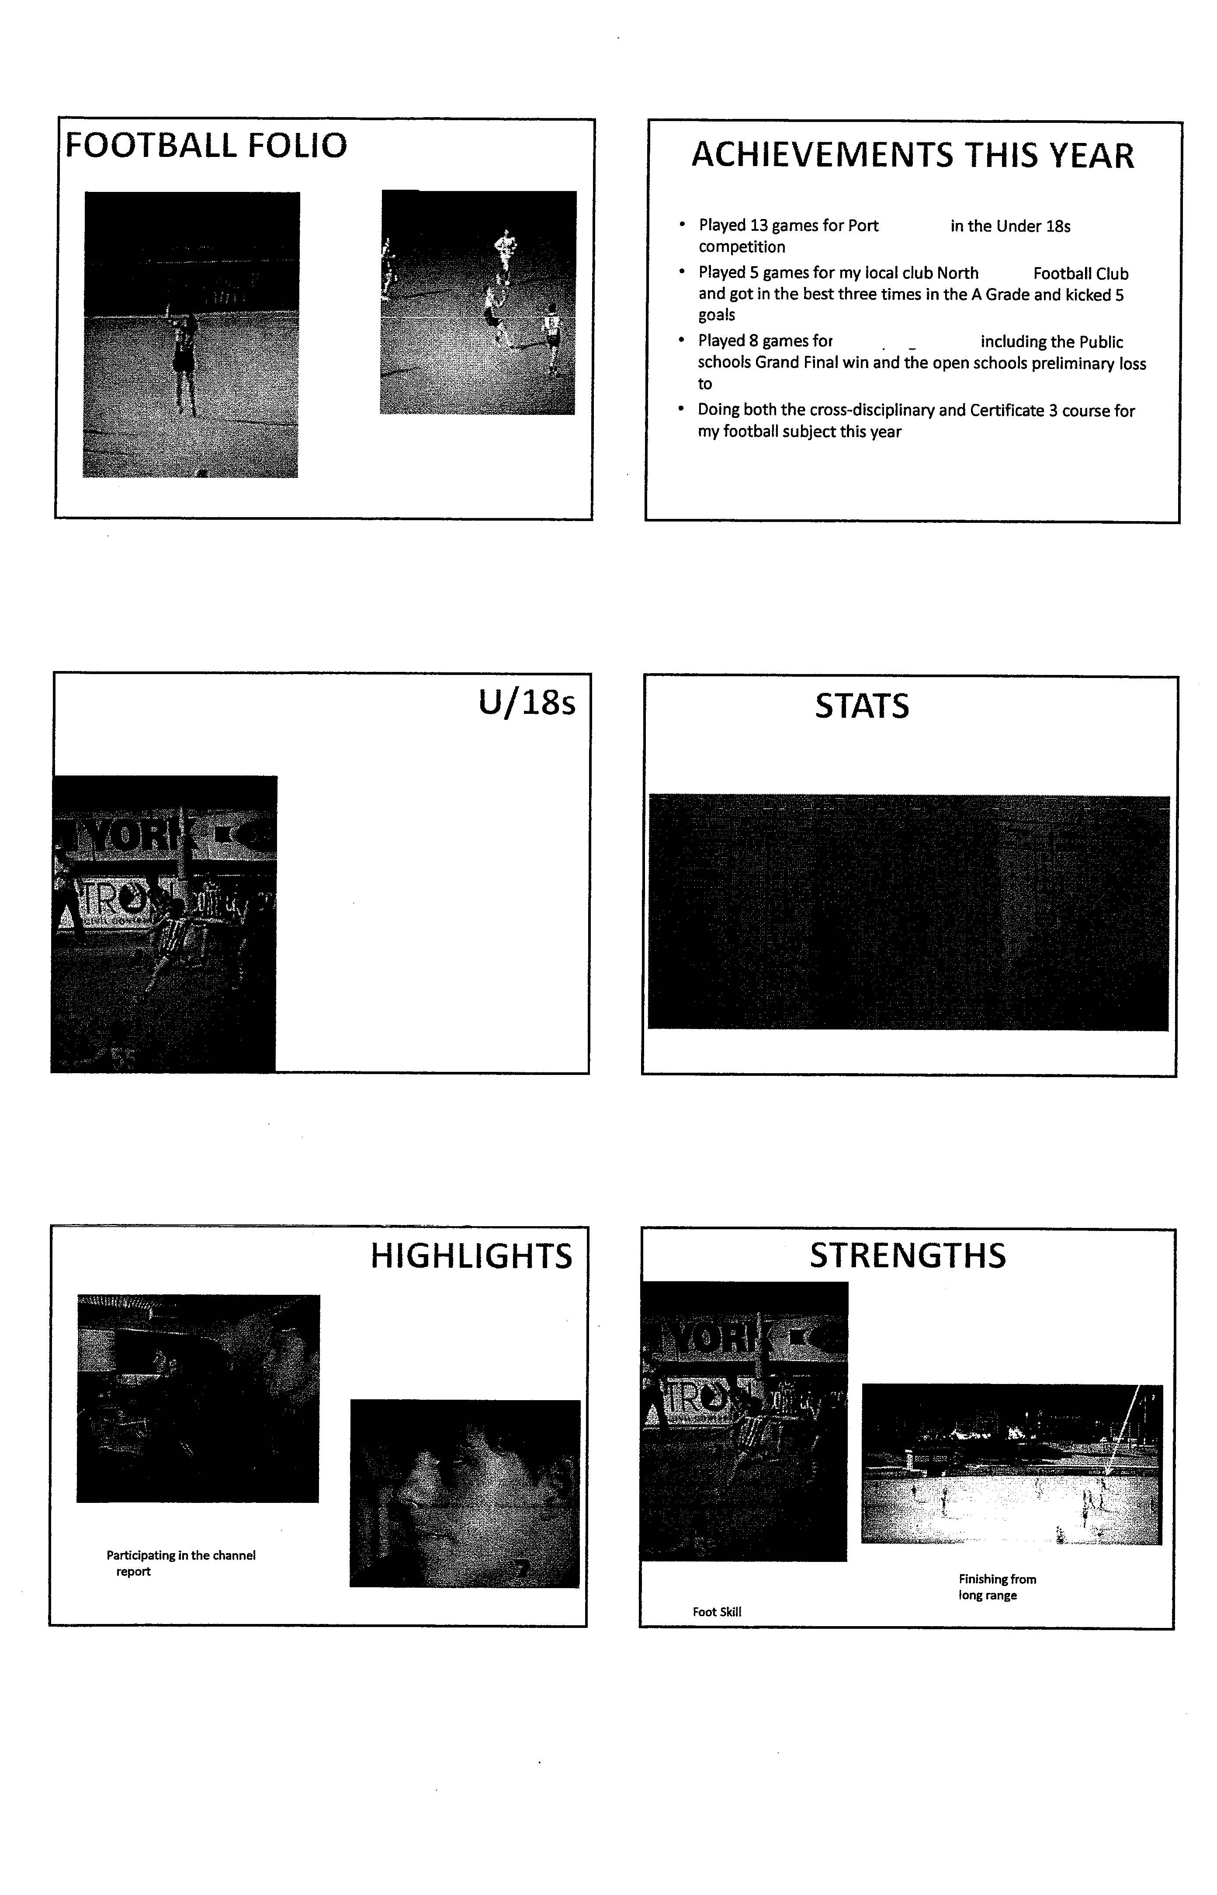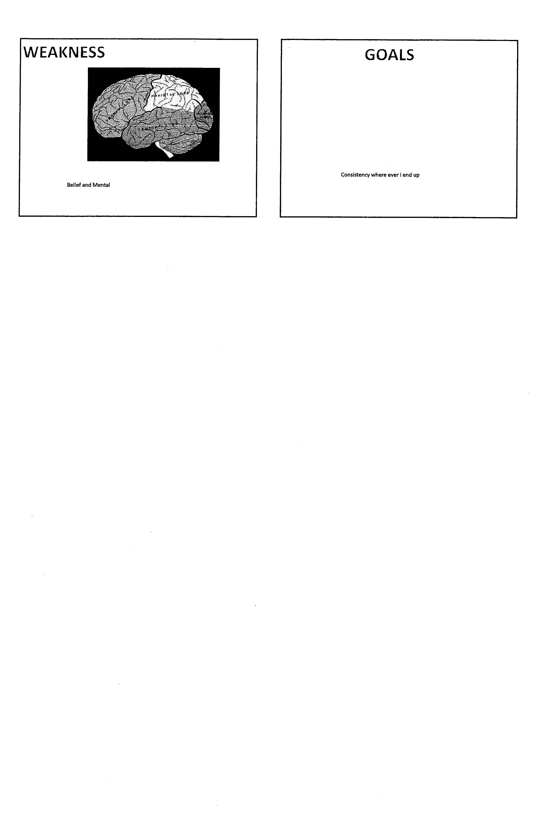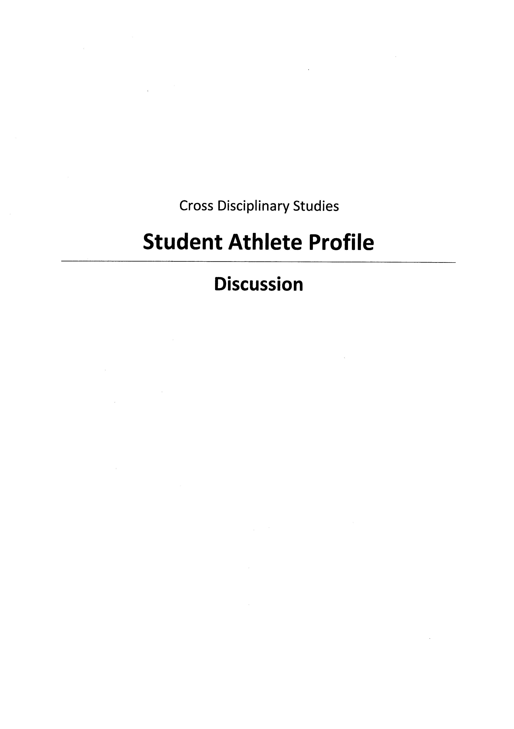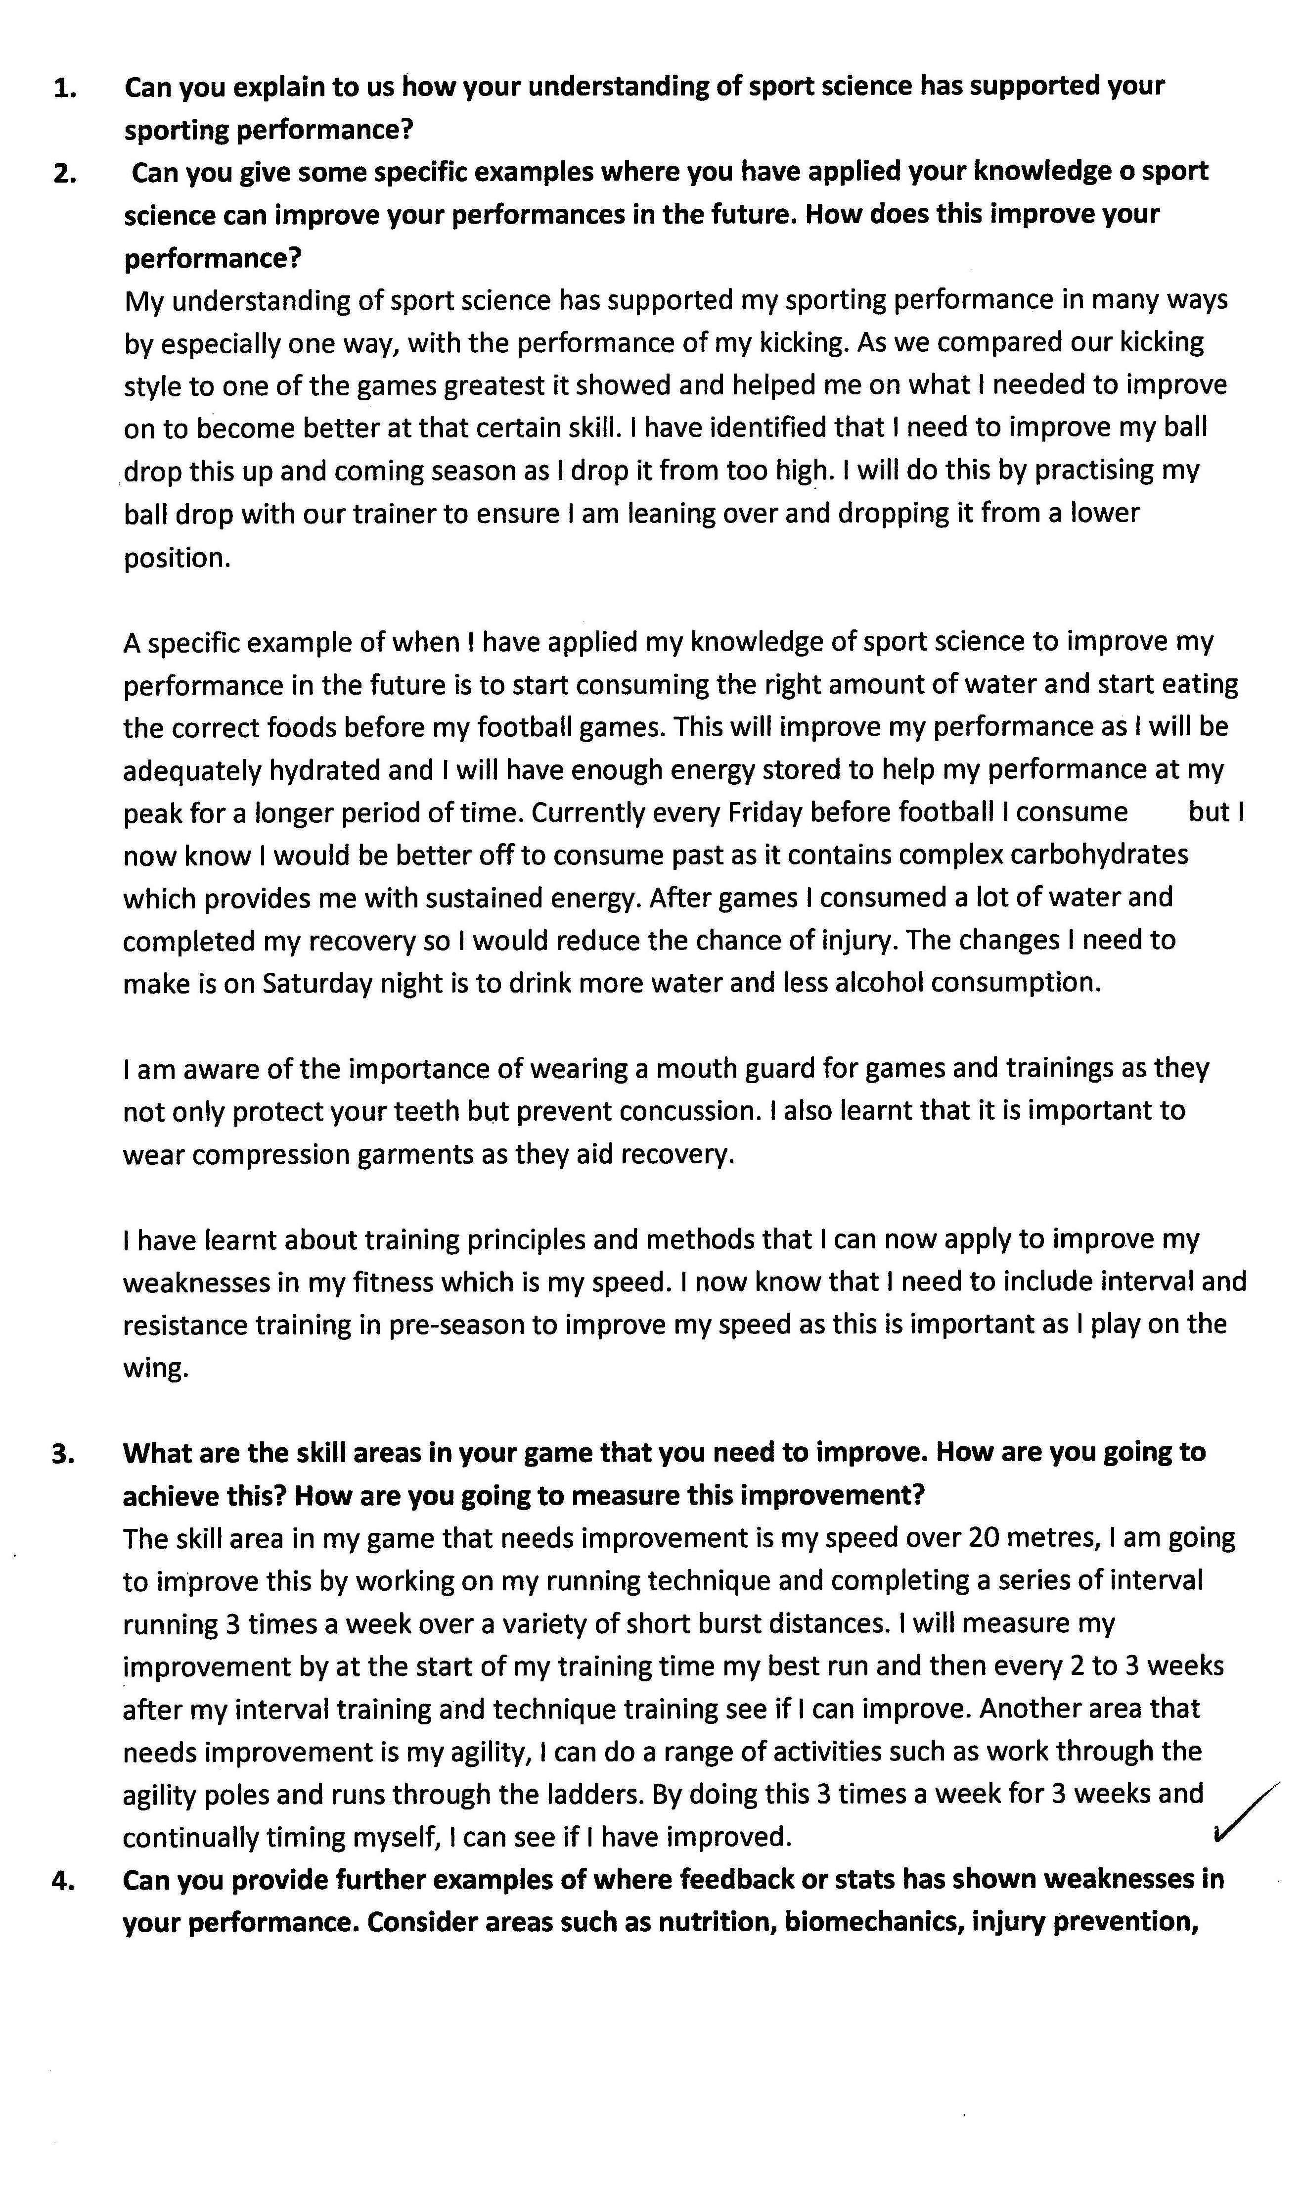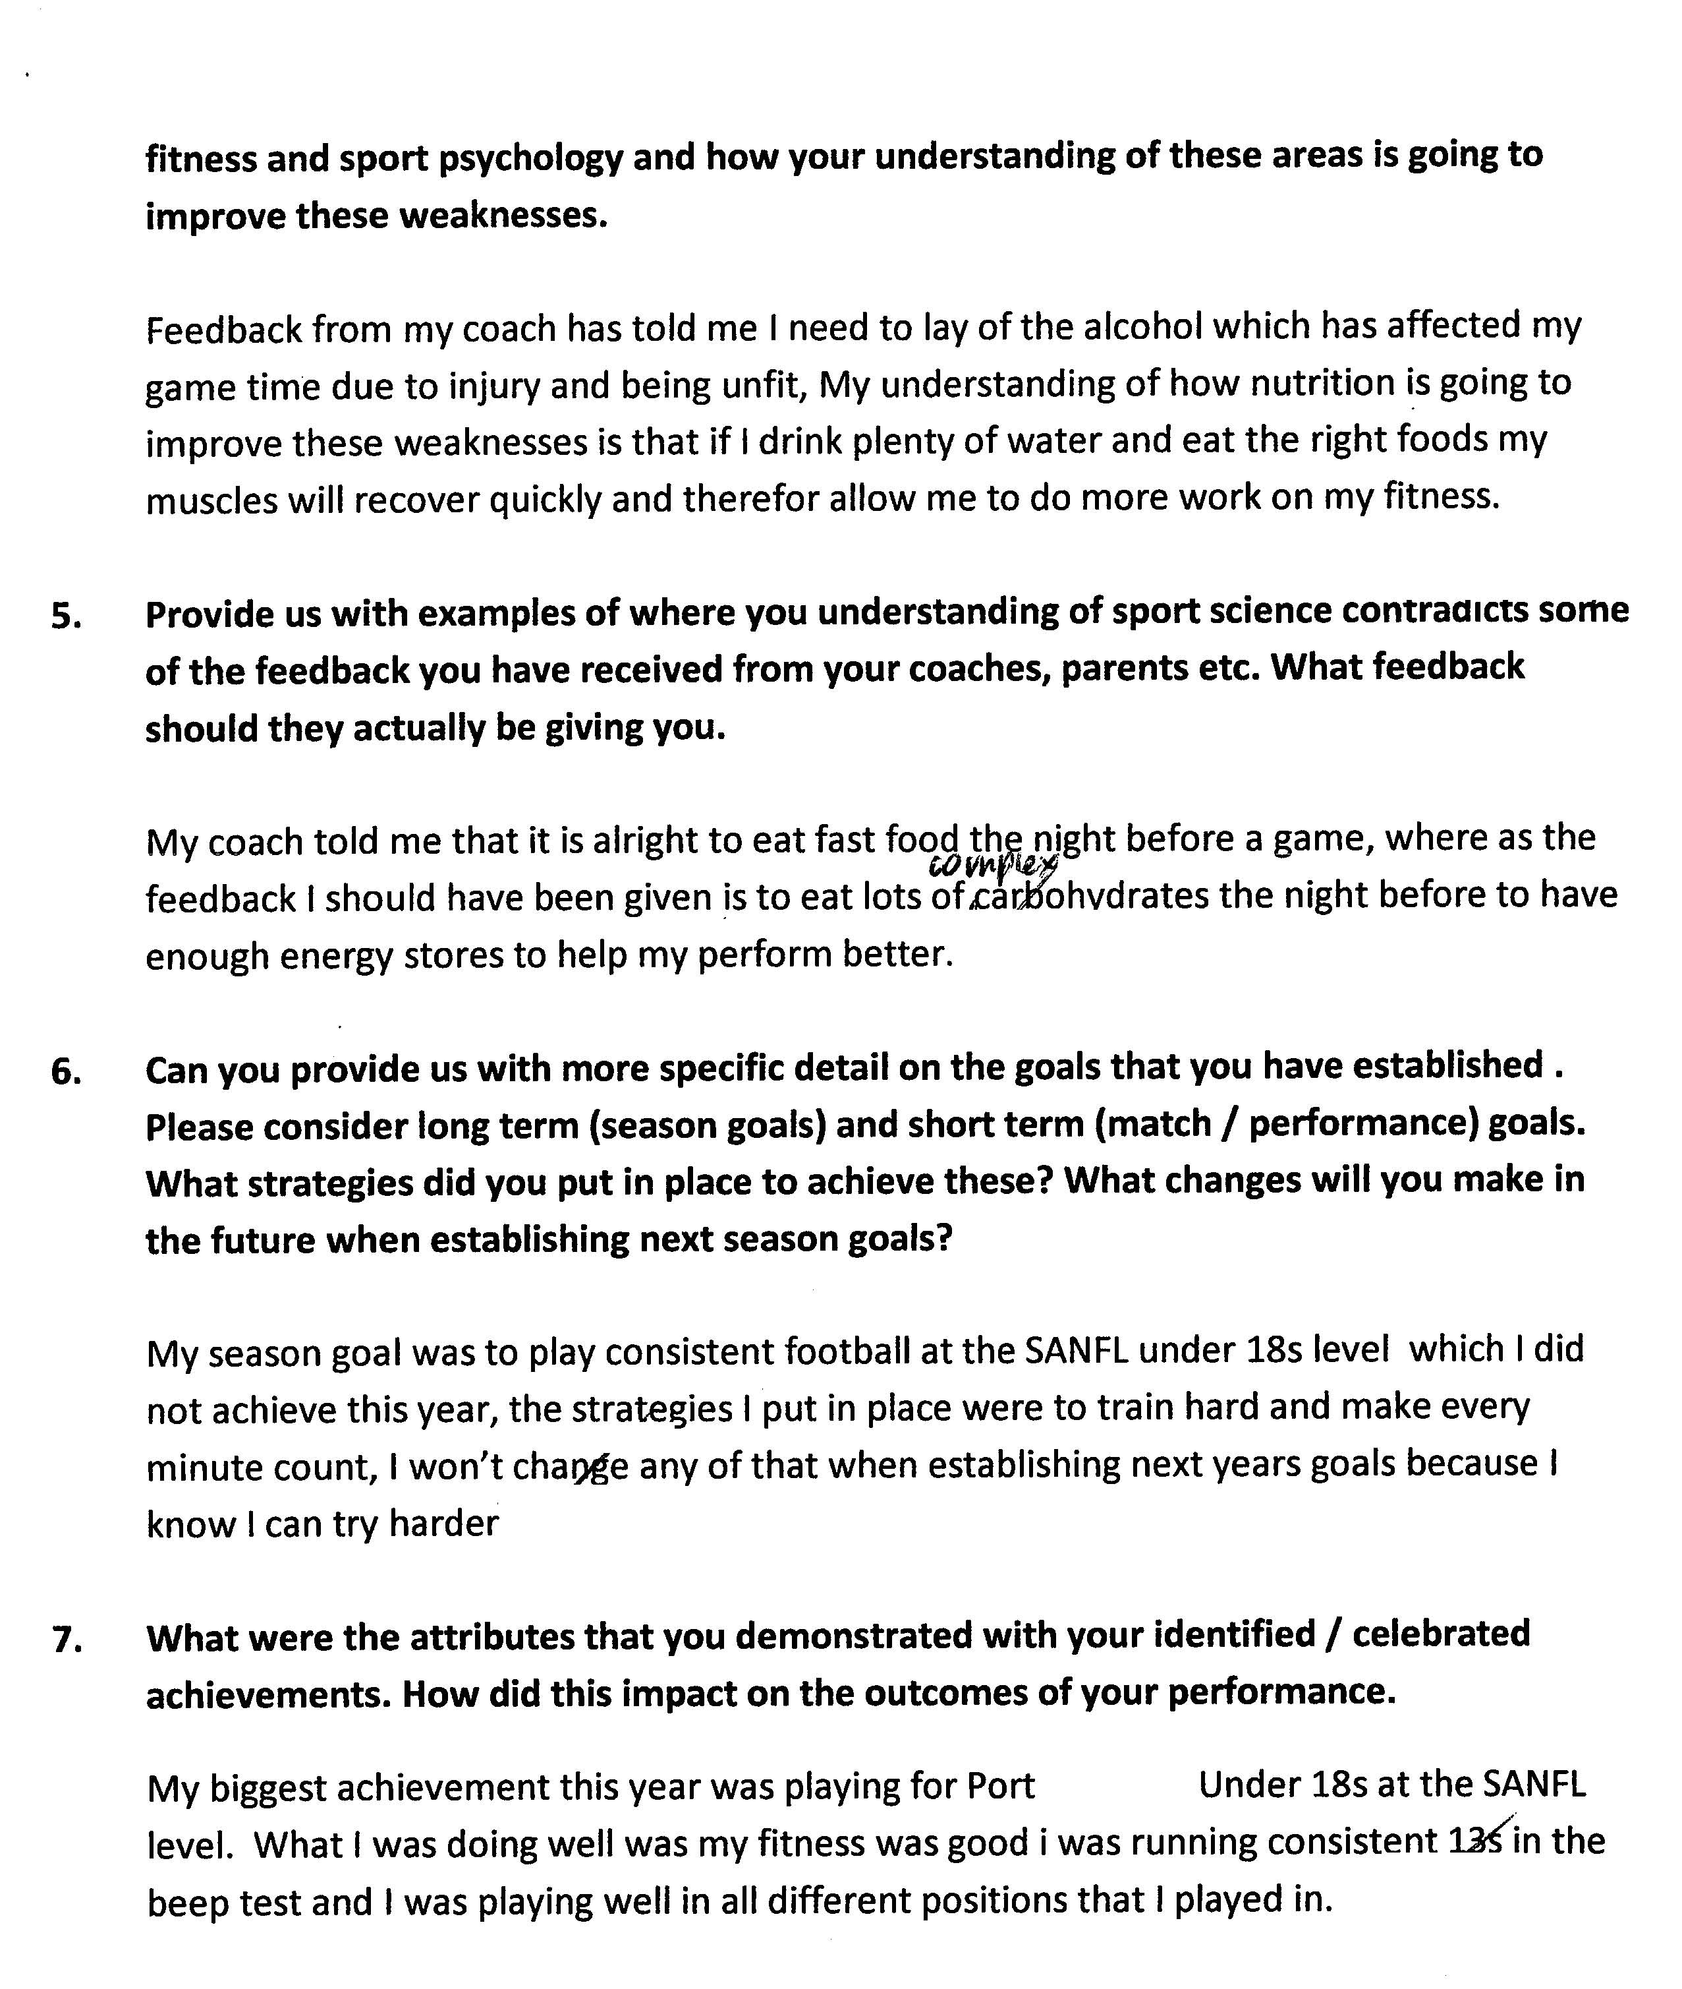

(Transcript of discussion provided)
Assessment Comments
This response is illustrative of a C- grade.
KU2 Knowledge and skills related to the learning interest are described and limited connections are made with the disciplines (especially sports science).
KU3 Informed understanding demonstrated of the capabilities of Communication and Personal Development.
A2 Application of knowledge to solve problems and effect changes in practices takes the form of suggestion rather than an exploration of broader implications.
A3 Some development of basic ideas is evident in both presentation and discussion.
AE1 Information is gathered from a variety of sources (e.g. coaches, data from statistics) to provide a narrative of different perspectives. Some attempt is made to analyse the information to make future changes to performance.
AE3 Reflection on own learning is evident and is supported by some considered analysis.
AE4 Basic consideration of feedback from coaches.
IC2 Expression and communication is generally clear. Plans for future changes are outlined with little direct connection to the learning interest.

Performance Standards for Stage 2 Cross-disciplinary Studies
 | Knowledge and Understanding | Application | Analysis and Evaluation | Interaction and Communication
A | Insightful and sophisticated exploration of key elements of the relevant disciplines and their connections to the learning interest.  Well-informed and highly effective understanding of the learning interest, incorporating specific discipline knowledge and skills.  In-depth knowledge and understanding of the relevant capabilities. | Comprehensive integration and application of aspects of the relevant disciplines in familiar as well as complex, less familiar situations.  Highly focused application of knowledge and understanding to solve problems with insightful creativity and initiative.  Convincing and in-depth development of ideas, insights, and further questions. | Comprehensive analysis and evaluation of ideas and information from a variety of sources and perspectives to deepen understanding of the learning interest.  Sustained and insightful evaluation of the contributions of the disciplines.  Well-considered and substantive analysis of and reflection on the student’s own learning.  Perceptive evaluation of feedback from others. | Convincing and sustained demonstration of purposeful interactive and collaborative skills in a range of situations.  Clear, coherent, and highly focused communication of understanding, reasoned conclusions, and new ideas and insights about the learning interest.
B | Well-considered exploration of key elements of the relevant disciplines and their connections to the learning interest.  Well-informed understanding of the learning interest, incorporating discipline knowledge and skills.  Well-informed knowledge and understanding of the relevant capabilities. | Well-informed integration and application of aspects of the relevant disciplines in familiar and less familiar situations.  Well-considered application of knowledge and understanding to solve problems with creativity and initiative.  Thoughtful development of ideas, insights, and further questions. | Detailed analysis and evaluation of ideas and information from a variety of sources and perspectives to deepen understanding of the learning interest.  Sustained evaluation of the contributions of the disciplines.  Well-considered analysis of and reflection on the student’s own learning.  Well-considered evaluation of feedback from others. | Mostly sustained and focused interactive and collaborative skills in a range of situations.  Clear, coherent, and mostly focused communication of understanding, conclusions, and new ideas and insights about the learning interest.
C | Exploration of key elements of the relevant disciplines and their connections to the learning interest.  Informed understanding of the learning interest, linked to discipline knowledge and skills.  Informed understanding of the relevant capabilities. | Informed integration and application of aspects of the relevant disciplines in mostly familiar situations.  Considered application of knowledge and understanding to solve problems with some creativity and initiative.  Competent development of ideas and insights, and further questions. | Considered analysis and evaluation of ideas and information from different sources and perspectives to deepen understanding of the learning interest. Analysis sometimes tends towards summary and narration.  Some evaluation of contributions of the disciplines, tending towards description.  Considered analysis of and reflection on the student’s own learning.  Considered evaluation of feedback from others. | Competent interactive and collaborative skills in different situations.  Generally clear communication of understanding, conclusions, and new ideas and insights about the learning interest.
D | Some basic connections between aspects of two or more disciplines and the learning interest.  Awareness of aspects of the learning interest, discipline knowledge, or skills.  Recognition of some of the capabilities. | Superficial integration or application of aspects of the relevant disciplines in highly familiar situations.  Some creativity evident in occasional problem-solving.  Some development of basic ideas and insights. | Partial summary of ideas and information, with some increased understanding of learning interest.  Description of some elements of the contributions of the disciplines.  Some reflection on the student’s own learning.  Basic consideration of feedback from others. | Simple interactive and collaborative skills.  Basic communication of some ideas and insights about the learning interest, with some attempted conclusions.
E | Identification of limited connections between one or more aspects of disciplines and the learning interest.  Emerging awareness of one or more aspects of the learning interest or skills.  Identification of one or more capabilities. | Attempted application of an aspect of a relevant discipline.  Attempted identification of a possible solution to a problem.  Attempted development of an idea or question. | Simple summary of ideas and/or information that may have some relevance to learning interest.  Attempted description of one or more elements of the contributions of the disciplines.  Attempted description of an aspect of the student’s own learning.  Limited attempt at reflecting on feedback. | Attempted interactive and collaborative skills.  Attempted communication of partially developed ideas that are not necessarily new.

